Connect 2

Revision sheet

2019/2020

Name: ……………………………………

Class: ……………………………………..

**Unit (1)**

study

Father – mother – brother – sister – grandpa – grandma – family.

**Unit (2)**

King – doctor – boy – girl – school – bird – fur.

**Unit (3)**

Boots – dress – glasses – coat – hat – watch – pants.

**Unit (4)**

Team – football – tennis – karate – swimming – basketball – kick – throw – healthy – unhealthy.

**Unit (5)**

Cloud – plane – planet – clock – classroom – friends – breakfast – play – drink.

**Unit (6)**

Milk – water – juice – burger – chicken – ice cream – fruits – eggs – grapes – fries.

Test (1)

1. **Listen and write the missing vowel:**
2. **Gray 2) girl 3) fur 4) car 5) uncle**
3. **Look and match**

|  |
| --- |
| 1. Family (c) 2. Doctor (e) 3. Glasses (d) 4. Team (b) 5. Friends(a) |

|  |
| --- |
| a.    b.  c.  d.  e. |

**4- Look and circle:**

**3**

**2**

**1**

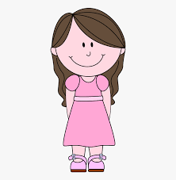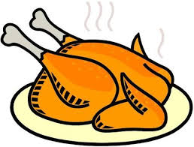

**chicken grapes**

**father**

**sister**

**fruit**

**milk**



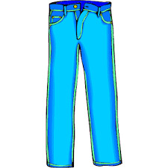

**healthy**

**unhealthy**

**5**

**coat**

**pants**

**4**

**5- Unscramble and write:**

**3**

**1**

**2**

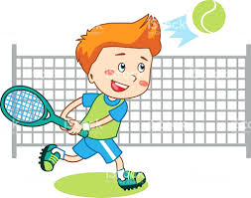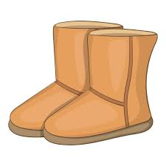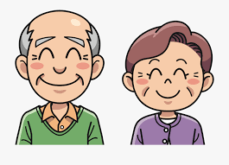

**ragndap otobs nntnie**

**Grandpa Boots Tennis**

**6- Look and write:**

**2**

**1**

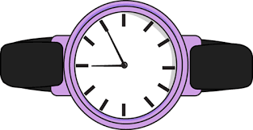

**These are my grandparents It is a watch**

**7- Punctuate the following:**

**it is a boat**

**…………It is a boat . …………………………………………………......................................**

**8- Copy the following sentences:**

1. **I’m happy.**

**……………I’m happy . ……………………………………………………………………………….**

1. **He is a firefighter.**

**………………He is a firefighter …………………………………………………………………………….**

Test (2)

1. **Listen and write the missing vowel:**
2. **Green 2) cube 3) clay 4) drum_ 5) cousin**
3. **Look and match**

|  |
| --- |
| 1. Cousins (c) 2. Shirt ( e ) 3. Fries ( a) 4. Juice ( b ) 5. Planet ( d) |

|  |
| --- |
| a.    b.    c.  d.  e. |

**4- Look and circle:**

**3**

**2**

**1**

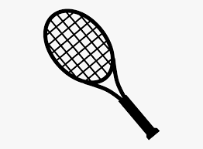

**parents boys**

**basket**

**racket**

**tennis**

**karate**

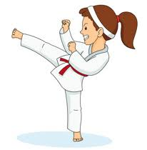



**healthy**

**unhealthy**

**5**

**dress**

**pants**

**4**

**5- Unscramble and write:**

**3**

**1**

**2**

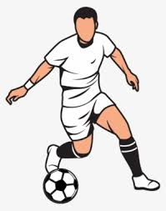

**ragndam oftoallb lenpa**

**Grandma Football plane**

**6- Look and write:**

**2**

**1**

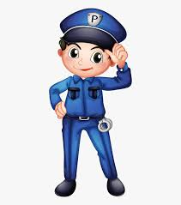

**…He is eating healthy food He is a police officer**

**7- Punctuate the following:**

**what time is it**

**……What time is it ? ………………………………………………………......................................**

**8- Copy the following sentences:**

1. **I can play tennis.**

**……………I can play tennis .……………………………………………………………………………….**

1. **They clean the house.**

**……………They clean the house .……………………………………………………………………………….**

Test (3)

1. **Listen and write the missing vowel:**
2. **Juice 2) egg 3) throw 4) hot 5) blue**
3. **Look and match**

|  |
| --- |
| 1. Fruit ( c) 2. Clock ( e) 3. Cloud (d) 4. Draw ( a) 5. Chicken (b) |

|  |
| --- |
| a.    b.    c.    d.    e. |

**4- Look and circle:**

**3**

**2**

**1**

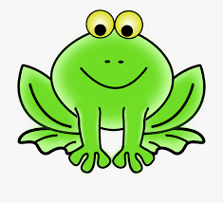

**family children**

**sheep**

**frog**

**Ice cream**

**fruit**

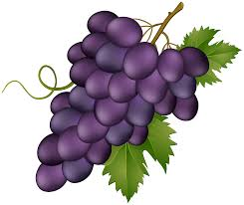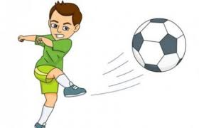

**fries**

**grapes**

**5**

**kick**

**throw**

**4**

**5- Unscramble and write:**

**3**

**1**

**2**

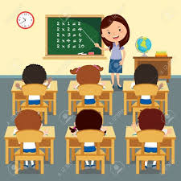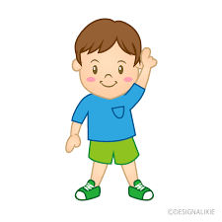

**inuosc lcssaomro lpetna**

**Cousin Classroom Planet**

**6- Look and write:**

**2**

**1**

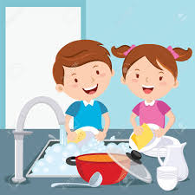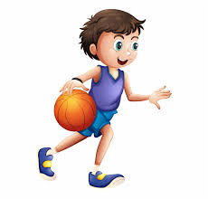

**He is playing basketball They are washing dishes**

**7- Punctuate the following:**

**can he hit the ball**

**…Can he hit the ball ? …………………………………………………………......................................**

**8- Copy the following sentences:**

1. **She plays with her friends.**

**She plays with her friends.**

1. **The gardener looks after the garden.**

**The gardener looks after the garden .**

Test (4)

1. **Listen and write the missing vowel:**
2. **Black 2) clock 3) cloud 4) home 5) parents**
3. **Look and match**

|  |
| --- |
| 1. Watch (c) 2. Nurse ( e) 3. Drum ( d) 4. Breakfast (a) 5. Sheep (b) |

|  |
| --- |
| a.    b.    c.      d.  e. |

**4- Look and circle:**

**3**

**2**

**1**

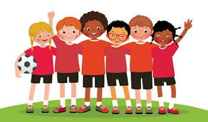

**hat shirt**

**clothes**

**team**

**glasses**

**watch**



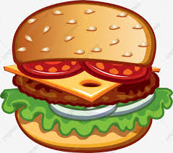

**boots**

**head**

**5**

**fries**

**burger**

**4**

**5- Unscramble and write:**

**3**

**1**

**2**

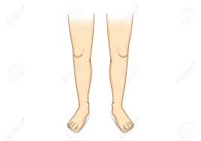

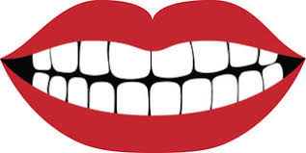

**thete egls ertaka**

**Teeth Legs Karate**

**6- Look and write:**

**2**

**1**

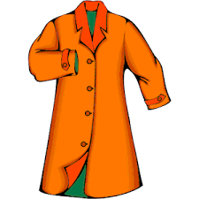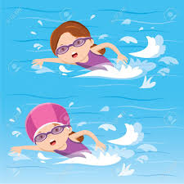

**They are swimming in the sea This is a coat**

**7- Punctuate the following:**

**ahmed can speak with his hands**

**…Ahmed can speak with his hands .**

**8- Copy the following sentences:**

1. **They can wash the dishes.**

**They can wash the dishes.**

1. **He is a cleaner.**

**He is a cleaner.**

Test (5)

1. **Listen and write the missing vowel:**
2. **Sheep 2) frog 3) water 4) far 5) fo ( b)ot**
3. **Look and match**

|  |
| --- |
| 1. Face (b ) 2. T – shirt ( e) 3. Drink ( d) 4. Basketball (a) 5. Racket ( c) |

|  |
| --- |
| a.    b.  c.    d.  e. |

**4- Look and circle:**

**3**

**2**

**1**

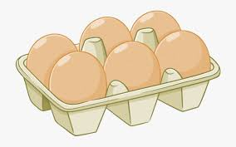

**doctor police officer**

**fries**

**eggs**

**water**

**milk**



**grand parents**

**parents**

**5**

**football**

**tennis**

**4**

**5- Unscramble and write:**

**3**

**1**

**2**



**lagssse emat robhter**

**Glasses Team Brother**

**6- Look and write:**

**2**

**1**

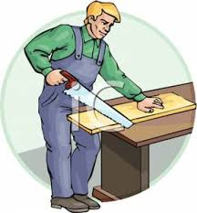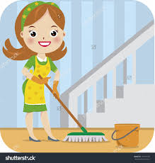

**She is cleaning He is a carpenter**

**7- Punctuate the following:**

**who plays basketball**

**Who plays basketball?**

**8- Copy the following sentences:**

1. **We drink tea with milk.**

**We drink tea with milk .**

1. **He is a gardener.**

**He is a gardener .**