 Mid-Year Revision

Match (1)

1. How are you ? a-five o’clock . ( 2 )
2. I get up at b-I live in Cairo . ( 3 )
3. Where do you live ? c-I’m fine, thank you . ( 1 )
4. Hello , Sara ! d-Hi, Hana . ( 4 )

e-Good morning . ( )

Match (2)

1-This is an a-herd . (3 )

2-Baby lions are called b-nest . (4)

3-Group of animals live in c-He is playing tennis . ( )

4-Birds live in a d-elephant.( 1 )

e-cubs . (2)

Match (3)

1. I wash a-is tall . ( 2 )
2. Giraffe b-have colourful wings. ( 4 )
3. Tortoise c-has long arms . ( )
4. Butterflies d-is slow . ( 3 )

e-my face . ( 1 )

Match (4)

1. Do you eat a- is unhealthy . ( 2 )
2. The opposite of healthy b-water . ( 4 )
3. He isn’t fit c-wood . ( )
4. I drink d-healthy food ? ( 1 )

e-He is unhealthy . ( 3 )

Match (5)

1. We see Owls a-the river . ( 2 )
2. Fish live in b-pet . ( 4)
3. The opposite of short c-trash . ( )
4. The animals live in a house d-is tall. ( 3 )

e-at night . ( 1 )

Match (6)

1. Camels live in a a-tundra. ( )
2. Elephants live in b-mountain. ( 4 )
3. Sick pets can go to c- rain forest . ( 2 )
4. I can climb a d-desert. ( 1 )

e-the vet. ( 3)

Match (7)

1. The museum is made a-plastic . ( 3 )
2. They see a boat on the b-river . ( 2)
3. Toys are made of c-Yes ,she does. ( )
4. Do you stay in a hotel? d-of stone . ( 1 )

e-No, I don’t. ( 4 )

Match (8)

1. Come to visit a-I go to Karnak. ( 2)
2. Where do you go ? b-No, I can not . ( )
3. You can c-My mum . ( 4 )
4. Who is making cake ? d-the Giza Pyramids. ( 1)

e-take photos. ( 3 )

Choose :

1-(How – what-who) are you? I am fine.

2-I eat (sandwiches –water-school) at half past ten.

3- I (Play – plays – playing) tennis.

4-She (going – goes- go) home at half past five.

5-Does (they- he-you) have lunch at one o’clock.

6-(Bad – Good – Fast ) morning , Ali .

7-Do you get ( up – at-down ) at seven o’clock .

8-Hoda is playing the ( piano – cake-sandwich ).

9-He (playing – play –plays ) tennis after school .

10-( Does- Do – Doing ) he eat his breakfast?

11- A giraffe has four (wings – legs – feather ) .

12-I have two ( arms – face- heads ).

13-The ant is a tiny ( bird – animal – insect ).

14-The bus took four hours , it is very ( fast – slow- quiet) .

15- A ( fish – tortoise- giraffe ) has got long neck .

16-A/An ( bird - elephant – lion ) has got long trunk .

17-I kick the ball with my ( teeth –face-feet ) .

18-Abird has got ( feather- leather-skin ) .

19-The bird has got two ( wings –face-arms ).

20-The opposite of short is ( tall-big-small).

21-(where-when-what ) can you see by the river ? –A boat.

22-I want to (see-sees-seeing ) some fish.

23-What (do-does-did) you want to see?

24-Where (do-does-are )she go?

25-I( go-goes-going ) to the river.

26-What do you want (up-of-to) see?

27-It is (a-an-some ) bear .

28- What is she (do – does – doing)?

29-Salah el-din castle is in (Cairo-Alexandria-Luxor ).

30-Acitadel is a type of ( school- castle-park ).

31-We ( enjoys-enjoy-enjoying ) our time .

32-He ( play – plays-playing ) football.

33-The citadel is made ( of-at-on) stone.

34-This cup is made (of-on-in ) glass.

35-This chair is made of (plastic-wood-paper).

36-This bridge is made of (metal-wood-cotton ).

37-They see a boat on the ( park-school-river ).

38-Toys are made of (stone-plastic-cloth ).

39-This car is made of ( glass-wood-metal ).

Supply the missing letters:

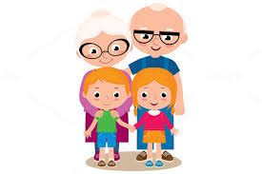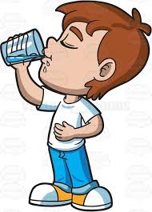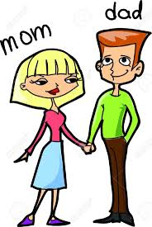

parents Grand children drink

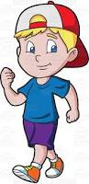

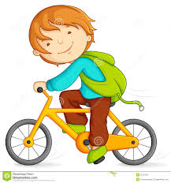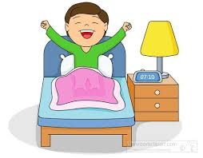

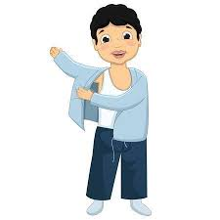 G et Up Walk R ide

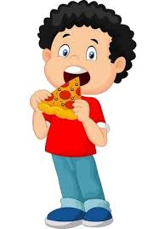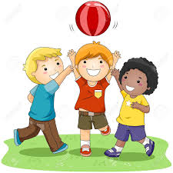

Wear Play Eat

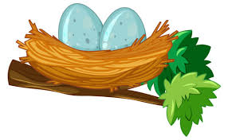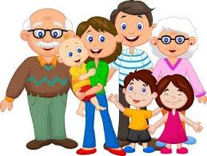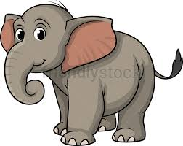

Elephant Family Nest

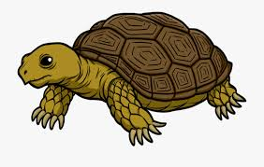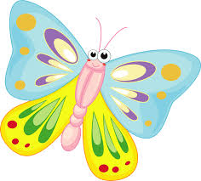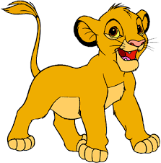

Cub Butterfly Tortoise

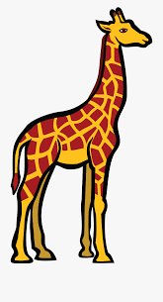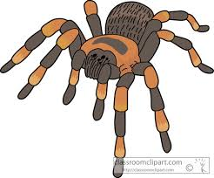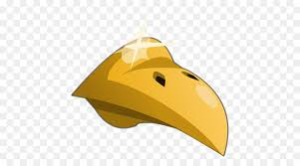

Giraffe Spider Beak

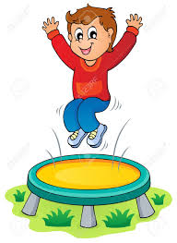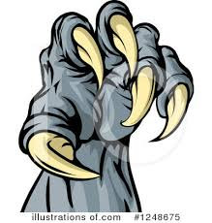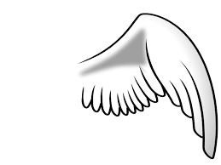

Wing Claws Jump

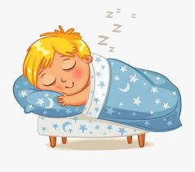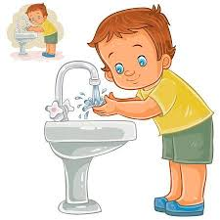

Swim Sleep Wash

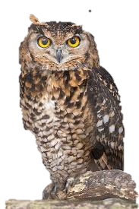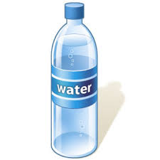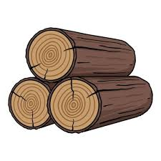

Wood Water Owl

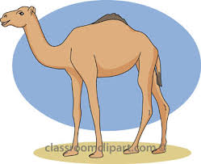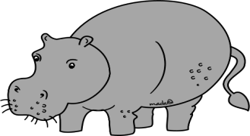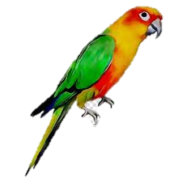

Parrot Hippo Camel

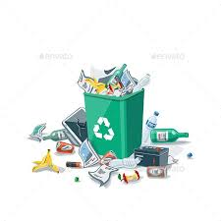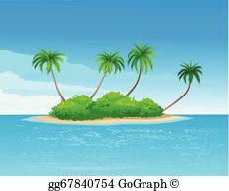

Island Trash Vet

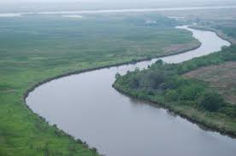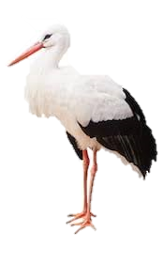

Boat Stork River

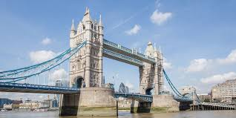

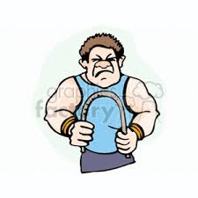

Bridge bend Coffee

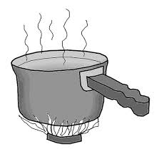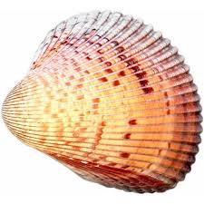

Shell Cook Boil

Grammar

Choose the correct answer:

* 1. Tarek (copy – is copying – are copying) the words at the moment.
  2. The children are (write – writes – writing) the words in the copybooks at the moment.
  3. Nahla is (point – points – pointing) to the window now.
  4. The babies (am – is – are) drinking milk at the moment.
  5. She (eat – eats – is eating) a cake now.
  6. The baby isn't (sleep – sleeps – sleeping) now.
  7. The men (aren't – isn't – can't) working at the moment.
  8. Are the children (laugh – laughing – laughs) happily now?

-Yes, they (aren't – is – are).

* 1. The girls (are – is – am) playing with the dolls now.

10.Are you (draw – draws – drawing) now?

-Yes, (he is – I am – they are).

11.Adel (brush – brushes – brushing) his teeth three times every day.

12.Ramy (go – goes – going) to a language school.

13.You (live – lives – living) in El Haram Street.

14.Heba (walk – walks – walking) to school in the morning.

15.Dalia (watch – watches – watching) T.V every day.

16.She (cross – crosses – crossing) the road at the green light.

17.Ahmed (walk – walks – walking) to school in the morning.

18.We (watch – watches – watching) the clowns on TV on Thursdays.

19.Ali (skate – skates – skating) in the garden every weekend.

20.(Do – Does – Is) he listen to music?

21.(Do – Does – Are) they speak English?

22. (Do – Does- Am) your father drive a car?

23. You (don't – doesn't – aren't) eat strawberries.

24. She (don't – doesn't – aren't) play football.

25. Do Kelly and Emma (help – helps – helping) their mother?

26. Does your brother (eat – eats – eating) meat?

27.We don't (wash – washes – washing) our car every day.

28.(Am-Is-Are)the boys playing football?

29.What are you (do – doing – does)?

30.She is (works-working-work) at the moment.

31, Look!The birds (am-is-are)flying.

32.She isn’t (cooks-cook-cooking) now.

33.Ahmed and I (am-is- are) climbing on the climbing wall.

34.They are studying(yesterday-now-tomorrow).

35.They (isn’t-aren’t-am not) working hard.

Choose the correct answer:-

1. Omar is (young – younger – youngest) than Nora.

2.The plane is (faster – fastest – fast) than the train.

3.Huda is (tall – tallest – taller) than Sally.

4. Shady is (old – oldest – older) than Kareem.

5.Ahmed is cleverer (than – then – that) Ola.

6.Summer is (hot – hotter – hottest) than Spring.

7. Asia is (big – biggest – bigger) than Africa.

8.The rabbit is (lazyer – lazier – lazy) than the turtle.

9.Winter is colder (that – then – than) Autumn.

10. The lake is (small – smaller – smallest) than the river.

11. The elephant is (fat – fatter – fattest) than the monkey.

12. The lion is (stronger – strongest – strongly) than the elephant.

13.The green snake is (long – longer – longest) than the white one.

14. Peter is (happily – happier – happy) than Dave.

15. Lucy is (nicest – nicer – nice) than her sister.

16. Huda is (pretty – prettier – prettiest) than Sana.

17. Monkeys are funnier (than – the – that) rabbits.

18.The ant is (small – smaller – smallest) than the tiger.

19. The car is (slower – slowest – slow) than the train.

20.Tom is (shorter – shortest – shortly) than Ted.

21. A lion is faster (the – then – than) A cat.

22.The city is (large – larger – largest) than the town.

23.The red glasses are (cheaper – cheapest – cheap) than the yellow glasses.

24.English exam is (easy – easiest – easier) than the Arabic exam.

25.France is (old – oldest – older) than Italy.

26.Rasha is fatter (then – than – that) Noha.

27.The Eiffel tower is (high – higher – highest) than Cairo tower.

**Complete the following :-**

1- The boys are watching the fast car.

**Noun:** boys-car **Adjective** fast

2- The girl is riding a dirty bicycle.

**Noun:**  girl – bicycle **Adjective dirty**

3- The dog is eating an old shoe.

**Noun:** dog – shoe **Adjective** old

4- This is a big box.

**Noun:** box **Adjective** big

5- The city is clean.

**Noun:** city **Adjective** clean

6- I don't like the dirty places.

**Noun:** places **Adjective** dirty

7- It is smelly in the city.

**Noun:** city **Adjective** smelly

8- He has got a new bike.

**Noun:**. bike **Adjective** new

Pictorial Composition



-He is swimming. – She is drinking.

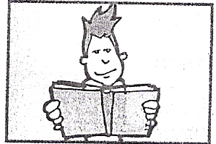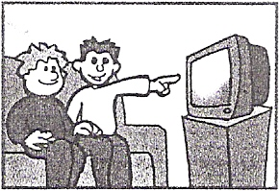

-He is reading a book. –They are watching TV.

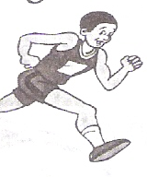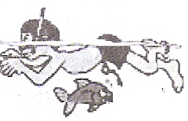

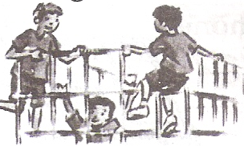-He is swimming. –He is running.

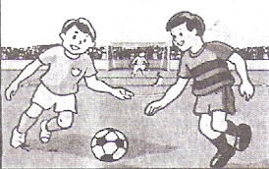

…………………………..………………………. ……………………………..……………………

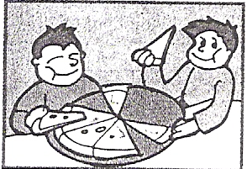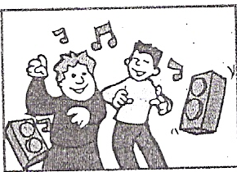

-They are dancing. –They are eating pizza.

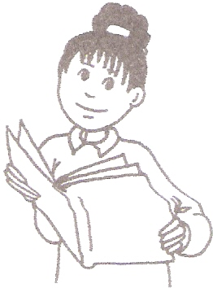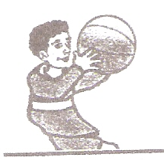

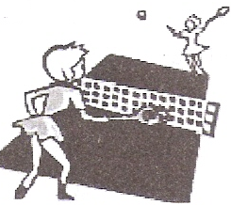-She is reading a book. -He is playing basketball.

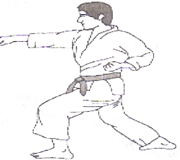

-He is doing karate. –They are playing tennis.

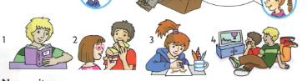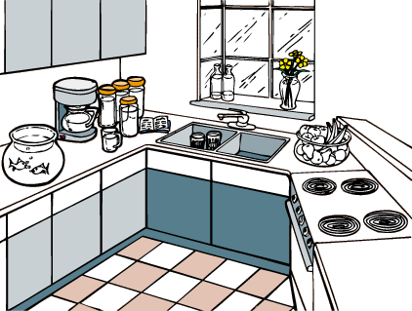

-This is a kitchen. –She is drawing.

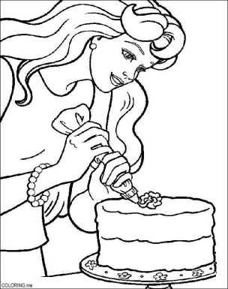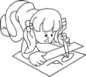

-She is making a cake. – She is drawing.

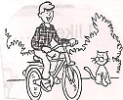



-He is riding a bike. –I drink coffee.





- These are my parents. – I get up in the morning.



-This is my family. –He is jumping.



-This is a camel. – This is a boat.



-She is cooking in the kitchen. – This is a vet.



-This is a butterfly. –This is a nest.

Comprehension 1

**Read and mark ( 🗸) or (🗴) :**

The giraffe is the tallest animal. We see a giraffe in the zoo. It has two small ears, a small head, and a long neck. It has a short tail, it eats leaves, and it has four long legs.

1- The giraffe has big ears. ( x )

2- It has a long neck. ( √)

3- It is the shortest animal. ( x)

4- We see the giraffe in the street ( x )

Comprehension 2

**Read and mark ( 🗸) or (🗴) :**

**I like dogs and I like snakes, too .I don’t like spiders or birds. I like cats but I don’t like frogs. I like horses but I don’t like monkeys. I like bananas and apples, too.**

**1. I don’t like spiders or frogs. (√)**

**2. I like cats and dogs. (√)**

**3. I don’t like monkeys but I like birds. (x)**

**4. I like bananas and frogs, too. (x)**

Comprehension 3

**Read and mark ( 🗸) or (🗴) :**

**Omar is eight years old. He is in primary two. His sister Samar is ten years old. She is in primary four. They go to the same school. Their mother is a teacher so she goes with them.**

**1. Samar is Omar’s sister. (√)**

**2. Omar is in primary four. (x)**

**3. Omar’s mother is a teacher. (√)**

**4. Samar is eight years old. (x)**

Comprehension 4

**Our house is big. We have three rooms, a kitchen and a bathroom. The phone is in the living room. The TV is in the living room too. There are two beds in the bedroom. The table and the chairs are in the kitchen.**

**1. The table is in the kitchen. (√)**

**2. The phone is in the living room. (√)**

**3. The chairs are in the bathroom. (x)**

**4. The TV is in the bedroom. (x)**

Story:

Complete:

1. The shoemaker is old and tired
2. The shoe maker is walking home.
3. The shoemaker has got some red leather.
4. The wife says; “Let’s go upstairs to bed”.
5. It’s sunny in the morning.
6. The shoemaker wants people to see the shoes.
7. The shoemaker puts the red shoes in the shop window.
8. A lady sees the red shoes.
9. The shoemaker looks at the money in his hand.
10. The shoemaker buys some more leather.
11. The lady gives three gold coins to the shoemaker.
12. The shoemaker has got some green and yellow leather.
13. The stars are in the sky.
14. The shoemaker’s face is happy, his eyes are smiling.
15. There are two pairs of shoes on the table.
16. A man sees the yellow pair and the green pair.
17. The man gives six gold coins to the shoemaker.
18. The shoemaker’s wife wants to brush her hair and go to bed.
19. It’s cold outside. It’s snowing.
20. When the clock says twelve, they see two little elves.
21. The elves work all night.
22. In the morning the elves run away
23. The shoemaker and his wife will make some clothes for the elves.
24. The shoemaker and his wife put the new clothes into little boxes.
25. At midnight the little elves run in.