science Revision for primary 3
- Choose the correct answer :
- Chlorophyll is inside (the root – the stem – the leaves)
- The plant forms food and gives out (nitrogen – oxygen)
- The plant needs (oxygen – carbon dioxide) to make photosynthesis
- A group of cells form a (tissues – organs)
- A group of organs form a (system – tissues)
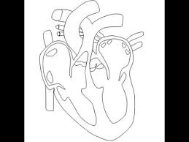
2 join each sentence to the right picture:
- It contains the iris

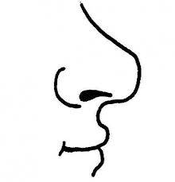
- It pumps the blood

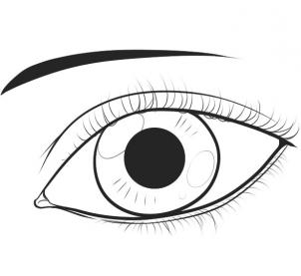
- It can keep us alive

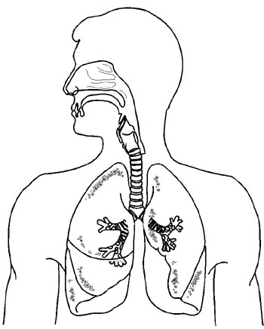
- It has three parts

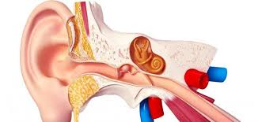
- It warms the air we breathe

3-put the right word in the right place:
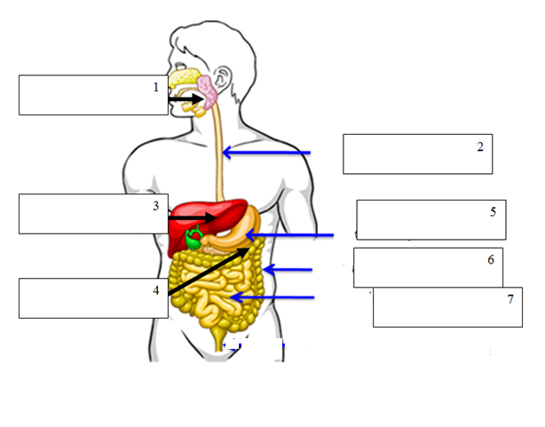
Esophagus – stomach – liver – large intestine – small intestine – mouth - pancreas

4- give one word:
- The process in which the plants can make food (………………………..........................)
- The living thing that feed on dead body
(…………..…………………………………….)
- The living thing that eats other living things
(………………..……………………………….)
- The living thing that eats meat
(…………………………………………………)
- The living thing that eats plants
(………………………………………………….)
- The building unit of all living organisms
5-form two food chine from the following organisms:
Green plant – lion – snake – frog – cow – decomposer
1-……………………………………………………………………………………………………………

2-……………………………………………………………………………………………………………

