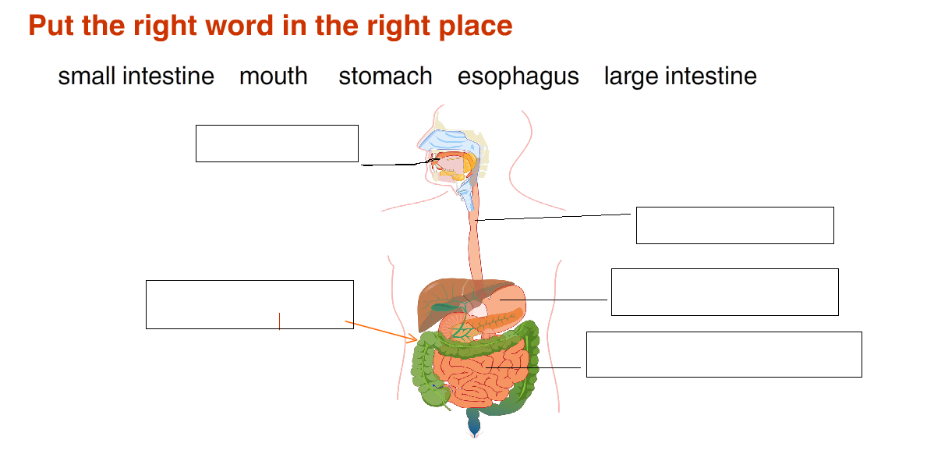
Science revision for primary two
1-

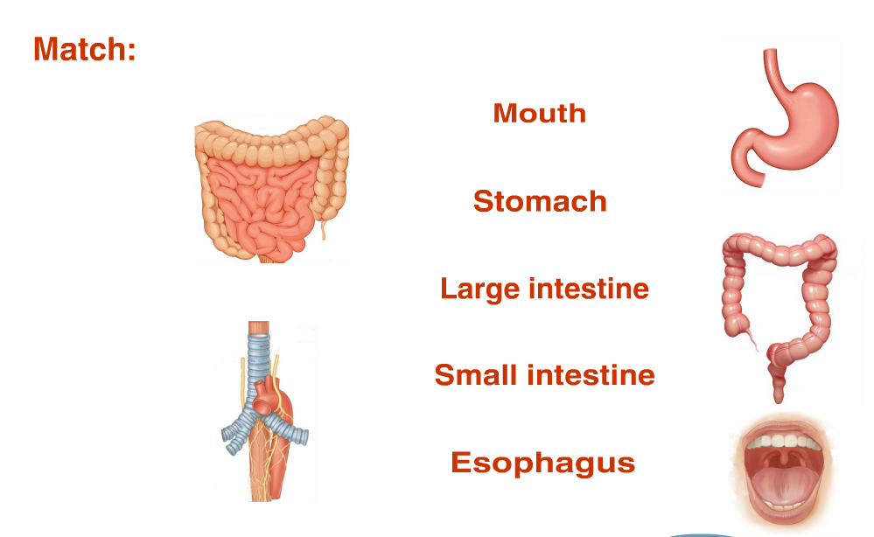
2-

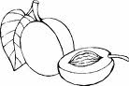
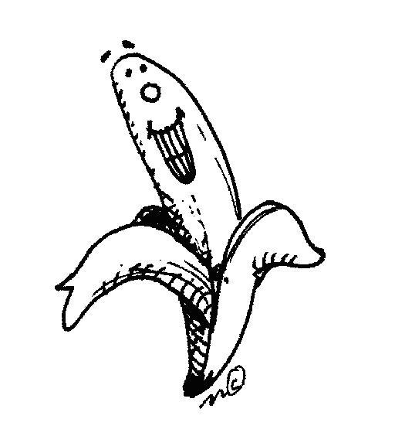
3- draw a circle around the fruit food group:
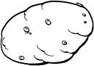

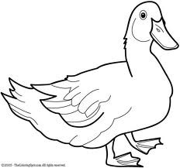
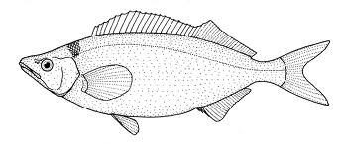

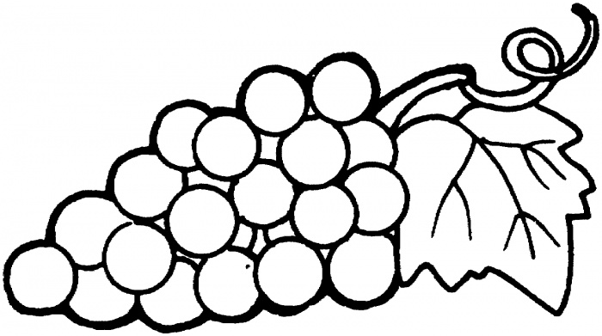

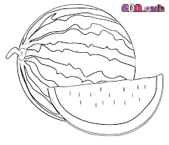

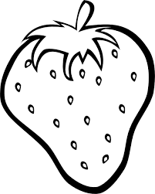

4- Put (√) or (×):
- Bread and rice help us to grow ( )
- Vegetables and fruit keep us healthy ( )
- We should eat one kind of food ( )
- Drinking milk is important for your teeth ( )
- People need water and food to grow ( )
- A nonliving things can grow and change ( )
- Carbohydrates give us energy ( )
- Vitamins keep us healthy ( )

