Science final revision for primary two

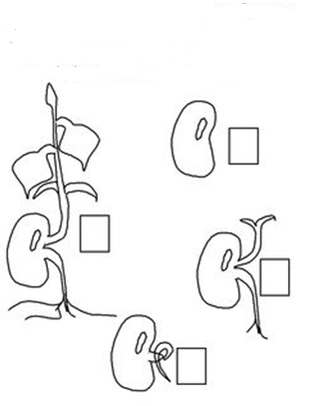
1-Arrange the following steps to show seed germination

2- choose:
- Most plants grow from ……………………………
( Root – stem – seed – fruit)
- The part of the plant that holds it to the soil is the ………………….
(stem – root – leaves – flower)
- The plant makes its food in the ………………………..
(stem – root – leaves – fruit)
- We made…………………. from plant
( shoes – milk – table)
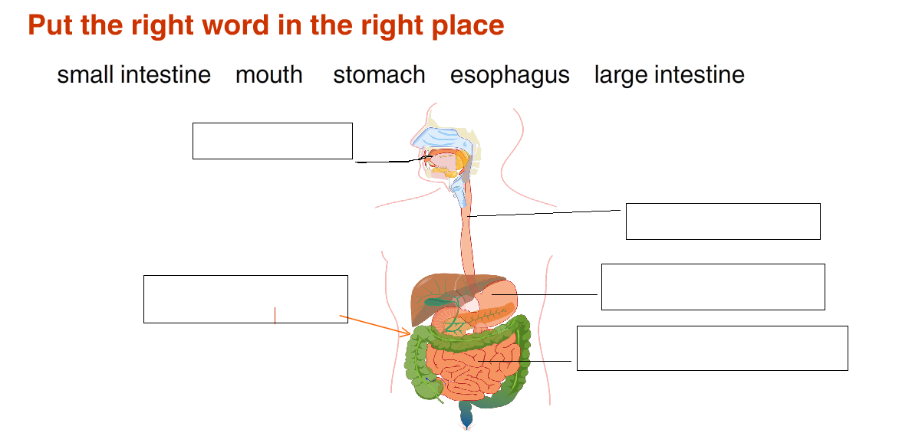
2-

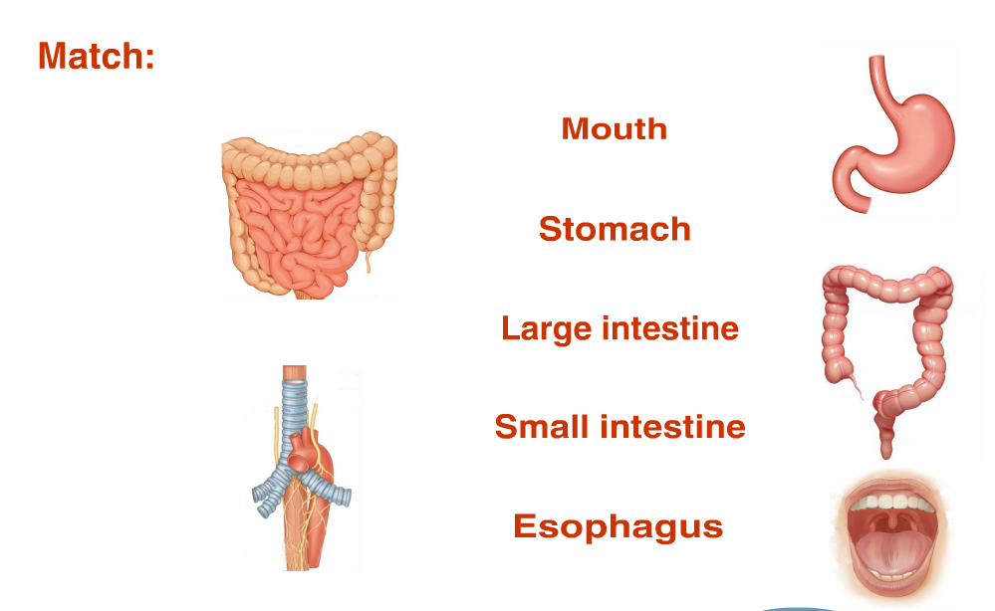

4- Put (√) or (×):
- Bread and rice help us to grow ( )
- Vegetables and fruit keep us healthy ( )
- We should eat one kind of food ( )
- Drinking milk is important for your teeth ( )
- People need water and food to grow ( )
- A nonliving things can grow and change ( )
- Carbohydrates give us energy ( )
- Vitamins keep us healthy ( )
- Write(healthy or unhealthy ) food below the picture
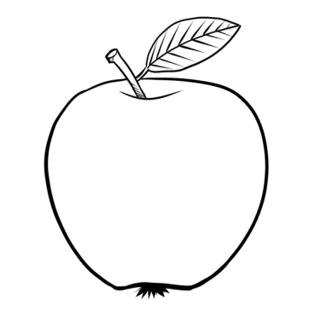
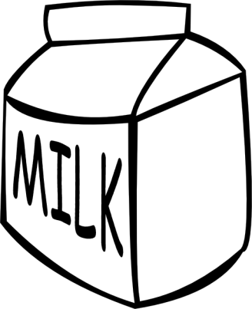
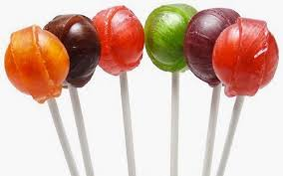

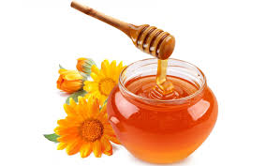

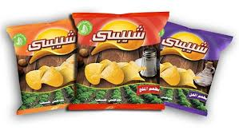

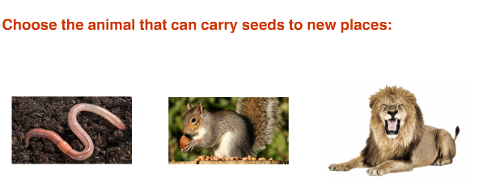
6-

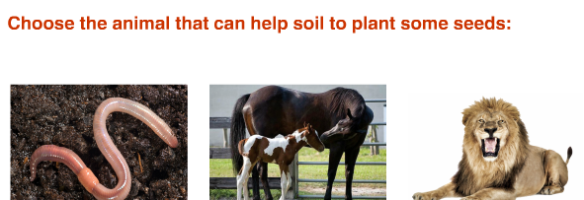
7-

