- Count and write the number:
C.W
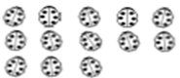
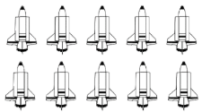

- Form set:

- Choose the correct answer:

- 9 , 8 , 7 , ……… [ 5 , 4 , 6 ]
- [ First , Second , Fifth ]

- The greatest number is ……….. [ 3 , 1 , 5 ]

- 5 is Smaller than ……… [ 1 , 4 , 8 ]
H.W
- Match:
a
Six 4
b
Eight 9
c
Nine 6
d
Four 8

- Count and write the number:

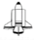

- Form Set:
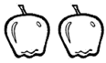
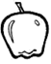

C.W
- Arrange the following numbers in ascending orders:

- 6 , 8 , 3 , 1 , 5

The order: ____ , _____ , _____ , _____ , _____

- 7 , 0 , 5 , 9

The order: ____ , _____ , _____ , _____

- Arrange the following numbers in descending orders:

- 0 , 1 , 4 , 9 , 6

The order: ____ , _____ , _____ , _____ , _____

- 8 , 3 , 2 , 0 , 5

The order: ____ , _____ , _____ , _____ , _____

H.W

- Arrange the following numbers in ascending orders:

- 7 , 2 , 5 , 3 , 9

The order: ____ , _____ , _____ , _____ , _____

- Arrange the following numbers in descending orders:

- 8 , 3 , 2 , 0 , 5

The order: ____ , _____ , _____ , _____ , _____

- Choose the correct answer:

- 7 is greater than ……… [ 9 , 10 , 3 ]

- [ First , Second , Third ]

- 5 , 6 , 7 , ……… [ 1 , 4 , 8 ]

- The smallest number is ……….. [ 5 , 9 , 1 ]

C.W
- PUT [ > , = , < ]

- 10 10 (b) 5 9

- 15 13 (d) 14 One

- 21 29 (f) 9 10

- 28 23 (h) 20 25

- Choose the correct answer:
- The apples are ………………… the circle
[ inside - outside ]

- The book is ……………. The table
[ on - under ]

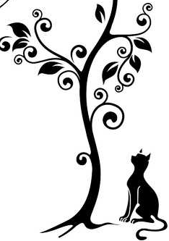
- The cat is …………… the tree
[ in front - behind ]

- PUT [ > , = , < ]
H.W

- 5 2 (b) 11 14

- 13 13 (d) 9 0

- 11 Seven (f) 1 11

- Choose the correct answer:
- The doll is ………………… the table
[ under - on ]

- How many apples are inside ……………. the circle
[ 2 - 1 ]

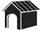
- The dog is …………… the house
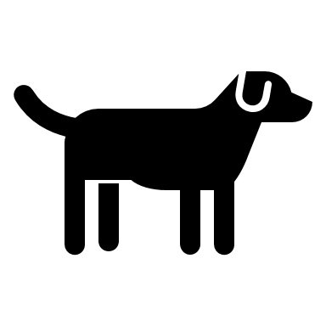
[ in front - behind ]

Find the result:
C.W

- 7 (b) 2
+ 2 + 4

- 8
+ 2

- 2 + 0 =

- 6 + 3 =

H.W
Find the result:

- 5 (b) 4
+ 2 + 5

- 7 + 3 =

- 4 + 3 =

Find the result:
C.W

- 6 (b) 5
- 2 - 3

- 9
- 2

- 8 - 2 =

- 9 - 0 =

H.W
Find the result:

- 4 (b) 9
- 1 - 4

- 6 - 3 =

- 8 - 3 =

C.WZZZZZZZZZZZZZZZZZZZZZZZZZ
- Ali bought a toy for 6 pounds and a pen for 3 pounds
How much money did Ali pay ?

What Ali paid = …………. + …………. = ………….. pounds

- Samy has 3 balloons and Ali has 2 balloons
How many balloons do they have ?

The number of balloons = …………. + …………. = ………….. balloons

H.WZZZZZZZZZZZZZZZZ
- Omar had 2 pounds in his saving box then he put another 5 pounds
How many pounds does he have in his saving box ?

What Omar saved = …………. + …………. = ………….. pounds

C.WZZZZZZZZZZZZZZZZZZZZZZZZZ
- There are 5 birds on a tree , 2 of them flew away
How many birds are left ?

The number of birds left = …………. - …………. = ………….. birds

- Nour has 7 dolls she gives 3 dolls to Salma
How many dolls does Nour have now ?

What Nour has = …………. - …………. = ………….. dolls

H.WZZZZZZZZZZZZZZZZ

- Sara had 9 oranges in her bag and 3 oranges fell down
How many oranges were left in her bag?

The number of oranges = …………. - …………. = ………….. oranges

What time is it ?
C.WZZZZZZZZZZZZZZZZZZZZZZZZZ

(1)
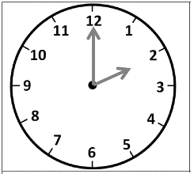

It is …………… O’clock

(2)
H.WZZZZZZZZZZZZZZZZ
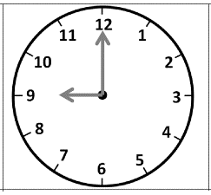

It is …………… O’clock

