Revision
2 st prim
Computer

Name :………………………
Class :………………………..

1-he picture name and (input/output) unit
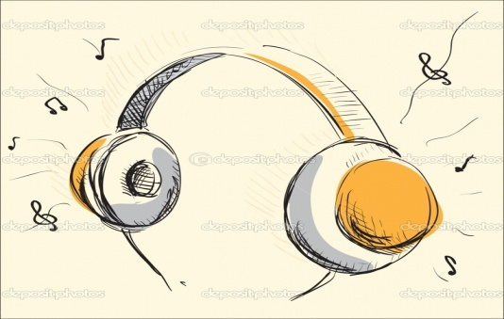

Name:………… Name:………….
Input Unit Output Unit

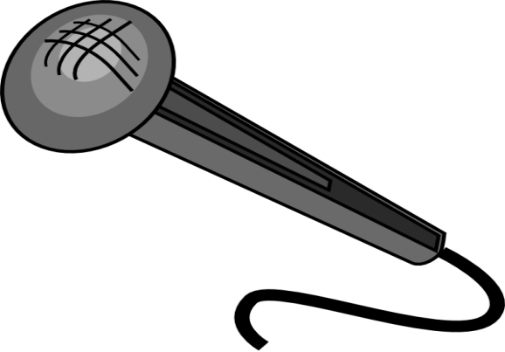
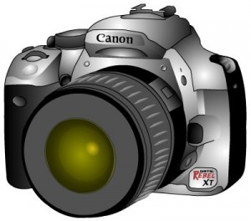
Name:………….. Name:………..
.
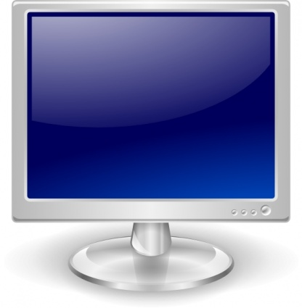
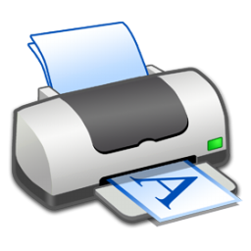

Name: …………… Name:…………….
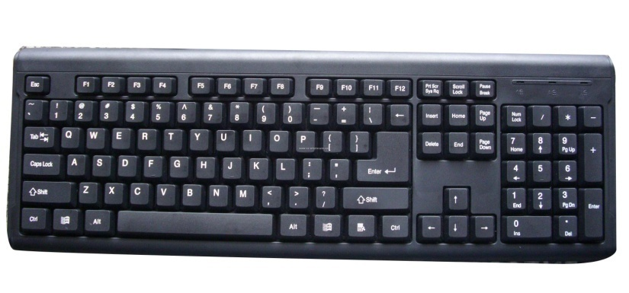

Name: keyboard.
Input Unit
Put ( √ ) or ( × )

the CPU connects to electricity ( )

Keyboard it is a flat board ( )

Mouse it is a big round ( )

Microphone it is an output ( )

Monitor it is a screen ( )

Mouse has One button ( )

3) Match
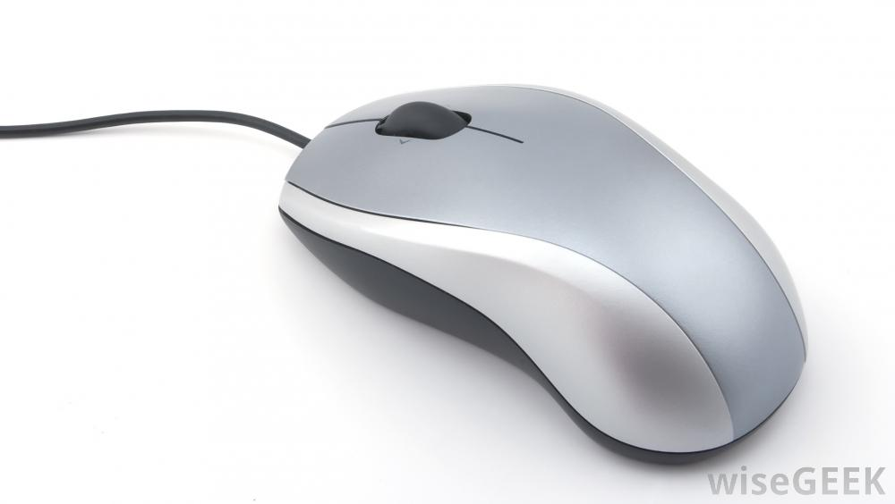
Mouse
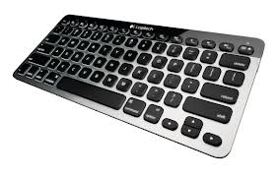
Keyboard
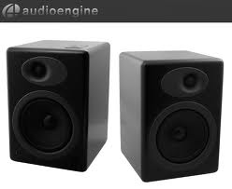
Speakers

Monitor

