Revision sheet

Primary 1

Name:…………………………………..

Put ( √ ) or ( X )
1- We get information using the input units. ( )
2- The input operation is the first operation. ( )
3- Computers process data in the CPU. ( )
4- The output operation is last operation ( )
5- We enter data into computer using the output units.( )
Underline the correct answer
- The mouse is an {input – output} unit.
- We use the {mouse – keyboard} for typing.
- The microphone is an {input – output} unit.
- We use the {digital camera – microphone} to input photos.
- We get information using the {output – input} units.

Match

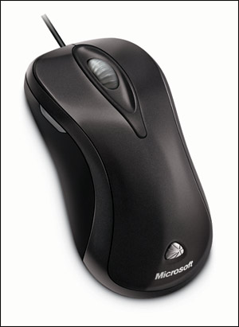
Keyboard

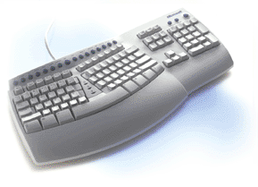
Mouse

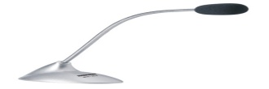
Digital camera
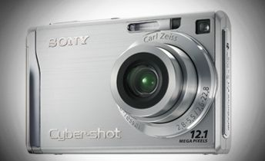
Microphone
Rearrange
1- Click Start ( )
2- Select Accessories ( )
3- Select Paint ( )
4- Select All Programs ( )

