Revision sheet

Primary 1

Name:…………………………………..

Put ( √ ) or ( X )
- A computer is used in schools. ( )
- A computer is used in offices. ( )
- Engineers can't use a computer. ( )
- A computer used in homes. ( )
- Doctors use a computer. ( )

Underline the correct answer
- A computer helps the teacher in ………………
{Playing football – typing}
- A computer helps …………………...to calculate.
{Accountants – doctor}
- A computer helps the designers in ………………
{Painting – swimming}
- A computer helps in drawing and coloring ……...
{Doctor – pupil}

Match

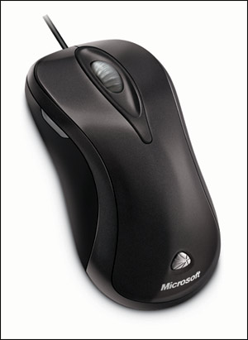
Keyboard

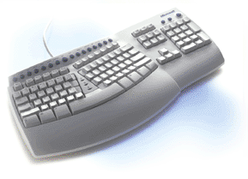
Mouse

Digital camera

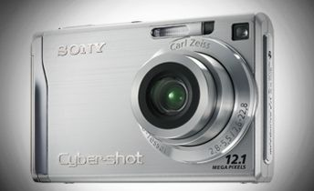
Microphone

