Cairo governorate
Nasr city educational zone
Alsun modern school

Mathematics
Final revision
For
Primary two

Name : ……………………………
Class : ……………………………

-: value and Place value :-

Complete
- The place value of digit 4 in number 465 is ………
- The place value of digit 9 in number 291 is ………
- The place value of digit 1 in number 421 is ………
- The value of dijit 4 in number 165 is ……….
- the value of digit 2 in number 524 is ………
- the value of digit 8 in number 193 is ……….
Don’t forget placevalue is my place

Don’t forget value means put the number and its zero

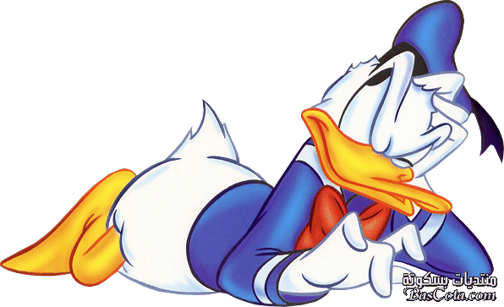

-: Ascending & descending order :-
:-

Arrange the following numbers:-
Ascending (a) means from the S to G
descending (a) means from the G to S

a) 352 , 224 , 505 , 202 , 90

ascending …… , ……, …… , ……. , …….

descending …… , ……, …… , ……. , …….

-: Make a number :-

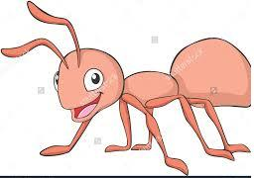
- 1 T , 2 U , 3 H = …………
1- Put the places.
2- put each number in its place
4- if we have empty place put 0

- 9 H , 8 T = ………….
- 7 H , 0 U = ………….
- 654 = ……… U , ……. T , ….… H

-:expanded form:-
We are going to write the value of each number

Write in expanded form

  - 123 = ……. + ……. + 3
  - 345 = ……. + 40 + ……
  - 567 = …… + ……. + ……
  - 987 = …… + ……. + ……

We will make plus one till reach bigger number
put < , > , = :
- 487 …………. 56

- 452 + 345 ……… 674
Don’t forget
Koky cant eat letters or signs
- One hundred ……… 100

Koky koky hungry fish always eat the bigger number

Write in Letters & in digits
- 123 …………………………………………………

- 304 …………………………………………………

- 450 …………………………………………………

- Four hunder and thirty two = ………………

- One hundred and two = ……………..
Digit means numbers
Letters mean A,B,C
don’t forget after hundreds put letter ( and )

After & before & between :

- The number just after 123 is ……….
- The number just before 456 is ……….
- The numbers lies between 765 and 762 is …….. , ……

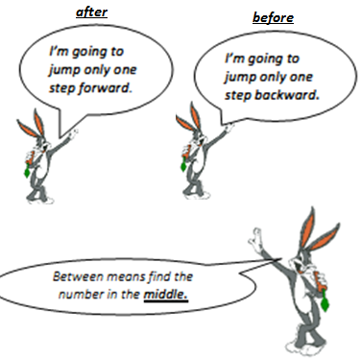
-: Form a number :-

complete :
- the greatest number formed from 3-digits is ……
- the greatest number formed from 3-different digits is ……
- the smallest number formed from 3-digits is …….

- the smallest number formed from 3-different digits is ……
E) the smallest number formed from 3 , 5 , 0 is ……..
f) the greatest number formed from 6 , 1 , 9 is ……..
Start with greatest number
- 6 , 6 , 5

Start with smallest number

Zero on left means nothing 025 , 205
×

- 215 , 225 , 235 , …….. , ……..
- 900 , 700 , 500 , ……… , ……..

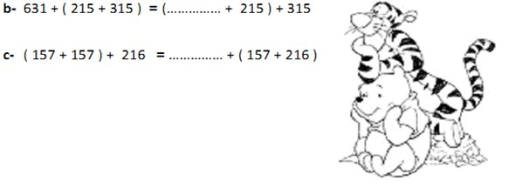
Its like mirror
×

Have a big number in my mind smaller number on my fingers count after the bigger number.
-: Addition :-

Don’t’ Forget to carry up..

d) $\frac{\begin{aligned}743 \\ + 73 \\ \end{aligned}}{……….}$ e)$\frac{\begin{aligned}666 \\ + 155 \\ \end{aligned}}{……….}$

- 156 + 258 = ……
- 358 + 417 = ……

Subtraction means eat
-: subtraction :: :-

d) $\frac{\begin{aligned}753 \\ - 53 \\ \end{aligned}}{……….}$ e)$\frac{\begin{aligned}666 \\ - 155 \\ \end{aligned}}{……….}$

- 156 - 258 = ……
- 358 - 417 = ……

(+) is always crazy
(-) crazy and calm
Relation between addition and subtraction

Complete :
- 123 + …….. = 765

- 987 - ……… = 456

- ……. – 321 = 456

-: solids :-

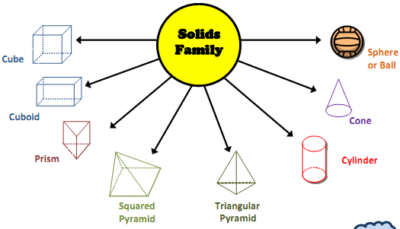

complete
7
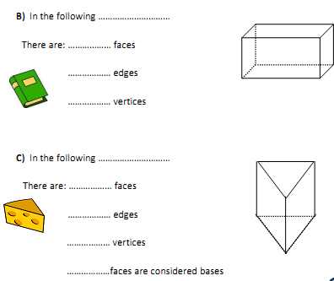
2)
1)

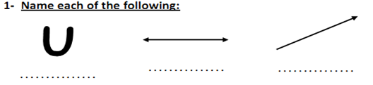

-: Meter and centimeter :-

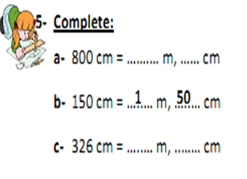
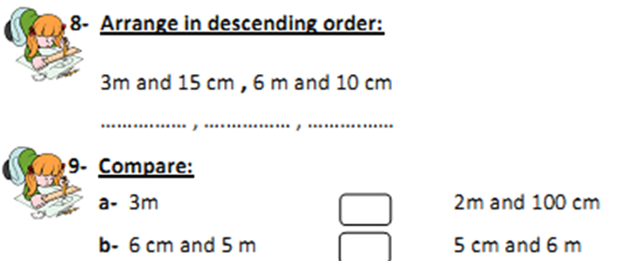
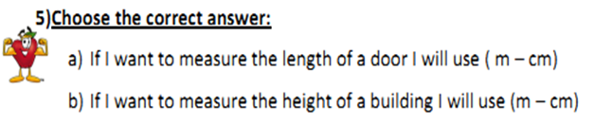

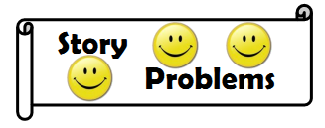

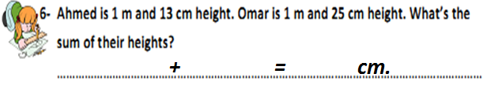
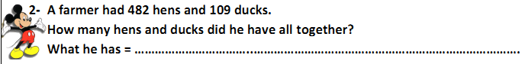
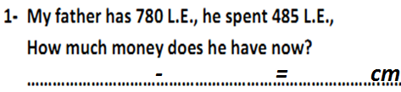

Complete :
