Cairo governorate
Nasr city educational zone
Alsun modern school

REVISION OF MATH
For primary three
Find:
4×7=
9×5=
7×9=
8×8=
3×8=
6×5=
4×9=
8×6=
81÷9=
35÷7=
18÷3=
56÷8=
54÷6=
30÷5=
63÷9=
27÷3=
49÷7=
32÷4=
0÷7=
42÷6=
5× =45
×3=18
8× =24
9× =63
7× =35
×6=24
18÷ =9
63÷ =7
28÷ =4
÷7=7
÷8=9
_________________________
- 8576 is written in letters as…
- 25552 is written in letters as…
- 11064 is written in letters as…
- 10010 is written in letters as…
- _______________________
Complete:
- 4965=……+……+…….+…….
- 18146=……+……+……+……+.......
- 75432=…….+…….+…….+…….+…….

Write the place value of digit:
44

- 95432
- 46801
- 65494
- 24513
- 25436
- 89721
- 74923
Write the value of digit:
44

- 78506
- 78162
- 45609
- 46808
- 75499
- 17503
Rearrange the following:
- 8721, 8235, 8324, 8887
Descendingly:…….,……..,…….,……
- 17849, 48928, 32567, 94328, 56394
Ascendingly:……,…….,…….,…….,…….

Complete in the same pattern:
- 6542, 6553, 6564….,……
- 2225, 3235, 4245,…….,…….
- 5686, 5675, 5664…….,…….
- 28530, 28630, 28730,……,……
- 59678, 58678, 57678,……..,….
5, 3 , 2, 1 ,8

Write the greatest number :
Write the smallest number :
6 ,0 ,3 ,1,8
Write the greatest number :
Write the smallest number :
Put ≥,≤or =
- 4567+2135 2135+4567
- 7234+1320 5234+4320
- 8527─2500 8527─3500
- 72163─3363 68800
- 8615─2419 3450+1250

Complete:
- 82565
__
61312
--------------
- 84573
_
57632

…………….
- 87052
_
42355
………………..

- 58607
+ 24654
---------------
- 63456
+ 26544
…………….

- 2164+3455=3455+…..
- ……+6210=6210+741
- 6315+……=1230+6315
Complete:

- The number of edges of the cube is ……….
- The number of a cuboid vertices is …….
- The number of faces of the cube ……
- The base of the cone s a shape of ……..
- Each face of the faces of the cube is ……
- 5. Each face of the faces of the cuboid is ……….
- The triangular pyramid has …… bases
- The base of the cylinder is a………….
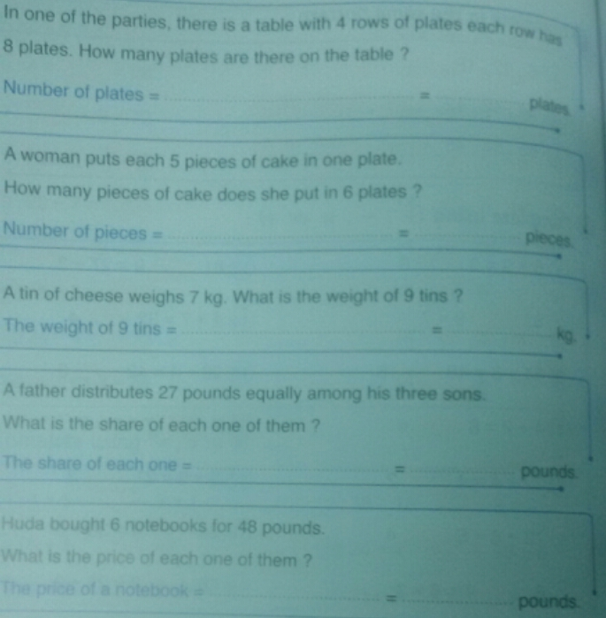
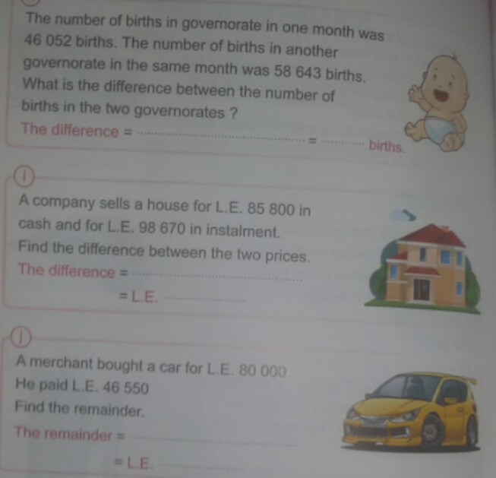

- Draw a rectangle ABCD its dimension 5 cm, 3cm

- Draw a square ABCD the length of each sides is 4 cm

The measure of the angle | Its type
50°
120°
90°
45°

135°
100°
180°

Use the protractor to measure each of the following angles,

THE measure of angle A=…..°
ITS type is ……….

A
THE measure of angle B=…..°

ITS type is ……….

B
THE measure of angle C=…..°

ITS type is ……….

C
THE measure of angle D=…..°

ITS type is ……….

D
Draw angles with the following measures:
50°
90°

150°
65°

Complete:
What is the greatest 5 different digits number ?...........

What is the greatest 5 digits number ?...........

What is the smallest 5 different digit number ?.......
Look at school book

