REVISION MATH SHEETS
1
2
3
4
5
6
7
8
9
10
11
12
13
14
15
16
17
18
19
20
21
22
23
24
25
26
27
28
29

1 | 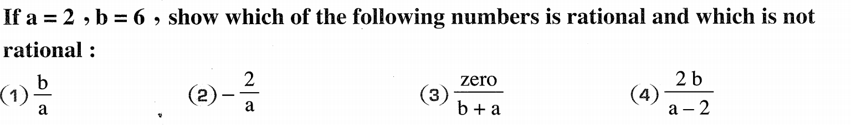
2 | 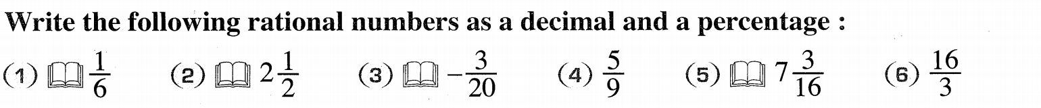
3 | 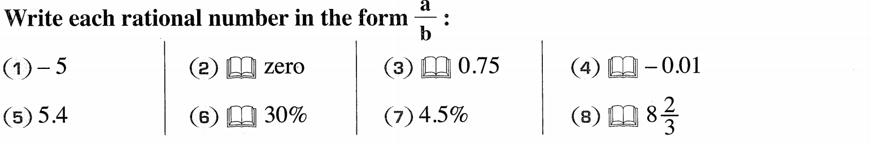
4 | 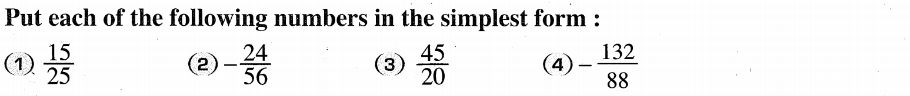

16
17
18
19
20
21
22
23
24
25
26
1 | 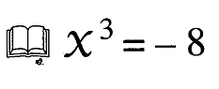  Exercise ( 1 ) Question ( 5 ) ( 5 )
2 | 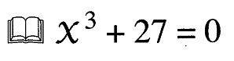  Exercise ( 1 ) Question ( 6 ) ( 1 )
3 | 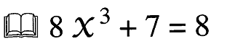  Exercise ( 1 ) Question ( 6 ) ( 2 )
4 | Exercise ( 1 ) Question ( 8 )

1 | 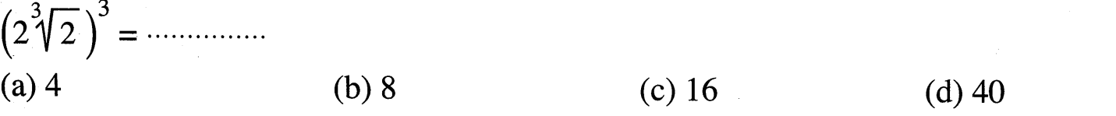
2 | 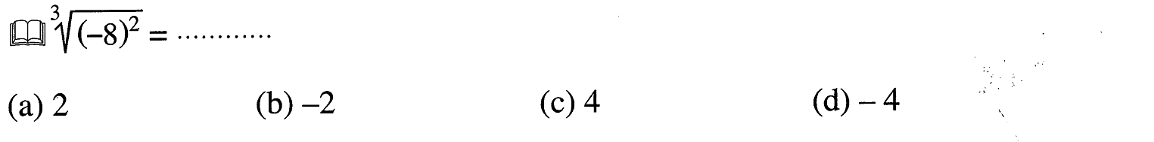
3 | 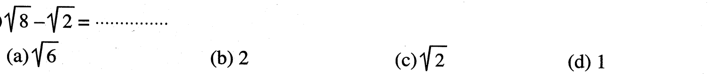
4 | 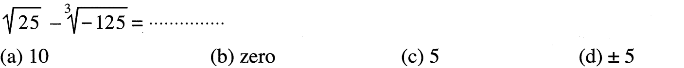
5
6 | 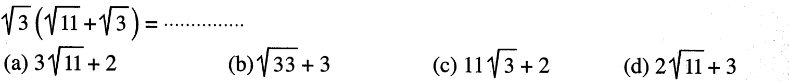
7
8 | 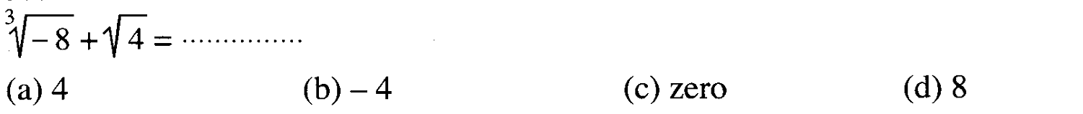
9 | 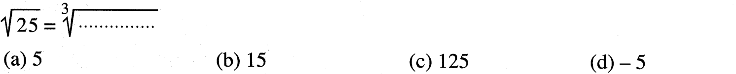
10
11 | 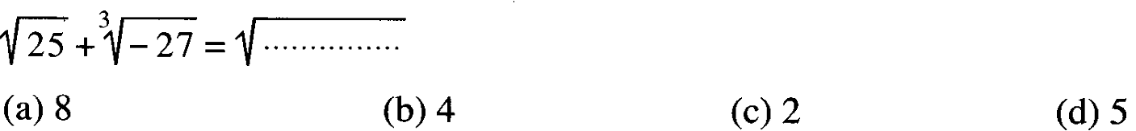
12 | 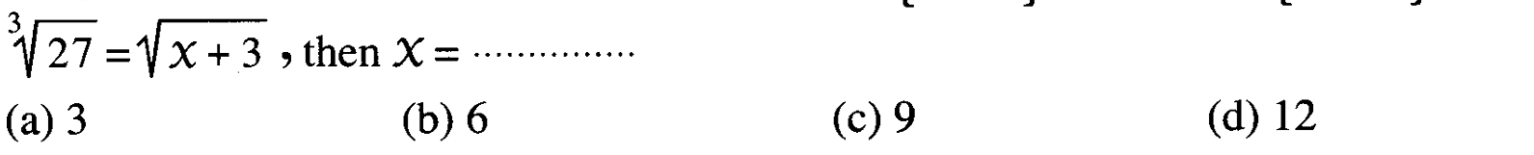
13
14
15
16
17
18
19
20
1 | 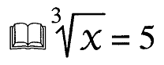  Exercise ( 1 ) Question ( 5 ) ( 1 )
2 | Exercise ( 1 ) Question ( 5 ) ( 5 )
3 | Exercise ( 1 ) Question ( 6 ) ( 1 )
4 | Exercise ( 1 ) Question ( 6 ) ( 2 )
5 | 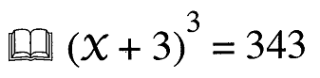  Exercise ( 1 ) Question ( 6 ) ( 5 )
6 | 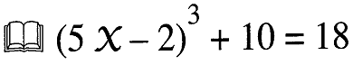  Exercise ( 1 ) Question ( 6 ) ( 8 )
7 | Exercise ( 1 ) Question ( 8 )
8 | Exercise ( 1 ) Question ( 12 )
9 | Exercise ( 1 ) Question ( 13 )
GEOMETERY
1 | 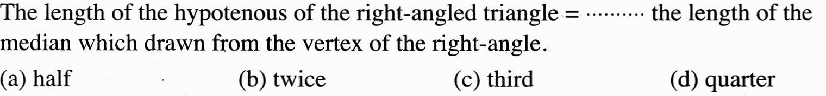
2 | 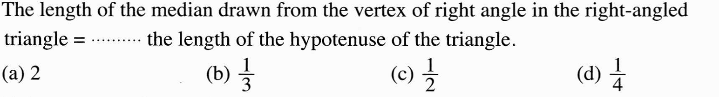
3 | 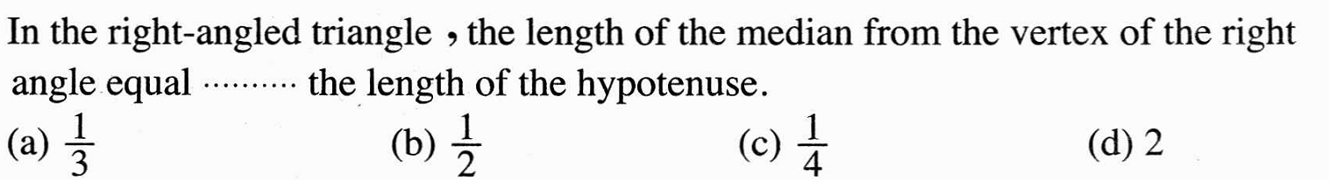
4 | 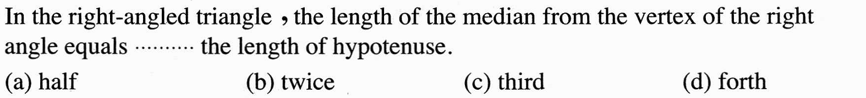
5 | 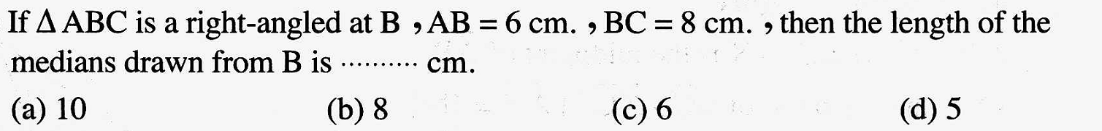
6 | 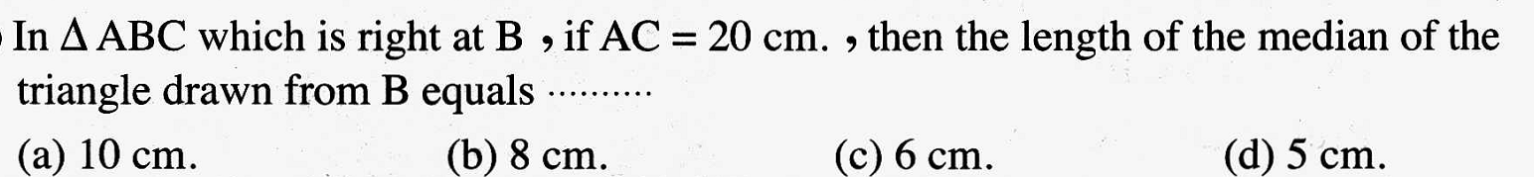
7 | 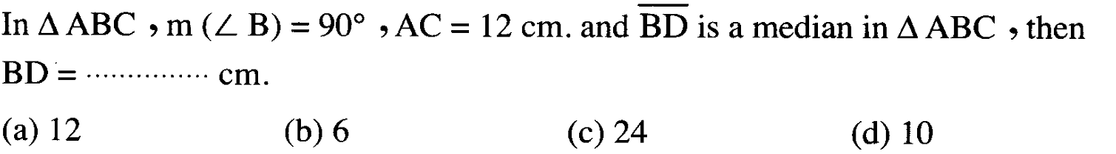
8 | 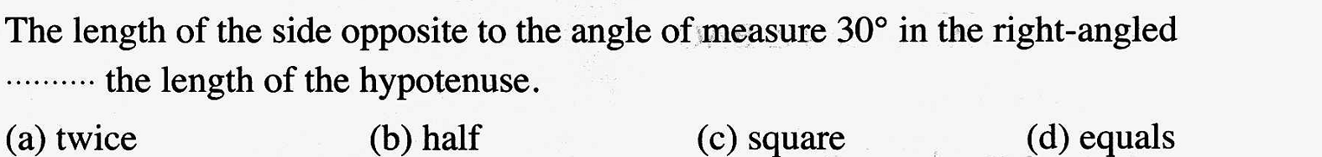
9
10
11 | 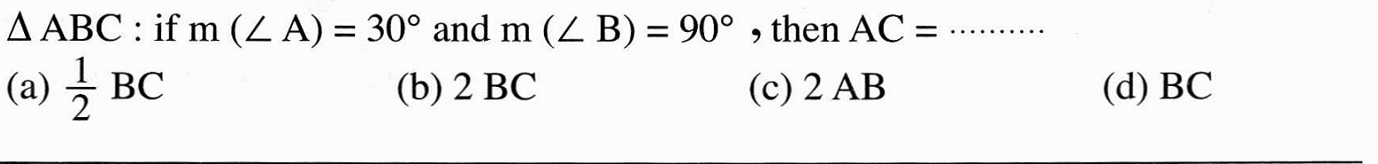
12 | 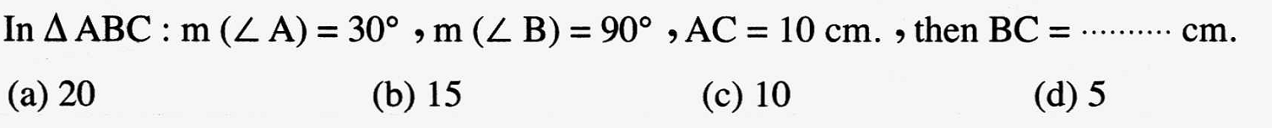
13 | 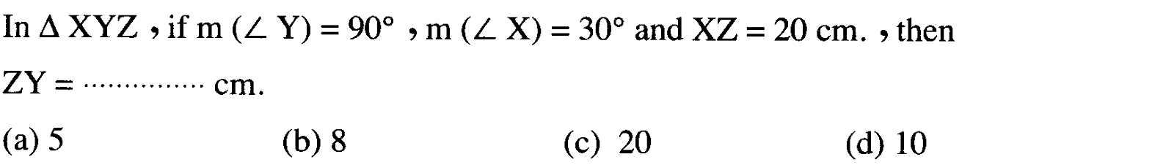
14
15
16
17
18
19
20
21
22
23
1 | 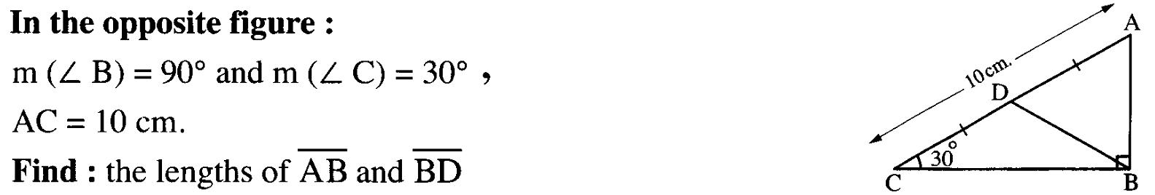  2015 Exam ( 12 ) Question ( 3 ) ( b )
2 | 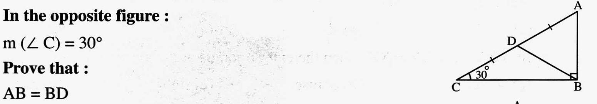2014 Exam ( 3 ) Question ( 4 ) ( a )
3 | 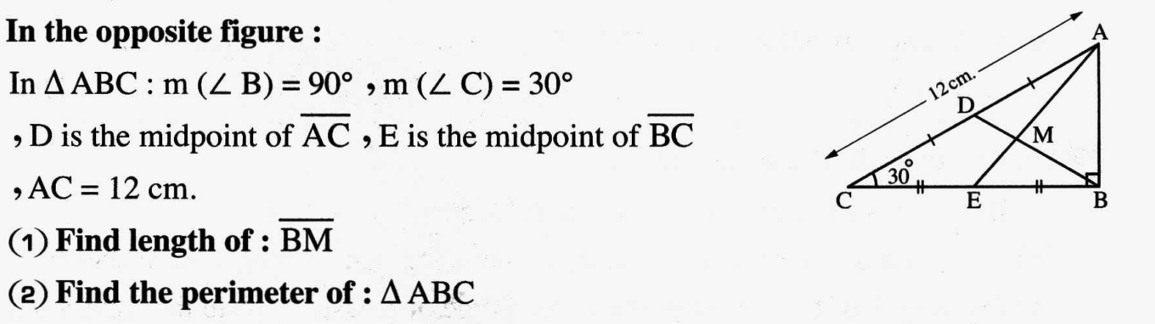2014 Exam ( 12 ) Question ( 5 ) ( a )
4 | 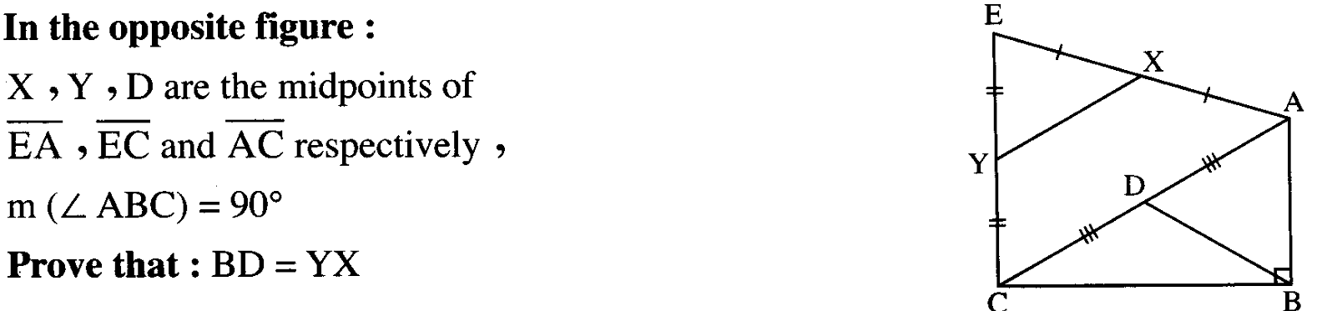  2015 Exam ( 6 ) Question ( 4 ) ( a )

\

REVISION
1
2
3
4
5
6
7
8
9
10
11
12
13
14
15
16
17
18
19
20
21
22
23
24
25
26
27
28
29

1
2
3
4
GEOMETRY

11 | 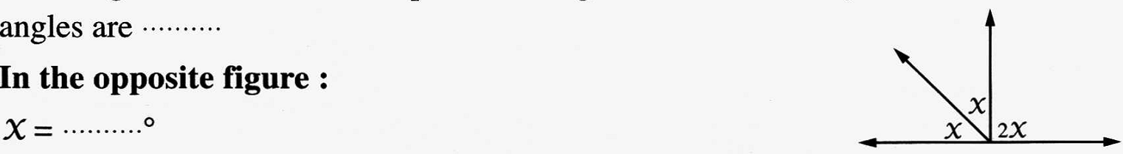
12 | 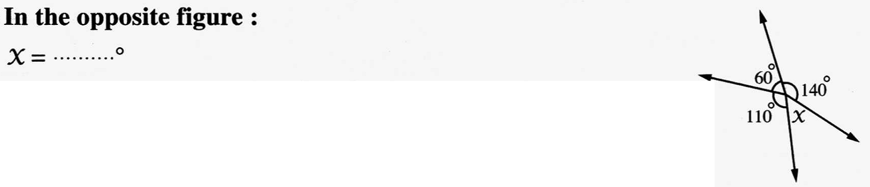
13 | 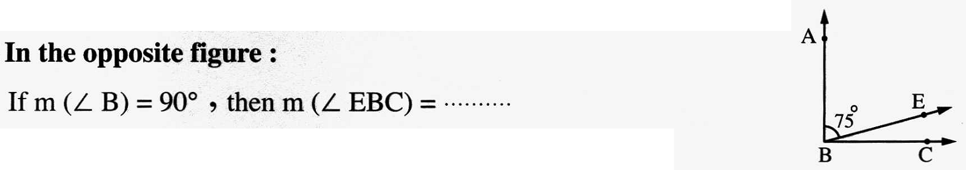
14 | 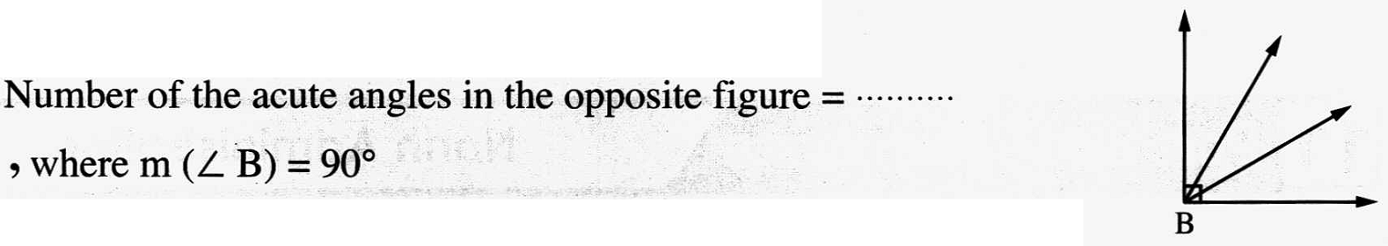
15 | 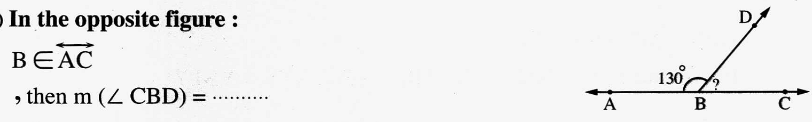
16 | 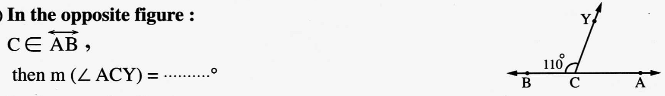
17 | 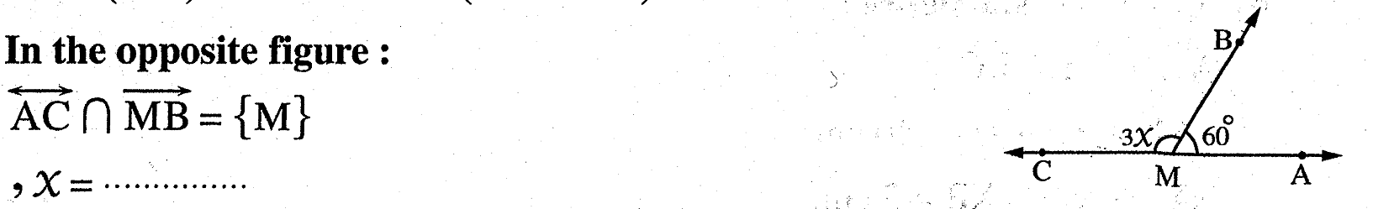
18 | 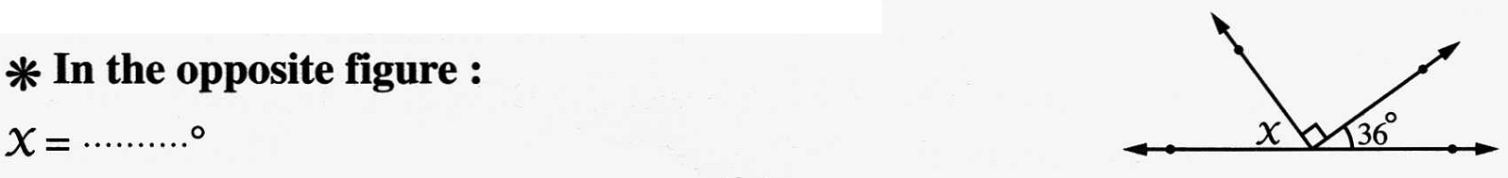
1 | 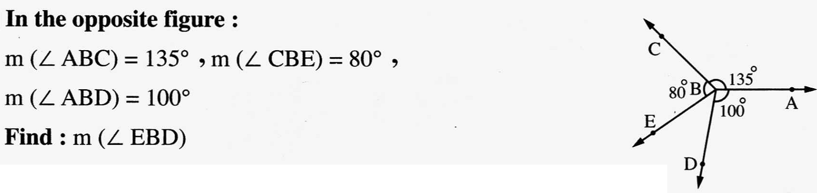2013 Exam (15) Question ( 3 ) ( b )
2 | 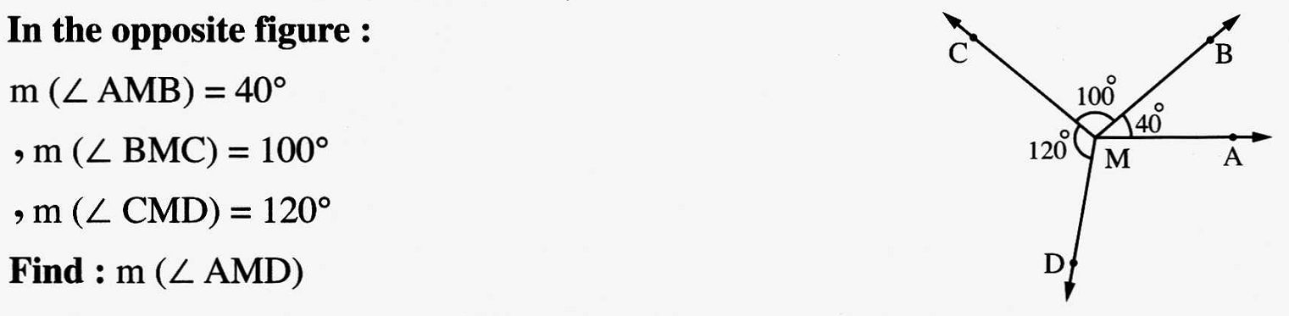2014 Exam ( 1 ) Question ( 4 ) ( b )
3 | 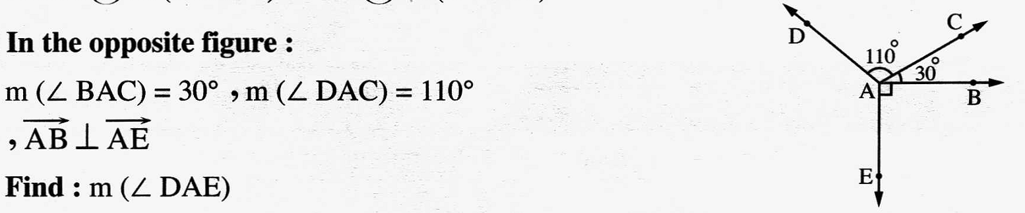2013 Exam ( 8 ) Question ( 3 ) ( a )
4 | 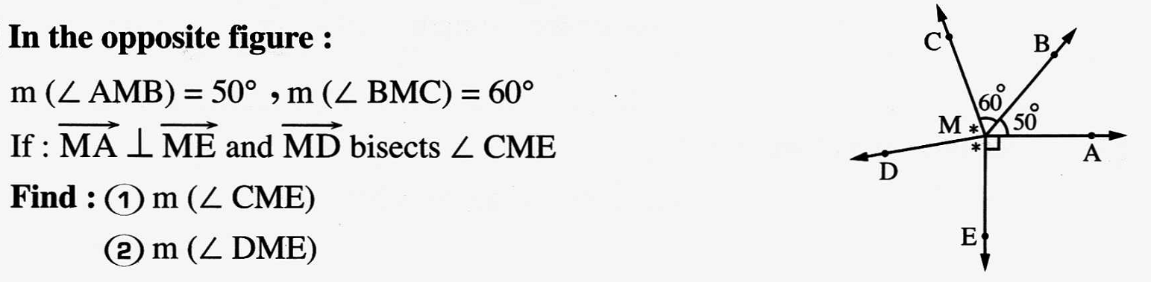2013 Exam ( 1 ) Question ( 3 ) ( b )
11
12
13
14
3
4

