Cairo governorate
Nasr city educational zone
Alsun modern school

REVISION OF MATH
For primary one
- form sets :

2) Count and write the numbers :

........... ………… ………..

…………… ………… …………

- Write the number:
7 Nine 8 six
….…… ………. ……….. …….

5 four 3 two
……… …….. ………. .………

Zero 1 seven
…….. ……… ………

- Complete in order :

- 0 , 2 , 4 , ……… , ………
b) 5 , 6 , 7 , ..……, ……….
c) 0 , 1 , ……, …….., …….., 5 ,……. ,……..
d) 1 , 3 , 5 , ………. , ……….
F ) …… , …… , 7 , 6 , ……. , ……… , ………

5) which are more ?

6)complete using ( morethan or lessthan )
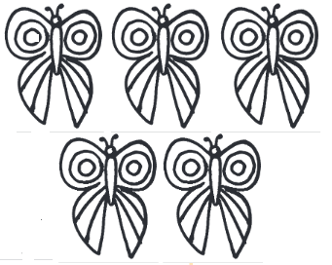
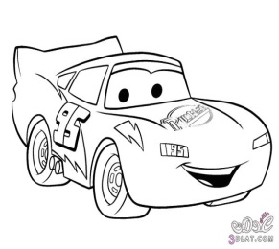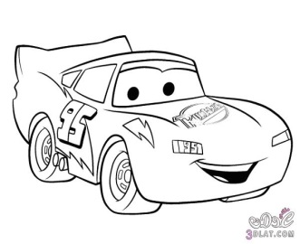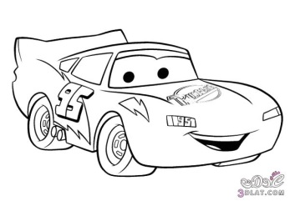
The cars are…...…………………the butterflies

Note : the revision started from sets until zero
Ordinal numbers h.w not with the revision
Fifth | fourth | third | second | First
tenth | ninth | eighth | seventh | sixth

