# Revision sheet

# Primary 4

**Q1: underline the correct answer:**

1. **(icons- taskbar) is a bar at the bottom of the screen.**
2. **(icons- taskbar) is used to refer to the various programs.**
3. **(windows- taskbar) is the operating system.**
4. **Used to refer to the window (icons- desktop)**
5. **It is contains all delete file (recycle bin- document)**
6. **(Computer – document) contains all the document.**
7. **Is one of the windows (software- hardware).**
8. **Used (web browser- the computer )to deal with the internet**
9. **(Icons – taskbar) is a bar show the language and date and time.**
10. **One of the input units(Monitor – keyboard – mouse – printer – speaker)**
11. **To switch on the set, you should press on (Speaker – the set operating button – the monitor button)**
12. **To shut down the computer choose (Stand by – shut down – restart)**

**Q2: 1-how to open my computer?**

**1-……………………………………………………………………………………………………………**

**2-……………………………………………………………………………………………………………**

**3-……………………………………………………………………………………………………………**

Q3: Underline the correct answer:

1) **(My Computer – My Documents) has all your files and folders.**

**2) (Icons – Taskbar) are used to represent different programs.**

**3) (Taskbar – Icons) is the bar at the bottom of the screen.**

**4) The (My computer window – Desktop) is the first screen you will see after turning computer on.**

**5) We use (Internet explorer – My computer) to deal with the internet.**

**6) To change My Computer window view select (Edit – More options)**

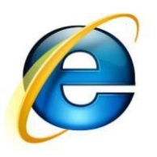Q3: Match

My Computer



My Document

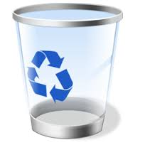Recycle Bin

Internet Explorer

