[](http://www.google.com.eg/url?sa=i&rct=j&q=&esrc=s&source=images&cd=&cad=rja&uact=8&ved=0ahUKEwj1sZXl5ofYAhVEbVAKHbZ9AUIQjRwIBw&url=http://cliparting.com/free-fish-clipart-2358/&psig=AOvVaw3v_R6iFpVxkmXMI5EpflXH&ust=1513282506323546)[](http://www.google.com.eg/url?sa=i&rct=j&q=&esrc=s&source=images&cd=&cad=rja&uact=8&ved=0ahUKEwiXzIPV6IfYAhWLblAKHX-JCusQjRwIBw&url=http://cliparting.com/free-octopus-clipart-11517/&psig=AOvVaw2FF4ag5Ibg-9uPUkIDDkN5&ust=1513283011532300)[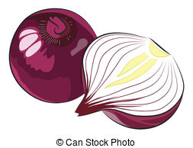](http://www.google.com.eg/url?sa=i&rct=j&q=&esrc=s&source=images&cd=&cad=rja&uact=8&ved=0ahUKEwjkzrbD6IfYAhXEIlAKHYmjC0AQjRwIBw&url=http://www.clipartpanda.com/clipart_images/red-onion-clipart-69509400&psig=AOvVaw0gkZQnr206Ydz8yern4xwf&ust=1513282974270412)[](https://www.google.com.eg/url?sa=i&rct=j&q=&esrc=s&source=images&cd=&cad=rja&uact=8&ved=0ahUKEwiSveux6IfYAhUEYlAKHeRIBkEQjRwIBw&url=https://www.pinterest.com/guriucpetronela/cartoane-colorate-1/&psig=AOvVaw2avy5MBvNp55FTver9jOqE&ust=1513282935218868)[](http://www.google.com.eg/url?sa=i&rct=j&q=&esrc=s&source=images&cd=&cad=rja&uact=8&ved=0ahUKEwjblcmH6IfYAhXDL1AKHRPgAUQQjRwIBw&url=http://clipartix.com/clipart-house-image-13429/&psig=AOvVaw2uaB-bL_WzbI6-im5FjJw5&ust=1513282847900642)[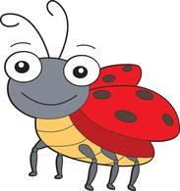](https://www.google.com.eg/url?sa=i&rct=j&q=&esrc=s&source=images&cd=&cad=rja&uact=8&ved=0ahUKEwiiwKfl54fYAhXEI1AKHQFhAEIQjRwIBw&url=https://classroomclipart.com/clipart/page-54/Clipart/Animals/Insect_Clipart.htm&psig=AOvVaw21mfNUv7Khhqieb9VSVJQG&ust=1513282775649957)[](http://www.google.com.eg/url?sa=i&rct=j&q=&esrc=s&source=images&cd=&cad=rja&uact=8&ved=0ahUKEwicv66f54fYAhXOLVAKHVhuAEoQjRwIBw&url=http://www.clipartpanda.com/clipart_images/pen-clip-art-69198338&psig=AOvVaw35AdE9KRVUvts_zwjLaZVL&ust=1513282629947598)[](http://www.google.com.eg/url?sa=i&rct=j&q=&esrc=s&source=images&cd=&cad=rja&uact=8&ved=0ahUKEwiSmeLO54fYAhWMblAKHUwnDkEQjRwIBw&url=http://gclipart.com/ice-cream-cone-clip-art_4668/&psig=AOvVaw1omGIhWYmKm98MBKP0qDJS&ust=1513282724862705)[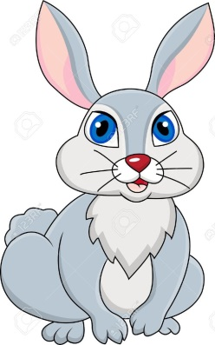](http://www.google.com.eg/url?sa=i&rct=j&q=&esrc=s&source=images&cd=&cad=rja&uact=8&ved=0ahUKEwjZ5-C754fYAhWLmLQKHXrrCUAQjRwIBw&url=http://clipartix.com/rabbit-clipart-image-11907/&psig=AOvVaw1W2SkKvL2nVzsZym5ZR-mQ&ust=1513282690244549)[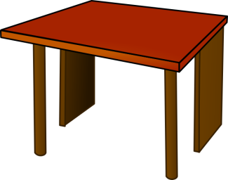](https://www.google.com.eg/url?sa=i&rct=j&q=&esrc=s&source=images&cd=&cad=rja&uact=8&ved=0ahUKEwjrx_CI54fYAhWEmLQKHfvYBkAQjRwIBw&url=https://www.clker.com/clipart-table-top-wood.html&psig=AOvVaw28nAxEsCWnu62IdfGQG24N&ust=1513282579261017)[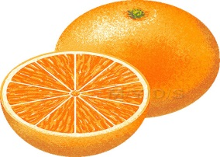](http://www.google.com.eg/url?sa=i&rct=j&q=&esrc=s&source=images&cd=&cad=rja&uact=8&ved=0ahUKEwi8muDO5ofYAhXJhrQKHYMsBkAQjRwIBw&url=http://cliparting.com/free-orange-clipart-26769/&psig=AOvVaw1v4joB0egnYiR_zjy2pN1C&ust=1513282459914413)[](http://www.google.com.eg/url?sa=i&rct=j&q=&esrc=s&source=images&cd=&cad=rja&uact=8&ved=0ahUKEwjDmcOs5ofYAhXIalAKHbrWCkAQjRwIBw&url=http://cliparting.com/free-book-clipart-843/&psig=AOvVaw1zARtbKZJ13ZQPQgwAH4x_&ust=1513282387164947)

[](http://www.google.com.eg/url?sa=i&rct=j&q=&esrc=s&source=images&cd=&cad=rja&uact=8&ved=&url=http://www.clipartpanda.com/categories/smiley-face-star-clipart&psig=AOvVaw2gloL0FrpvS0nYLp2uUnzI&ust=1513283615967601)[](http://www.google.com.eg/url?sa=i&rct=j&q=&esrc=s&source=images&cd=&cad=rja&uact=8&ved=0ahUKEwjyvcTF6ofYAhUFEVAKHQBxC-sQjRwIBw&url=http://www.clipartpanda.com/categories/school-desk-clip-art&psig=AOvVaw2wo2PNk0RqWoPAggy7kQDB&ust=1513283515360679)[](http://www.google.com.eg/url?sa=i&rct=j&q=&esrc=s&source=images&cd=&cad=rja&uact=8&ved=0ahUKEwif7dy06ofYAhUIK1AKHavmCgAQjRwIBw&url=http://www.clipartpanda.com/clipart_images/apple-clipart-186959&psig=AOvVaw3Ys3vuT8EqMCBlU2pD2PUE&ust=1513283480716910)[](http://www.google.com.eg/url?sa=i&rct=j&q=&esrc=s&source=images&cd=&cad=rja&uact=8&ved=0ahUKEwjUscrg6ofYAhUJmrQKHWzuDEUQjRwIBw&url=http://clipartix.com/balloon-clipart-image-50232/&psig=AOvVaw22VcGfpqkQfETu8dvTXBlP&ust=1513283566779471)[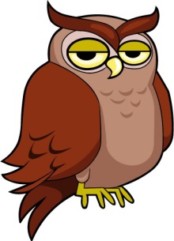](http://www.google.com.eg/url?sa=i&rct=j&q=&esrc=s&source=images&cd=&cad=rja&uact=8&ved=0ahUKEwjj36qj6ofYAhXNJlAKHSB6C0MQjRwIBw&url=http://cliparting.com/free-owl-clip-art-1614/&psig=AOvVaw2aiv2kWyLZNagh1W6UOotq&ust=1513283424305904)[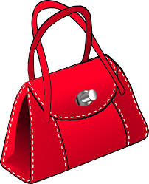](http://www.google.com.eg/url?sa=i&rct=j&q=&esrc=s&source=images&cd=&cad=rja&uact=8&ved=0ahUKEwin4YCD6ofYAhUFJVAKHd0GBUEQjRwIBw&url=http://clipart-library.com/free-purse-cliparts.html&psig=AOvVaw3KDANCOjfyiI9j_iC3fuGN&ust=1513283241774359)

[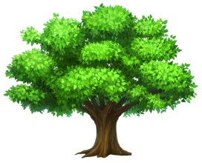](http://www.google.com.eg/url?sa=i&rct=j&q=&esrc=s&source=images&cd=&cad=rja&uact=8&ved=0ahUKEwj86aTr9IfYAhWNJ1AKHdANAjkQjRwIBw&url=http://cliparting.com/free-tree-clipart-1214/&psig=AOvVaw0L2jesxyZmdvn7EBQNeoUZ&ust=1513286266915567)[](http://www.google.com.eg/url?sa=i&rct=j&q=&esrc=s&source=images&cd=&cad=rja&uact=8&ved=0ahUKEwjUscrg6ofYAhUJmrQKHWzuDEUQjRwIBw&url=http://clipartix.com/balloon-clipart-image-50232/&psig=AOvVaw22VcGfpqkQfETu8dvTXBlP&ust=1513283566779471)[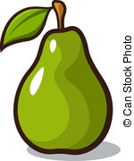](https://www.canstockphoto.com/illustration/pear.html)[](http://www.google.com.eg/url?sa=i&rct=j&q=&esrc=s&source=images&cd=&cad=rja&uact=8&ved=0ahUKEwjjn_SI9YfYAhUPYlAKHTbmAp4QjRwIBw&url=http://www.clipartpanda.com/categories/clown-clip-art&psig=AOvVaw2rxq4hc_QYSmcc_1GuvqYY&ust=1513286328268428)[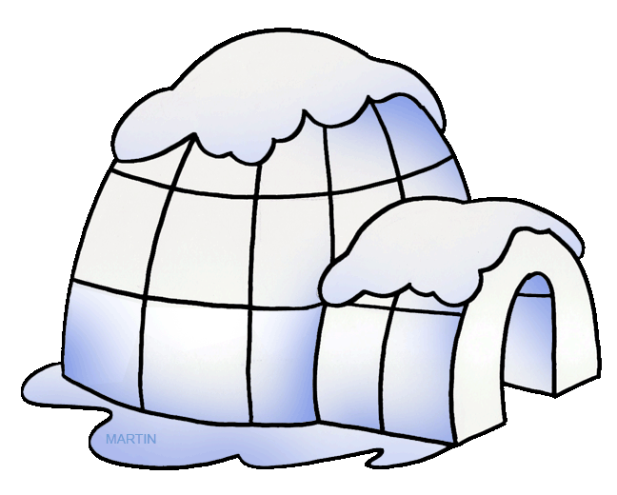](http://www.google.com.eg/url?sa=i&rct=j&q=&esrc=s&source=images&cd=&cad=rja&uact=8&ved=0ahUKEwjPnpbq9YfYAhXHUlAKHRT1Aj0QjRwIBw&url=http://wikiclipart.com/igloo-clipart_2776/&psig=AOvVaw3fD2pKfna2Ld8l2Bek5iDf&ust=1513286532989060)[](https://www.google.com.eg/url?sa=i&rct=j&q=&esrc=s&source=images&cd=&cad=rja&uact=8&ved=0ahUKEwiIjvig9YfYAhXDPFAKHarXDgkQjRwIBw&url=https://www.freeclipartnow.com/signs-symbols/arrows/&psig=AOvVaw2jEzn5c-5QccawK9BkgrZi&ust=1513286379606905)[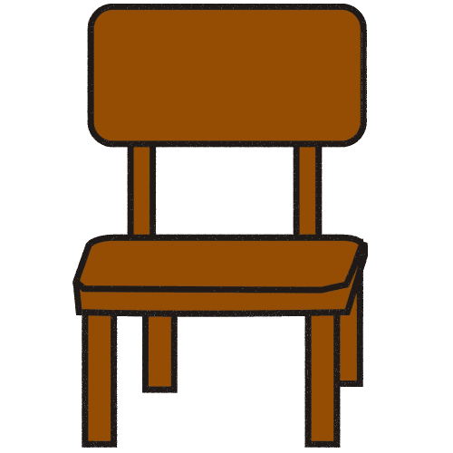](https://www.google.com.eg/url?sa=i&rct=j&q=&esrc=s&source=images&cd=&cad=rja&uact=8&ved=0ahUKEwiZpYfK9IfYAhWOYlAKHa21D0MQjRwIBw&url=https://thecliparts.com/the-best-free-clipart-32975/&psig=AOvVaw1MSB9SvJVTDMucIHy3NEr_&ust=1513286181392744)

[](https://www.google.com.eg/url?sa=i&rct=j&q=&esrc=s&source=images&cd=&cad=rja&uact=8&ved=0ahUKEwi1_d6x94fYAhVKYlAKHRnACdgQjRwIBw&url=https://www.clker.com/clipart-simple-flower.html&psig=AOvVaw1scbxDuZUySTkCotSMQgq3&ust=1513286951087751)[](http://www.google.com.eg/url?sa=i&rct=j&q=&esrc=s&source=images&cd=&cad=rja&uact=8&ved=0ahUKEwi8muDO5ofYAhXJhrQKHYMsBkAQjRwIBw&url=http://cliparting.com/free-orange-clipart-26769/&psig=AOvVaw1v4joB0egnYiR_zjy2pN1C&ust=1513282459914413)[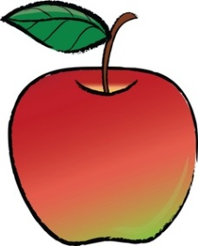](http://www.google.com.eg/url?sa=i&rct=j&q=&esrc=s&source=images&cd=&cad=rja&uact=8&ved=0ahUKEwiu7OLJ94fYAhVRKlAKHSO8DIoQjRwIBw&url=http://www.foodclipart.com/food_clipart_images/apple_with_a_leaf_0515-0906-0401-1617.html&psig=AOvVaw2gIwEpGraf9vHA-EAqXkJW&ust=1513287012716109)[](http://www.google.com.eg/url?sa=i&rct=j&q=&esrc=s&source=images&cd=&cad=rja&uact=8&ved=0ahUKEwiMkLeX94fYAhVHPFAKHdWDBsQQjRwIBw&url=http://cliparting.com/free-rabbit-clipart-17430/&psig=AOvVaw3-mInz_zaYuagpD6FiiufP&ust=1513286895954037)

[](http://www.google.com.eg/url?sa=i&rct=j&q=&esrc=s&source=images&cd=&cad=rja&uact=8&ved=0ahUKEwj7lYP58YfYAhURLFAKHZUQA0IQjRwIBw&url=http://clipart-library.com/nose-cliparts.html&psig=AOvVaw2c84f25ndMhV3ug29QnApy&ust=1513285487790265)[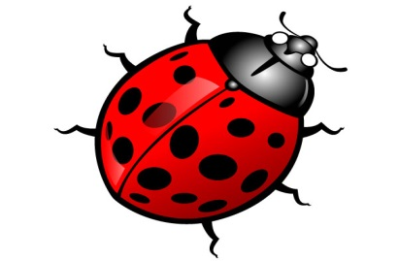](http://www.google.com.eg/url?sa=i&rct=j&q=&esrc=s&source=images&cd=&cad=rja&uact=8&ved=0ahUKEwiGj8a-8YfYAhXKYVAKHbduCj8QjRwIBw&url=http://clipart-library.com/free-bug-clipart.html&psig=AOvVaw0yszsJIwRZuP5hpvW7-yoD&ust=1513285373955170)[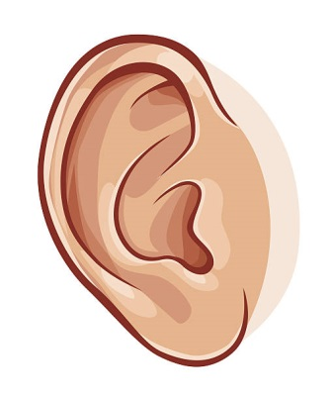](https://www.google.com.eg/url?sa=i&rct=j&q=&esrc=s&source=images&cd=&cad=rja&uact=8&ved=0ahUKEwjOqqnX8YfYAhXEJVAKHZs7A0EQjRwIBw&url=https://clipartxtras.com/categories/view/06e128c45d43322da343335f99587d9bcf90a762/human-ear-clipart.html&psig=AOvVaw3IeWgMAyHKzfD_1Hy3hFdd&ust=1513285432093719)[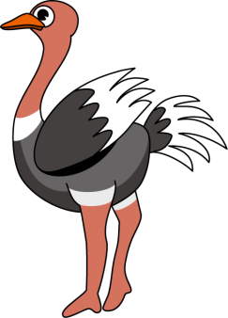](https://www.google.com.eg/url?sa=i&rct=j&q=&esrc=s&source=images&cd=&cad=rja&uact=8&ved=0ahUKEwifooel8YfYAhWIL1AKHUEfDssQjRwIBw&url=https://thecliparts.com/the-best-free-clipart-26309/&psig=AOvVaw3jHmELebgQcdkovAkyh2co&ust=1513285314926300)[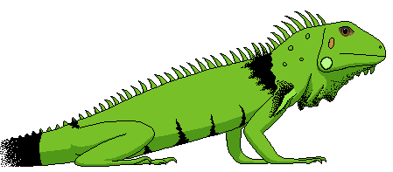](http://www.google.com.eg/url?sa=i&rct=j&q=&esrc=s&source=images&cd=&cad=rja&uact=8&ved=0ahUKEwjWm6mG8YfYAhWCJVAKHbMQCkEQjRwIBw&url=http://clipart-library.com/iguana-cliparts.html&psig=AOvVaw2h81YhiaqF2OpG7SnzxCUW&ust=1513285232381103)[](http://www.google.com.eg/url?sa=i&rct=j&q=&esrc=s&source=images&cd=&cad=rja&uact=8&ved=&url=http://clipart-library.com/clipart/616992.htm&psig=AOvVaw1RG19sPdFx9hPaZMpWvcqt&ust=1513285156934043)[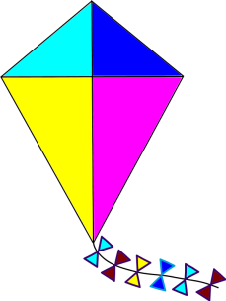](http://clipart-library.com/clipart/162138.htm)[](https://www.google.com.eg/url?sa=i&rct=j&q=&esrc=s&source=images&cd=&cad=rja&uact=8&ved=0ahUKEwi9gN3774fYAhXImLQKHSvqBUIQjRwIBw&url=https://www.mycutegraphics.com/graphics/hat-images.html&psig=AOvVaw2wcAASWjBYwXDzqzROqpb4&ust=1513284933234615)[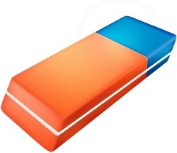](http://www.google.com.eg/url?sa=i&rct=j&q=&esrc=s&source=images&cd=&cad=rja&uact=8&ved=0ahUKEwjVoqO-74fYAhXKJFAKHQzYCkAQjRwIBw&url=http://all-free-download.com/free-icon/eraser-clip-art.html&psig=AOvVaw25kKF9_FiVJpN7blVP81kf&ust=1513284839281724)[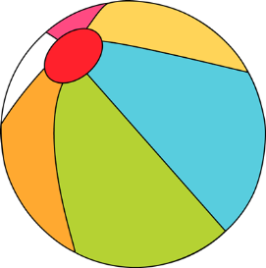](http://www.google.com.eg/url?sa=i&rct=j&q=&esrc=s&source=images&cd=&cad=rja&uact=8&ved=0ahUKEwif_I_Z74fYAhUHLlAKHUPhAEEQjRwIBw&url=http://clipartix.com/beach-ball-clip-art-image-11657/&psig=AOvVaw1HSGoRwR7-WBYtN9Y7MQ1j&ust=1513284885284525)[](http://cliparting.com/free-bat-clip-art-15412/)[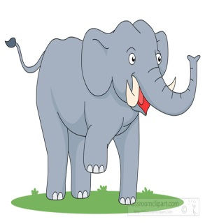](http://www.google.com.eg/url?sa=i&rct=j&q=&esrc=s&source=images&cd=&cad=rja&uact=8&ved=0ahUKEwjT89Ok74fYAhXKPFAKHSLnA0MQjRwIBw&url=http://cliparting.com/free-elephant-clipart-2403/&psig=AOvVaw1zaxRMO6mNAvr3jMk9PPDy&ust=1513284770214200)

