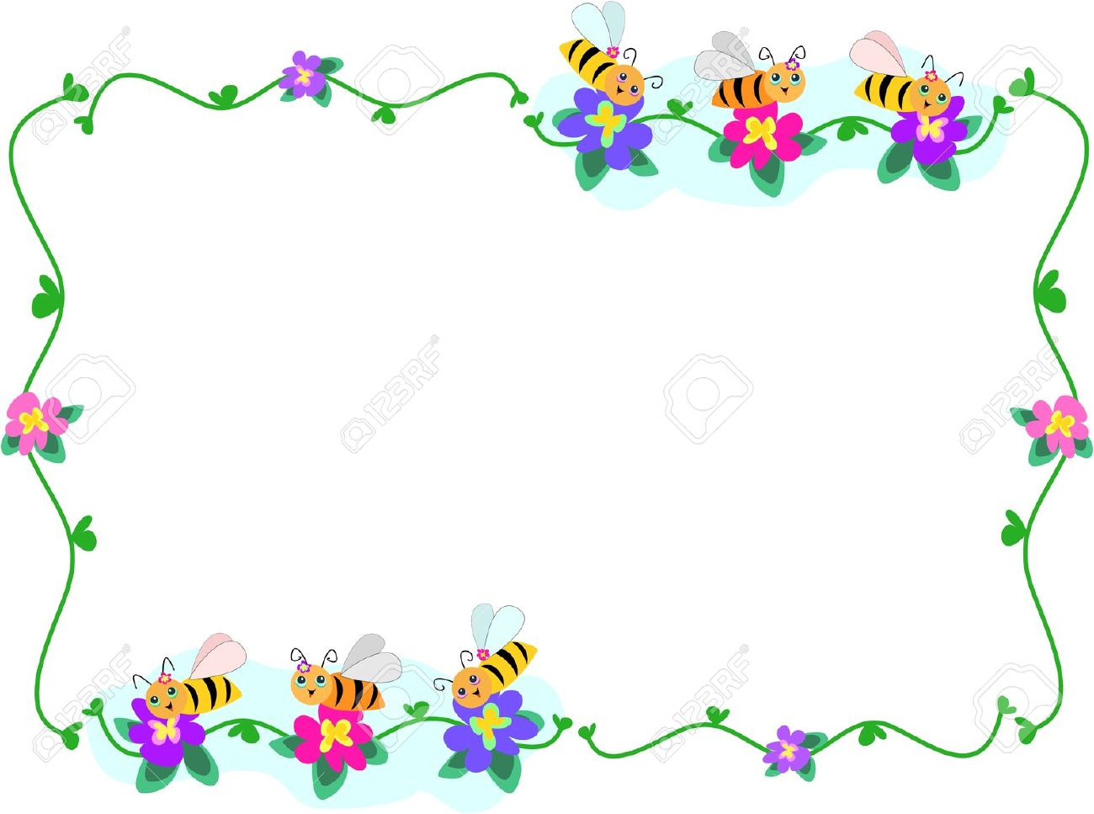

**مراجعة اللغة العربية**

**المستوى الثاني**

**الاسم:.....................**

**الفصل:....................**

**أكتب الكلمة أسفل الصورة**

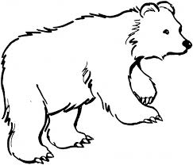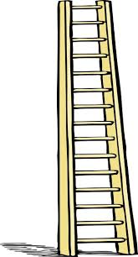

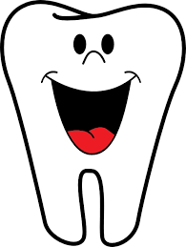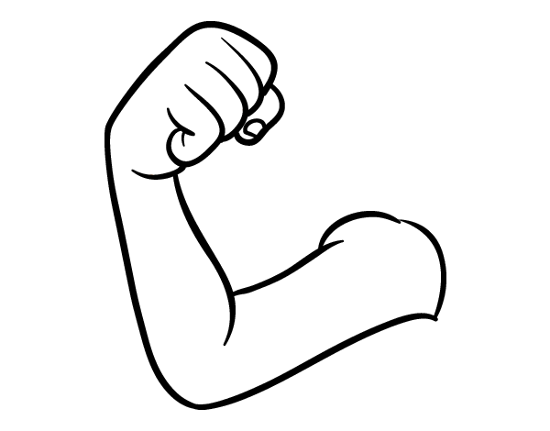

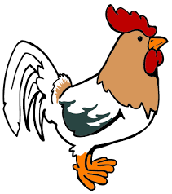

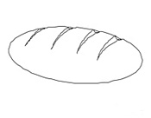

**حلل الكلمات**

**ذراع**

|  |  |  |  |
| --- | --- | --- | --- |
|  |  |  |  |

**دجاجة**

|  |  |  |  |  |
| --- | --- | --- | --- | --- |
|  |  |  |  |  |

**حمامة**

|  |  |  |  |  |
| --- | --- | --- | --- | --- |
|  |  |  |  |  |

**حصان**

|  |  |  |  |  |
| --- | --- | --- | --- | --- |
|  |  |  |  |  |

**زرافة**

**ثعبان**

|  |  |  |  |  |
| --- | --- | --- | --- | --- |
|  |  |  |  |  |

**سلم**

|  |  |  |
| --- | --- | --- |
|  |  |  |

**أكتب الحرف الناقص**

**ثُعبا......& أسـ.... & ضَابـ....**

**حَمامـ....& سُلـ.... & صُو....ة**

**حُـ...ت & بُر.... & بِنـ....**

**خِيا......& خَر..ف& سِتار....**

**شَمـ......& شُبـ..ك& زُهو..**

**صل الكلمة بالصورة المناسبة:**

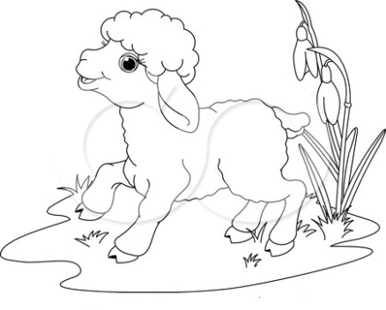

**حُوت**

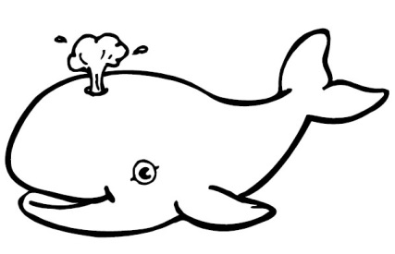

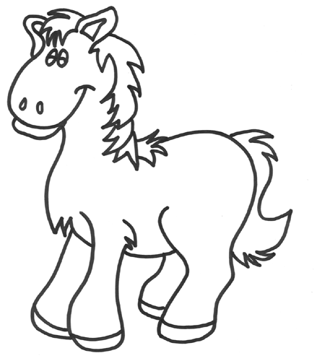 **خَروف**

**أَسد**

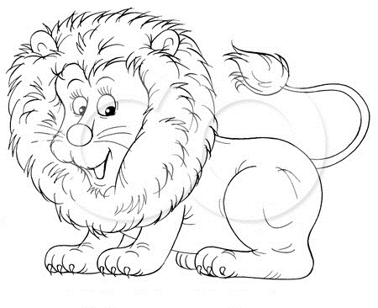

**حِصان**

**أكتب الكلمة أسفل الصورة**



      
      
      

          
          
          

          
          
          

