 Model Test (1)

1) Listen and circle the word with the short vowel:
Kite
pin

gum
flute

June
bus

home
hot

=====================================================
2) Listen and complete:
I ………………… want a kitten. | 1

she wants ................... . | 2

I …………...... up in the morning . | 3

He eats lunch in the ............. | 4

3) Read and write true(T) or Flue (F):

T F
1. There are a man and a woman ( ) ( )
2. They are in the bedroom. ( ) ( )
3. The woman is cleaning up. ( ) ( )
4. There are some eggs. ( ) ( )
4)Read and circle the odd one:
under | zero | On | in | A
jacket | shorts | Jeans | horse | B
teacher | farmer | Nurse | meat | C
key | run | sing | help | D

5)Choose the correct answer from a, b or c:
1- Heba ............. tennis well .
a) play b)plays c)playing
2- He ............. a snack .
a) has b) have c)had
3- They ............. like fish .
a) doesn't b)don't c)isn't
4- I can't .............. my mum .
a) finds b)finding c)find
===============================================================================
6)Read and write:

What do you want ? |  |  | Does She like a lizard ?
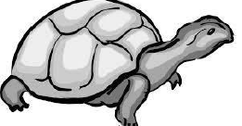 |  |  | 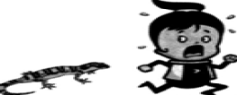
.......................................................................... |  |  | ..........................................................................
When does she listen to music? |  |  | What is this ?
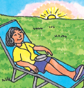 |  |  | 
.......................................................................... |  |  | ..........................................................................
===============================================================================
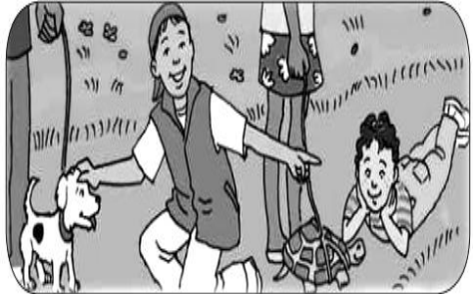
7)Look and write THREE sentences:

1- .....................................................................................................

2-.....................................................................................................

3-.....................................................................................................
===============================================================================
8)Punctuate the following:

let s go to the cinema on friday
.............................................................................................................................................................

 Model Test (2)

1) Listen and circle the word with the short vowel:
cup
tube

rain
ant

up
blue

box
home

=====================================================
2) Listen and complete:
Sounds ................. . | 1

Can you ............. help me ? | 2

What's .............. ? | 3

I want a ................... . | 4

3) Read and write true (T) or false (F):
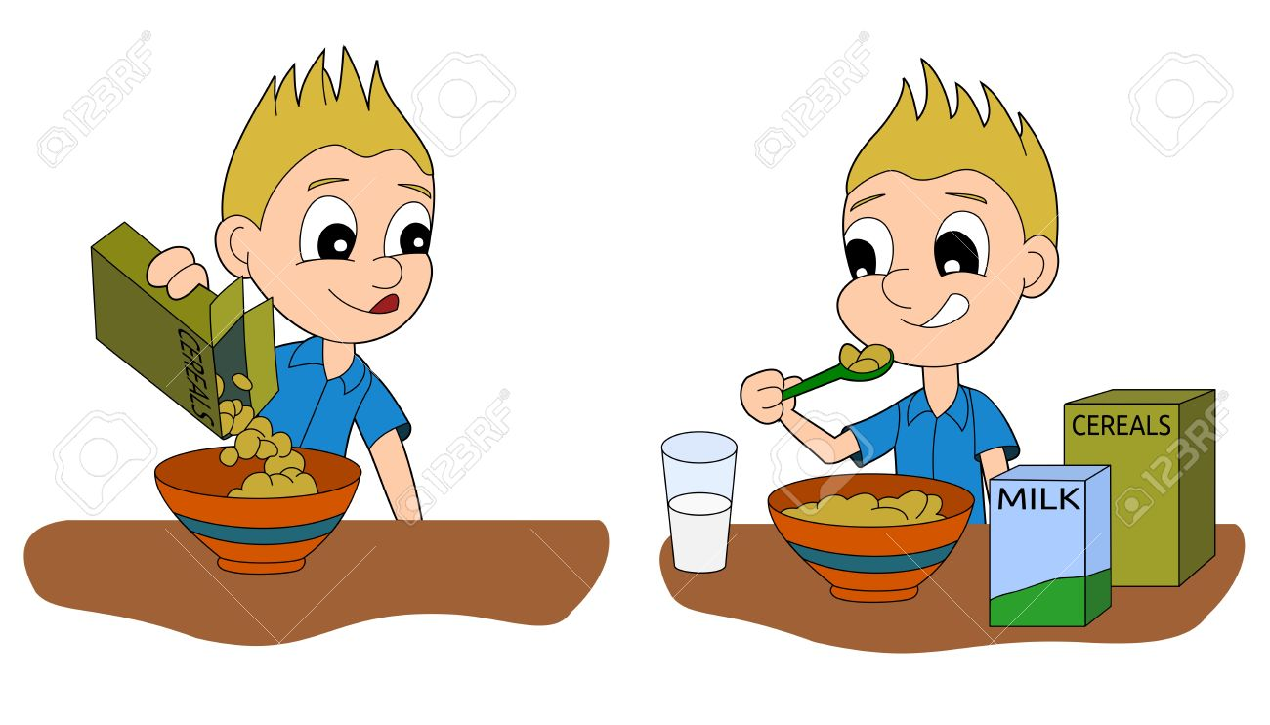
T F
1. There are a boy and a girl. ( ) ( )
2. the boy wants cereal. ( ) ( )
3. The boy doesn't want cereal. ( ) ( )
4. There is milk on the table. ( ) ( )
4)Read and circle the odd one:
ten | Two | Pen | six | A
Juice | Tea | Milk | horse | B
Find | Where | When | what | C
Meat | Pen | Bed | pet | D

5)Choose the correct answer from a, b or c:
1- Let's .................. English.
a) study b)studys c)studying
2- She .................... her face at night.
a) wash b) washes c)washs
3- We ............. like fish.
a) doesn't b)don't c)isn't
4- .............go to school by bus.
a) He b)She c)I
===============================================================================

6)Read and write:

Where is the rabbit? |  |  | When do you wash the car ?
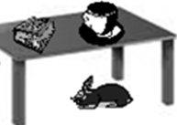 |  |  | 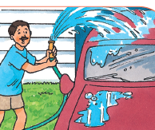
.......................................................................... |  |  | ..........................................................................
Do you want fish ? |  |  | What is this ?
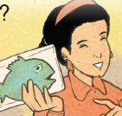 |  |  | 
.......................................................................... |  |  | ..........................................................................
===============================================================================
7)Look and write THREE sentences:
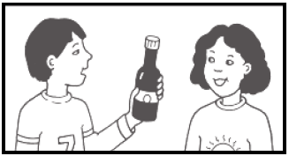
1- .....................................................................................................

2-.....................................................................................................

3-.....................................................................................................
===============================================================================
8)Punctuate the following:

yes ali doesn't like milk
.............................................................................................................................................................

 Model Test (3)

1) Listen and circle the word with the short vowel:
feet
met

sick
boat

run
moon

bake
bed

=====================================================
2) Listen and complete:
Where's the ................ ? | 1

What about ...................? | 2

She is ............... . | 3

I can't find my ................ . | 4

3) Read and write true (T) or false(F):

T F
1. The boy and the girl are in the market. ( ) ( )
2. There are some apples and bananas. ( ) ( )
3. There are some carrots. ( ) ( )
4. The boy likes vegetables. ( ) ( )
4)Read and circle the odd one:
Ten | Dog | Cow | cat | A
green | Red | Brown | town | B
Tall | Thin | Bed | fast | C
washes | Like | Goes | watches | D

5)Choose the correct answer from a, b or c:
1- How about .............. going to the cinema?
a) go b)goes c)going
2- She .................... her homework.
a) do b) does c)are
3- She's ................ a red dress.
a) wear b)wearing c)wears
4- .What do ............... like?
a) he b)she c)you
===============================================================================
6)Read and write:

What does she want? |  |  | What is he doing?
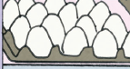 |  |  | 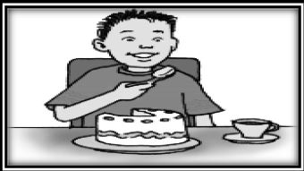
.......................................................................... |  |  | ..........................................................................
Can you help me ? |  |  | Does he want vegetables ?
 |  |  | 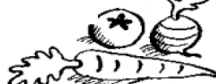
.......................................................................... |  |  | ..........................................................................
===============================================================================
7)Look and write THREE sentences:
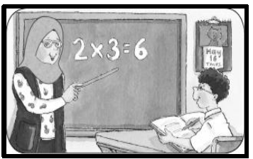
1- .....................................................................................................

2-.....................................................................................................

3-.....................................................................................................
===============================================================================
8)Punctuate the following:

what do amr and marwa want
.............................................................................................................................................................

 Model Teat (4)

1) Listen and circle the word with the short vowel:
three
six

sea
sun

coat
cat

sit
seat

=====================================================
2) Listen and complete:
Mona .............. to music . | 1

I can't .............. it . | 2

The ........ runs on the rug. | 3

It's next ......... the rice . | 4

3)Read and write true(T) or false (F):
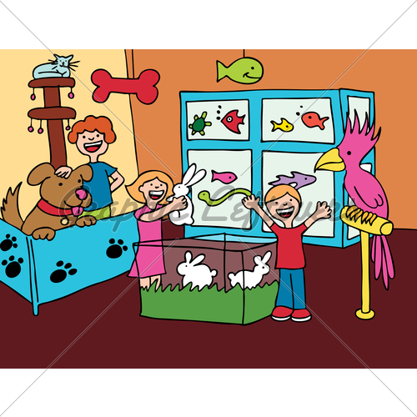
T F
1. There are a man and a woman. ( ) ( )
2. There is a parrot. ( ) ( )
3. There are two turtles. ( ) ( )
4. They are in the pet shop. ( ) ( )
4)Read and circle the odd one:

Doctor | Teacher | Chair | pilot | A
Nose | Ear | Brown | eye | B
Pens | Doors | Cats | tall | C
Meat | Run | Sun | gum | D

5)Choose the correct answer from a, b or c:
1- I don't ................. .Let's ask.
a) no b)know c)not
2- Arwa .................... TV.
a) watches b) watch c)watchs
3- ................ they like pasta?
a) Does b)Do c)Is
4-No, we .................
a) isn't b)doesn't c)don't
===============================================================================
6)Read and write:

What can you see? |  |  | What do they want?
 |  |  | 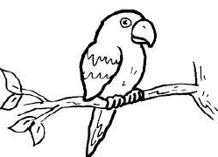
.......................................................................... |  |  | ..........................................................................
How many girls are in the picture? |  |  | Does he like fish?
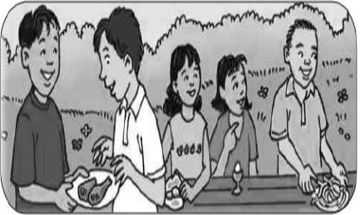 |  |  | 
.......................................................................... |  |  | ..........................................................................
===============================================================================
7)Look and write THREE sentences:
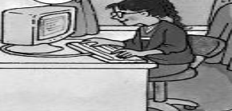
1- .....................................................................................................

2-.....................................................................................................

3-.....................................................................................................
===============================================================================
8)Punctuate the following:

do sally and salma love english
.............................................................................................................................................................
 Model Test (5)

1) Listen and circle the word with the short vowel:
home
hot

bee
bed

ten
tree

blue
run

=====================================================
2) Listen and complete:
My ........... hurts. | 1

We ........... homework at night . | 2

I go to school .......... bus. | 3

I............. want cereal. | 4

3) write true (T) or false (F):
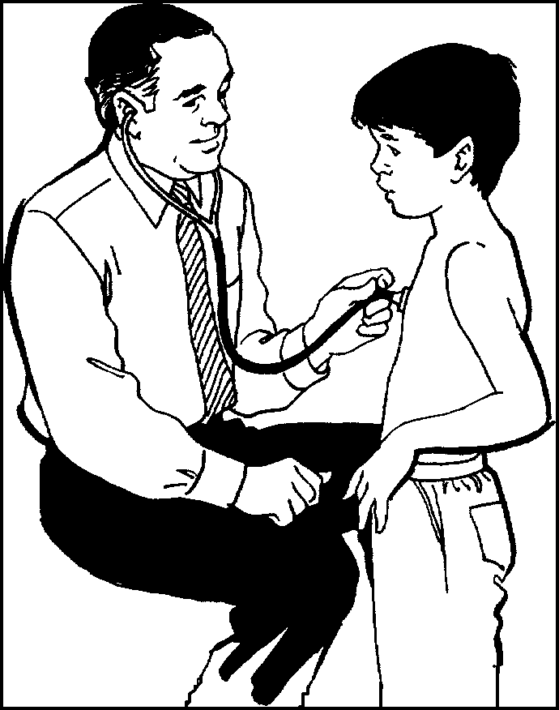
T F
1. He is a doctor. ( ) ( )
2. there are a boy. ( ) ( )
3. There are two girls. ( ) ( )
4. They are at hospital. ( ) ( )
4)Read and circle the odd one:
under | zero | on | in | A
when | where | what | horse | B
ear | nose | nurse | eye | C
black | blue | red | help | D

5)Choose the correct answer from a, b or c:
1- Hebe ............. to school in the morning.
a) go b)goes c)going
2- Let's ............. English.
a) study b) studies c)studying

3- They go to work ............. foot .
a) in b)by c)on
4- When .............. she sleep?
a) do b)does c)is
===============================================================================
6)Read and write:

What 's wrong? |  |  | Do you like fish?
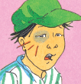 |  |  | 
.......................................................................... |  |  | ..........................................................................
When does she do homework? |  |  | What is this ?
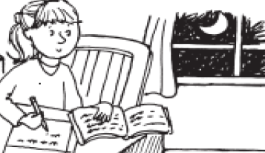 |  |  | 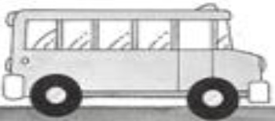
.......................................................................... |  |  | ..........................................................................
===============================================================================.
7)Look and write THREE sentences:
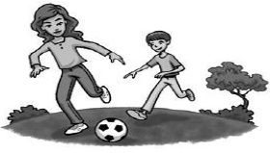
1- .....................................................................................................

2-.....................................................................................................

3-.....................................................................................................
===============================================================================
8)Punctuate the following:

she s playing tennis with mona
.............................................................................................................................................................

 Model Teat (6)

1) Listen and circle the word with the short vowel:
meat
met

red
need

glue
bug

read
ten

=====================================================
2) Listen and complete:
This camera is ................. . | 1

I wash my car........... night.  help me ? | 2

What's .............. ? | 3

They want a ................... . | 4

==============================================================================

3) write true (T) or false (F):

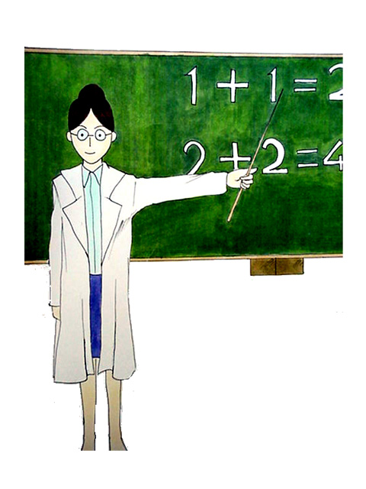
1. She is a teacher. ( ) ( )
2. She teaches English. ( ) ( )
3. There are boys and girls. ( ) ( )
4. She works in a hospital. ( ) ( )
4)Read and circle the odd one:
seven | two | Ten | pen | A
doctor | teacher | Milk | nurse | B
help | play | Find | what | C
We | It | She | He | D

5)Choose the correct answer from a, b or c:
1- .................. leg hurts.
a) My b)Ours c)I

2- These ............... tress.
a) am b) is c)are
3- We ............. like fish.
a) doesn't b)don't c)isn't
4- She .............TV at night.
a) watch b)watches c)watching

6)Read and write:

What can you see? |  |  | How do you go to school?
 |  |  | 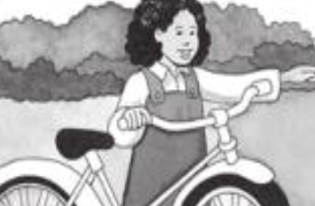
.......................................................................... |  |  | ..........................................................................
Does she want fish ? |  |  | How do you spell "lute" ?
 |  |  | 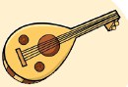
.......................................................................... |  |  | ..........................................................................
===============================================================================
7)Look and write THREE sentences:
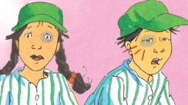
1- .................................................................................................... .

2-.....................................................................................................

3-.....................................................................................................
===============================================================================
8)Punctuate the following:

mona and ahmed like english
.............................................................................................................................................................

 Model Teat (7)

1) Listen and circle the word with the short vowel:
bed
seed

sea
sad

run
moon

bake
bed

=====================================================
2) Listen and complete:
Let's .......... to the cinema. | 1

My birthday is ......... friday. | 2

My ............... hurts . | 3

I can't find my ................ . | 4

3) write true (T) or false (F);

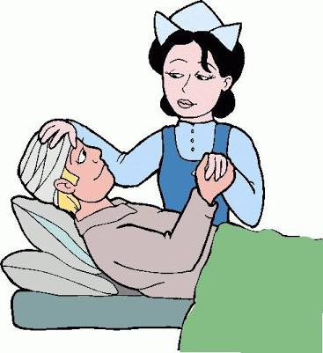
T F
1. She is a nurse. ( ) ( )
2. The man is sick. ( ) ( )
3. There is a doctor. ( ) ( )
4. They are at hospital. ( ) ( )
4)Read and circle the odd one:
finishes | washes | Find | goes | A
green | Tall | Fat | slow | B
mine | their | Our | my | C
turtle | Car | Puppy | lizard | D
5)Choose the correct answer from a, b or c:
1- These bags are..............
a)we b)I c)ours
2- She .................... her car at night.
a) wash b) washes c)washing
3- It's ................ to the bread.
a) next b)on c)in
4-.............. want a puppy.
a) He b)She c)I
===============================================================================
6)Read and write:

What's wrong? |  |  | What is he doing?
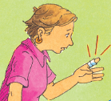
.......................................................................... |  |  | ..........................................................................
How do you go to school? |  |  | Does he want a turtle ?
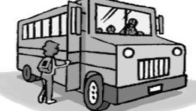 |  |  | 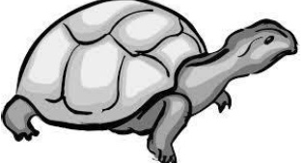
.......................................................................... |  |  | ..........................................................................
===============================================================================
7)Look and write THREE sentences:
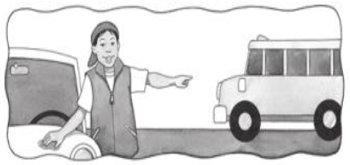
1- ................................................... ..................................................

2-.....................................................................................................

3-.....................................................................................................
===============================================================================
8)Punctuate the following:

no i don't
..........................................................................................................................................................

Best wishes

