Computer first term revision for 4 primary

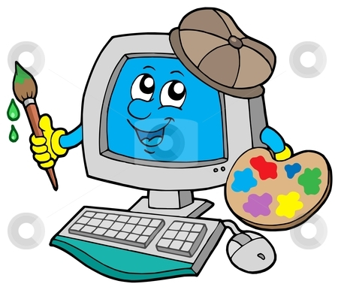

Name : ………………………………………………….
Class : …………………………………………………..

Q 1 Choose the correct answer :
Recyclebin,,Icons, Start ,taskbar , regional settinginternet explore
- We use ……….. to refer to the different programs .
- ………….is that bar at the bottom of the screen and that is characterized by ……………. Button .
- …………. Contains all the files deleted .
- …………. Used to deal with internet .

Q2:Complete the sentences
- The basic icons are ………………. , ………………. , ……………….. , ………………….
- The desktop consist of two main parts are ………………… , ……………………
- The windows are similar in ……………. , ……………. , ……………… , ………………… .
- You can recognize in the taskbar ………….. , …………… , ……………… ,……………… .

Q 3:Answer the questions:
- Steps to shut down the computer :
1)………………………
2)……………………….
- To turn on our computer we have to be sure from :
1)……………………….
2)……………………….

Q 4 :put( √ ) or ( × ):
- taskbar appear in the middle of the screen ( )
- we can recognize start menu in the taskbar ( )
- you can not know the time and date from taskbar ( )
- the desktop contains of three main parts ( )
- taskbar appear in the bottom of the screen ( )
- my computer and recycle bin are not basic icons ( )
- sound card not appear in the taskbar ( )

Q 5 :put a line under the correct answer :

- (windows – desktop) is operating system .
- (icons – taskbar) refer to different programs .
- (icons – taskbar) is a bar that appear in the bottom of the screen .
- (desktop – windows) the first thing we see when we turn on our computer .
- Press (power key – shut down) to turn on your computer .

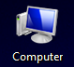
Q 6 :Match the Icons to it’s mean :
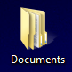
- Maximize key
- Computer
- The lock key
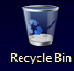
- Recycle bin
- Minimize key
- Internet explorer
- My documents
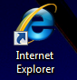
- The key to zoom out

