Alsun modern school

Time for English

Mid-year Revision 2017&2018

Name:
Class:

Test 1
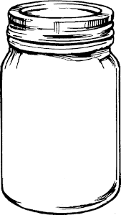
- Listen and number the pictures:

- Listen and fill in the gaps:
Noha: How old ……………… you?
Sally: I …………… ten years old.
- Read and match (A) with (B):
A | B
- We  - This is  - My sister's birthday  - You are | - for you.  - welcome.  - are walking to school.  - is on Monday.  - 's running.

4.Choose the correct word(s) between brackets:
- I'm (hungry – thirsty – angry). I want to eat.
- He is five (years – ears – yards) old.
- Who (am – is – are) she?
- It (aren't – am not – isn't) eating.
- My birthday is (in – of – on) Wednesday!

5. Look at the pictures and unscramble the words:

uqestion ihtrg
…………………………….. ……………………………..
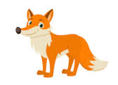

othmer ofx
…………………………….. ………………………………

- Look and write a sentence under each picture:

…………………………………………… ………………………………………….

- Punctuate the following sentence:
my birthday is on sunday
…………………………………………………………………………………………………………
- Copy the following sentence:
See you tomorrow
…………………………………………………………………………………………………

Test 2
- Listen an number the pictures:
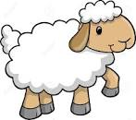

- Listen and fill in the gaps:
A: …………………… birthday.
B: Thanks.
A: You're ……………………………….
- Read and match (A) with (B):
A | B
- Happy  - They  - She is  - Is today | - aren't sleeping.  - eating.  - birthday.  - Wednesday.  - Monday?
4. choose the correct word(s) between brackets:
1. She's (watch – watches – watching) TV.
2. How old are (he – you – they) ? - I'm ten.
3. He (is – am – are) walking to school.
4. (See – Give – Read) you tomorrow !

- He's (talking – reading – walking) a book.
5. Look at the pictures and unscramble the words:

ukdc rdwa
…………………………… ………………………………

itfyf ings
…………………………... …………………………………
- Look and write a sentence under each picture:
………………………………………. …………………………………………
- Punctuate the following sentence:
how old are you
…………………………………………………………………………………………………………
- Copy the following sentence:
Is today Sunday?
……………………………………………………………………………………………………….

Test 3
1- Listen and number the pictures in order:

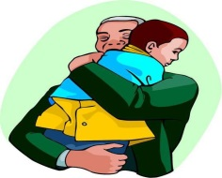

2- Listen and fill in the gaps:

A | : | This is .............. you
B | : | .............. birthday

[ 3 ] Read and match A with B:
{ A } | { B }
- How old | a- my father.
- Who is | b- you?
- Is Today | c- are you ?
- He is | d- She?.
 | e- Monday ?

[ 4 ] Choose the correct answer
1- He (is - am - are ) studying English.
2- Nice to (talk – meet - eat ) you.
3- ( When - where – how )are you from?
4- May I (speak - meet – run ) to Hisham, please?

5- I live (on - in - to ) Giza.

[ 5 ] Look at the pictures and unscramble the words

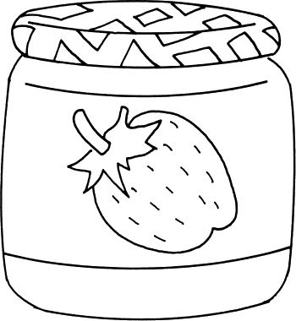 |  | 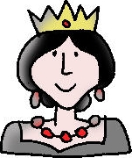
maj | shfi | eeunq | eeb
...................... | ...................... | ...................... | ......................

Look and write a sentence under each picture )[ 6 ]

 | 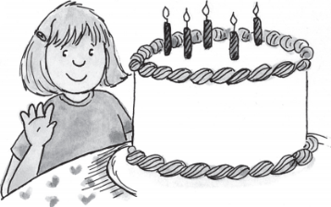
................................................. | .................................................

[ 7 ]-Punctuate the following sentence:
i 'm eight
……………………………………………………………………………………

[ 8 ]-Copy the following sentence:
1-They playing the guitar.
……………………………………………………………………………………
2- She is my mother.
……………………………………………………………………………………

Test 4
 |  |  |  | 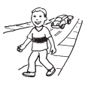
(.......) | (.......) | (......) | (.......) | (.....)
1-Listen and number the pictures:
2-Listen and fill in the gaps:
Ahmed : How ................... are you ?
Mona : I'm ................... .
3-Read and match A with B:
A) welcome. | Where do you live? | 1
b) She's my mother. | See you | 2
c) I live in Minia . | You're | 3
D) tomorrow . | Who's she? | 4
C) lion .
4-Choose the correct word(s) between brackets :
1-She ( is – am –are ) my sister .
2-My birthday is (in –on– of ) Friday.
3-What's she ( do – does – doing ) ?
4-These (are- is – am ) flowers.
5-This is ( for – four - on ) you .

5- Look at the pictures and unscramble the words :
 | 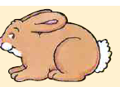
ivfe | abtbir | tea | nisg | tej
........... | .......... | .............. | ............ | ...........
6-Look and write a sentence under each picture:
…………………………. | ………………………….
7- Punctuate the following sentence:
ali and maher live in minia
.....................................................................
8-Copy the following in good handwriting:
They are watching TV.
…………………………………………………………………………………………………………

Test 5
1-Listen and number the pictures:
 | 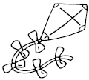 |  | 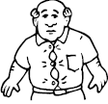
(.......) | (.......) | (......) | (.......) | (......)
2-Listen and fill in the gaps:
Ahmed : What time is ........................ ?
Mona : It's ....................... o'clock .

a) I'm ten . | Oh.You speak | 1
b) English very well . | This is | 2
c) for you . | How old are you ? | 3
d) my father . | He's | 4
e) years old.
3-Read and match A with B:
4-Choose the correct word(s) between brackets :
1-We ( am – is –are ) laughing .
2-What's (they – you– he ) doing?
3-Heba is ( sing – sings – singing ) .

4-That ( are - is - am ) a red flower.
5-She is my ( brother – sister- father ) .
5- Look at the pictures and unscramble the words:
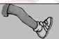 |  | 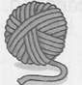
gel | aerd | rayn | upc | maj
......... | ........ | ........... | ......... | .......

6-Look and write a sentence under each picture:
……………………………………….…. | …………………………………………….
7- Punctuate the following sentence:
does ahmed live in minia
...................................................
8-Copy the following in good handwriting:
He is my brother.
…………………………………………………………………………………….

Test 6

1-Listen and number the pictures:
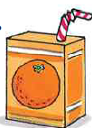 |  | 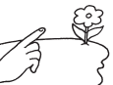
(.......) | (.......) | (......) | (.......) | (......)

2-Listen and fill in the gaps:
Ahmed : Where ………………… you live ?
Mona : I live ....................... Minia

3-Read and match A with B:
 | a) She ? | Happy | 1
 | b) jacket. | Bye- | 2
 | c) Minia . | Who is | 3
 | d) birhday. | I'm from | 4
 | e) bye!
4-Choose the correct word(s) between brackets :
1-How old are ( he – you –they )? - I'm ten.
2-No, it (isn't – am not – aren't ).

3- (He - You - She ) are crying.
4-(Who- What – How ) is she ? -She's my mother
5-What ( am – is are ) they doing ?

5- Look at the pictures and unscramble the words :
 |  |  | 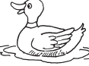 | 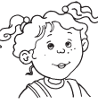
elesp | nria | rade | ckdu | tressi
........... | .......... | .............. | ............ | ...........

6-Look and write a sentence under each picture:
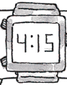 | 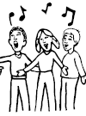
…………………………. | ………………………….
7- Punctuate the following sentence:
we re live in cairo
...................................................
8-Copy the following in good handwriting:
He is playing football .
…………………………………………………………………………………………….

Test 7
1-Listen and number the pictures:
 |  | 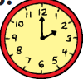 | 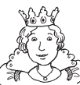
(.......) | (.......) | (......) | (.......) | (......)
2-Listen and fill in the gaps:
Ahmed : Hello. May I speak ................. Ahmed, Please?
Mona : ....................... .

3-Read and match A with B:
 | a) Hold on. | They are | 1
 | b) so much . | Sure. | 2
 | c) studying English. | Thank you | 3
 | d) France . | I'm from | 4
 | e) birthday.
4-Choose the correct word(s) between brackets :
1- ( See – Eat –look ) you tomorrow.
2-Maha is (draw – draws– drawing ).
3- ( He– We– I ) are shouting .

4-Who is ( they – she – you )? –She's a girl.
5-I ( am – is- are ) singing .

5- Look at the pictures and unscramble the words :
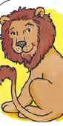 | 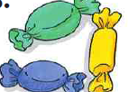 | 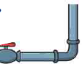 | 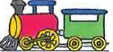
onli | adcyn | eppi | naitr | oyugtr
........... | .......... | ............ | ............ | ...........

6-Look and write a sentence under each picture:
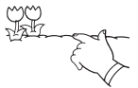 | 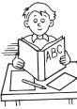
…………………………. | ………………………….

7- Punctuate the following sentence:
no it's tuesday
...................................................
8-Copy the following in good handwriting:
English is fun.
…………………………………………………………………………….

