Chapter 1: Problem Solving

1- Draw flowchart to calculate the sum of two numbers entered by the user and display the result
First: Define the problem
Output: The sum of two numbers
Input: The first number is “A “and the second number is “B”
Processing (Solution): C =A+B where the result is C

2- Draw the flowchart to solve a first degree equation Y=3x+2
First: Define the problem
Output: The value of “Y”.
Input: X.
Processing (Solution): Compute the value of “Y” from the equation Y=3x+2.
- The left hand side (LHS) of any equation should contain only one variable; the value of this variable will be the (output) or the solution of the equation.
- The right hand side (RHS) of the equation may contain abstracted values or arithmetic expressions that have one or more variables (inputs).
3-Write down the Algorithm, and draw aflowchart to compute area and the perimeter of a rectangle whose length (L) and width (W) are known, bearing in mind that the equation of the area is : Area=L*W and that of the perimeter is : perimeter =2(L*W)
First: Define the problem
Output: Area and perimeter of rectangle
Input: length (L) , width (W)
Solution : Area=L*W perimeter =2(L*W)
Second :Algorithm | Third :Flowchart
- start  - enter value of R  - processing Area=L*W  perimeter=2(L*W)  - directed output Area-Perimeter  - end | 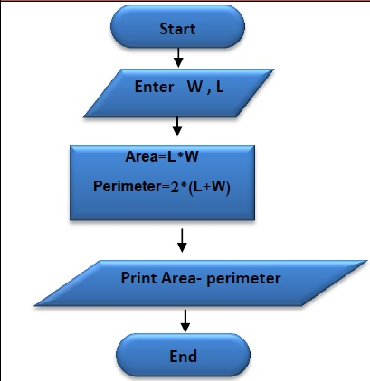

4-Write down the Algorithm, and draw a flowchart to calculate the area of a circle whose radius “R” is known , bearing in mind that the equation of the area of circle is : Area=3.14*R*R.
First: Define the problem
Output: Area of circle
Input: value of radius
Solution : Area=3.14*R*R
Algorithm | Flowchart
- start  - enter value of R  - processing Area=3.14*R*R  - print result Area  - end | 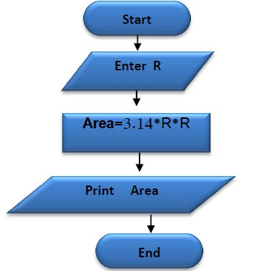

5- Write down the Algorithm, and draw a flowchart to calculate the number of years, bearing in mind that the number of months is known.
First: Define the problem
Output: number of years Y
Input: number of months M
Solution : Y=M/12
Algorithm | flowchart
- start  - enter value of Y  - processing Y=M/12  - print result Y  - end | 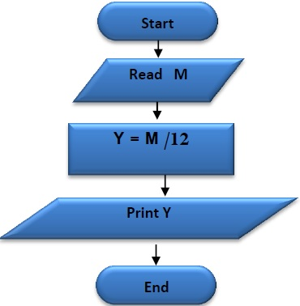
5-Draw the flowchart to print the word “successful” in the case of the degree input is greater than or equal to 50.
First: Define the problem
Output: print the word “ “.
Input: the score X.
Solution: If the value of X is greater than or equal 50; the word “successful” will be printed.
6: Draw the flowchart for a program that will calculate the division of two numbers. If the divisor equals (zero), the message displays “undefined”.
First: Define the problem
Output: print the result of dividing two numbers “R” or print the word “undefined"
Input: Numerator is “num1”, denominator is “num2”.
Solution: if num2=0 then print “undefined”, otherwise print the result of the division “R”.

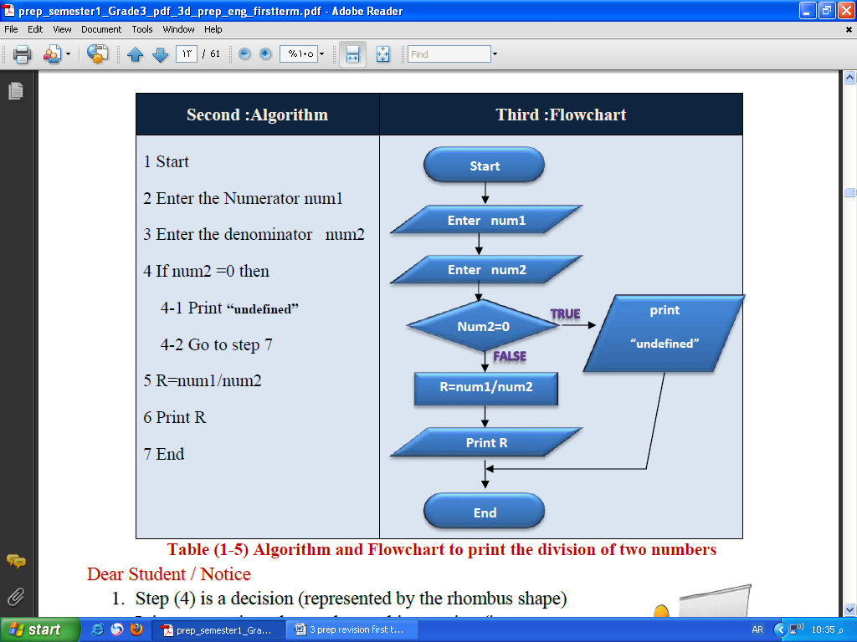
7: Draw aflowchart for aprogram that obtains anumber from the user. Determine the number type (even or odd)
First: Define the problem
Output: print the number type (even or odd).
Input: the number “N”.
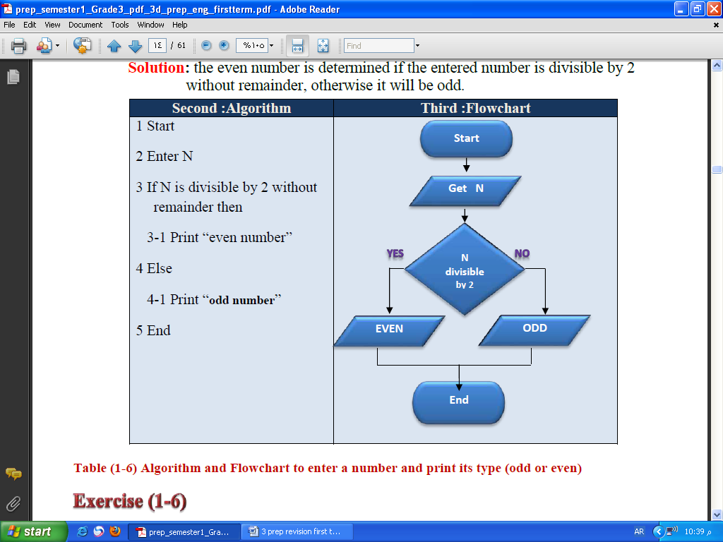
Solution: the even number is determined if the entered number is divisible by 2 without remainder, otherwise it will be odd.

8: Draw the flowchart to get a temperature degree , and print out the following results “greater than zero “ – “less than zero” or “equal zero “
First: Define the problem
Output: print out “greater than zero” – “less than zero “or “equal zero”.
Input: temperaturedegree Celsius “D”.
Solution: the temperature degree entered will be compared to zero.

9: Write down the algorithm, and draw aflowchart to center two unequal numbers, then print the largest is….? And the smallest number is ….?
First: Define the problem
Output: print out “the largest number is ...? “– “the smaller number is .…? “
Input: X, Y so x not equal y
Solution: ………………
Second :Algorithm | Third :Flowchart
- start  - enter value of X ,Y  - if X>Y then  3- 1 the largest number is X  3- 2 the largest number is Y  - end | 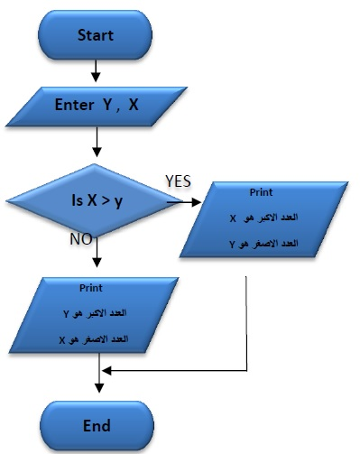

10: The following flowchart is used to calculate the Area of a circle with radius “R”. Redraw the flowchart so that it displays the message “not allowed” and exist from the program (when the value of “R” is negative).
Flowchart | Modified Flowchart
 | 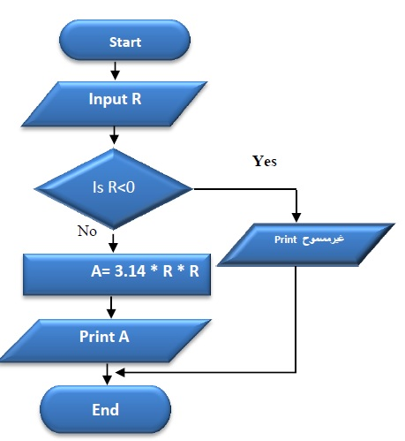
Table (1-8) Flowchart to calculate the area of a circle

11: Print out the numbers from 1 to 3
First: Define the problem
Output: print numbers from 1 to 3
Input: number M
Solution: print number M and increment it by
1 then continue printing until the value of
M become greater than 3

12-Print the multiplication table of number 3.
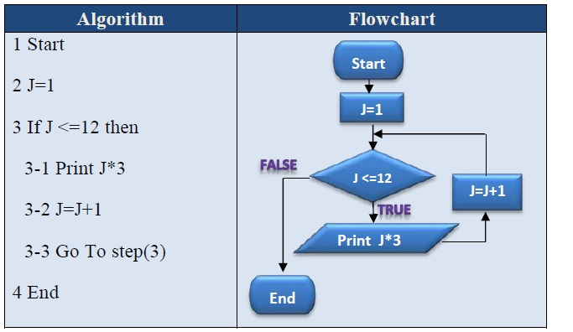
13-Print the multiplication table of entered number J
What is the value of variable J before the decision is not right and the loop end.
imposing the entered value of variable J start from 10
1- start | The value of J | Result
2- J=10 | 10
3- if J<=12 (True) | 10
3-1- print J*3 | 10 | 30
3-2- J=J+1 | 11
3-3- go to step 3 | 11
3- if J<=12 (True) | 11
3-1- print J*3 | 11 | 33
3-2- J=J+1 | 12
3-3- go to step 3 | 12
3- if J<=12 (True) | 12
3-1- print J*3 | 12 | 36
3-2- J=J+1 | 13
3-3- go to step 3 | 13
3- if J<=12 (False) | 13
4- end | 13
Algorithm | flowchart
1- start  2- enter N  3- J=1  4- if J<=12 then  4-1- print J*N  4-2- J=J+1  4-3- go to step 4  5- end | 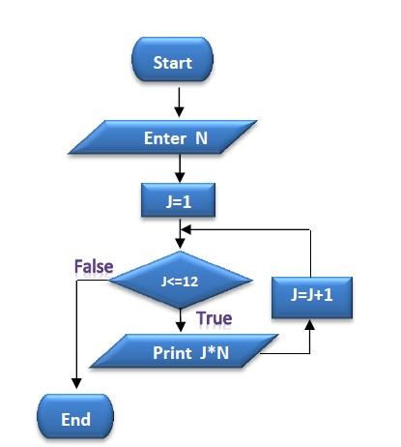
14-print the even numbers from 1 to 10
Algorithm | flowchart
1- start  2- M=2  3-if M<=10 then  3-1- print M  3-2- M=M+2  3-3- go to step 3  4- end | 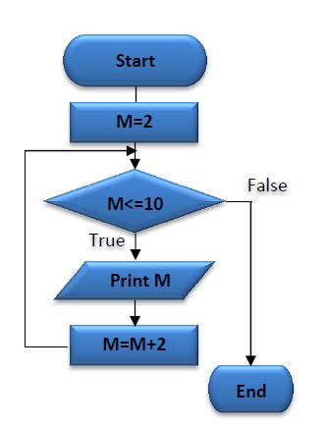

15- print out the sum of integer numbers from 1 to 3
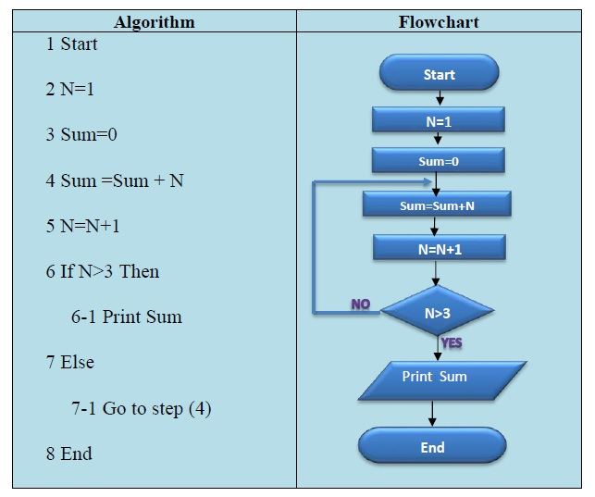

16- print out the sum of odd numbers from 1 to 10.
Algorithm | flowchart
1- start  2- N=1  3-sum=0  4-sum=sum+N  5- N=N+2  6- if N>10 then  6-1- print sum  7-otherwise  7-1- go to step 4  8-end | 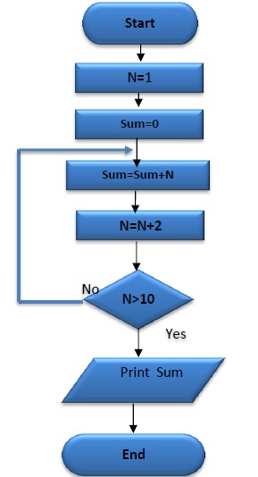

17- print the sum of even numbers from 1 to 10
Algorithm | flowchart
1- start  2- N=2  3-sum=0  4-sum=sum+N  5- N=N+2  6- if N>10 then  6-1- print sum  7-otherwise  7-1- go to step 4  8-end | 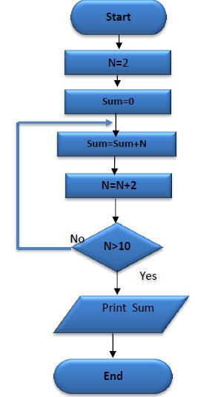

Quotations:
First: Put (✓) in front of the correct sentence and (X) in front of the wrong one:
1 | Flowcharts use standard symbols and lines to represent a problem algorithm. | (√ )
2 | You can use any Geometric shape to represent Algorithm when drawing flowcharts. | (× )
3 | The symbol is used to represent start and end of flowchart. | (√ )
4 | The rectangle symbol is used to represent the data input process. | (× )
5 | The symbol is used to represent a decision process in flowcharts. | (√ )
6 | The problem means that an objective or output is required to reach. | (√ )
7 | Preparing a c10up of tea is an example of a problem. | ( √ )
8 | Problem solving is the steps, activities, and processes to be done to reach an output or objective. | (√ )
9 | The program documentation is a set of procedures arranged logically for solving a specific problem. | (× )
10 | The program testing is writing down all the steps taken to solve a problem. | ( × )
11 | Documenting the program means making sure that the program is free of errors. | ( × )
12 | Algorithm is a set of procedures arranged logically for solving a specific problem. | ( √ )
13 | The program documentation is writing down all the steps taken to solve a problem. | (√ )
14 | Testing the program means making sure that the program is free of errors. | (√ )
15 | Flowcharts are schematic representations which depend on drawing some standard symbols to clarify the order of procedures to solve a problem. | (√ )
16 | Flowcharts help to facilitate understanding of the problem, analyze and convert it to a program. | (√ )

Second: Choose the appropriate answer to complete each phrase of the following:
1- Steps, activities and procedures to be done to reach an objective or an output - can be called:
a. problem definition b. problem c. problem solving
2- On drawing flowcharts we use:
a. standard symbols and lines b. all geometric figures c. one geometric figure
3- A set of procedures arranged logically for solving a specific problem –can be called:
a. problem b. algorithm c. program testing
4- Making sure that the program is free of errors –can be called:
a. program testing b. program documentation c. algorithm
5- Writing down all the steps taken to solve a problem errors–can be called:
a. program documentation b. program testing c. flowcharts
Problem-solving approach includes many terminologies, the terminology that expresses the preparation of a cup juice is:
a. Flowchart b. algorithm c. problem
7- Problem-solving approach includes many of the terminologies, the terminology that expresses the mathematical problem is:
a. Algorithm b. problem c. program design
8- A schematic representation that depends on drawing some standard symbols to clarify the order of procedures to solve a problem can be called:
a. Problem b. algorithm c. flowchart
9- In the following flowchart: The number of iterations (print the value of M) is:
a- 2 b- 3 c- 4

In Flowchart of the previous question, the value of M after the end of the iterativeloop equals:
a. 2 b- 3 c- 4

Chapter 2: Visual basic
Create a project with the name “my first project “ and the solution name is “ my first solution”
And then add another project to the solution write the name “ my second project”

Quations
First: Put (✓) in front of the correct sentence and (X) in front of the wrong one:
1 | The VB.net language is one of the high level languages. | (√ )
2 | The VB.net language is one of Event Driven languages. | (√ )
3 | The VB.net language is the only high level language. | (× )
4 | The VB.net language is considered a high level language because it is easy to learn. | (√ )
5 | The VB.net language is used in producing Windows applications and Web applications. | ( √ )
6 | The VB.net language is used in producing Web applications only. | (× )
7 | The VB.net language can't be used in producing Windows applications | (× )
8 | Every Object is characterized by certain properties and certain behavior when a certain event occurs on it. | ( √ )
9 | Events and procedures which belong to any object in VB.net language are called properties. | ( × )
10 | The name, the size and color of an object are all samples of events that can occur to the object in VB.net language. | ( × )
11 | The name, the size and color of an object are all samples of properties of some objects in VB.net language. | ( √ )
12 | The Events are the commands and instructions which are carried out when a certain procedure occurs to the object in VB.net language. | ( × )
13 | The procedures are the commands and instructions which are carried out when a certain procedure occurs to the object in VB.net language. | ( × )
14 | Pressing click and D-click are samples of some events that can occur to an object in VB.net language. | ( √ )
15 | Framework.net contains Compilers, libraries and runtime environment | ( √ )
16 | Compilers in Framework. Net are considered the environment of runtime for applications which are produced in VB.net language. | ( × )
17 | Compilers are programmes that translate commands and instructions written by the programmer from the high level language into machine language. | ( √ )
18 | Object oriented programming languages are the languages which work through objects that carry out procedures when a certain event occurs to them. | ( √ )
19 | All programming languages which carry out a group of commands and instructions are considered as Event Driven languages. | ( × )
20 | Visual Studio is considered IDE because it includes a group of tools, elements and characteristics necessary to produce applications. | ( √ )

Second: Choose the correct answer to complete each statement:
1-Object Oriented programming language depends on:
a- using Windows applications.
b- using Web applications
c- objects in computer memory.
You can produce Windows applications or Web applications by using:
a-Objects in computer memory
b-VB.net language
c- Properties and Events
3- Characteristics which describe the object such as size, name and colour are called:
a-Properties
b-procedures
c-Events
4-Click on Button is:
a-property
b-procedure
c-Event
5-Commands and instructions which we want to carry out are called:
a-properties
b-producers
c-Events
6- The Properties term refers to:
a- Features that describe the object.
b-Events that can occur to the object.
c- Commands and instructions that are carried out.
7-The Events term refers to :
a- properties that describe the object.
b-Events that can occur to the object.
c- Commands and instructions that are carried out.
8-The Procedures term refers to:
a-properties that describe the object.
b-Events that can occur to the object.
c- Commands and instructions that are carried out.
9-libraries, Compilers and Environment of runtime of applications are the most important components of:
a-Object Oriented.
b-Event Driven.
c-Framework.net.
10- IDE is called:
a-Visual Basic.net
b-Visual Studio.
c-Framwork.net.

Chapter 3 controls
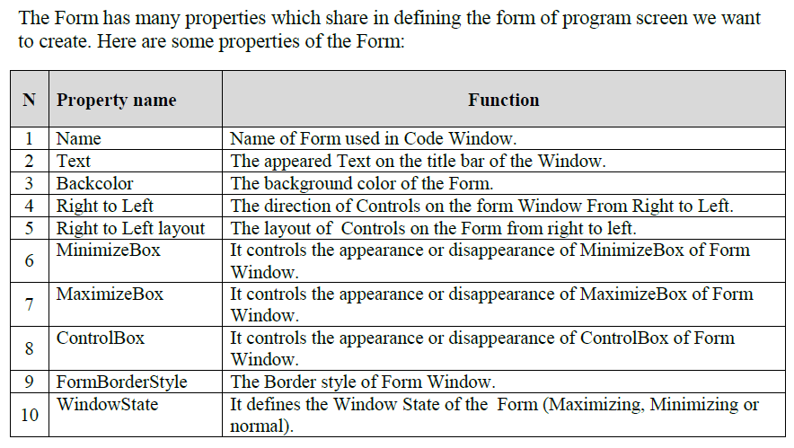
Questions
First: Put (✓) in front of the correct sentence and (X) in front of the wrong one:
1 | The function of the property RightToLeft of the Form is to define the direction of Controls from right to left. | ( √ )
2 | The function of the property RightToLeft of the Form is to define the state of the Form on the screen in a position of Maximizing or Minimizing. | ( × )
3 | Setting the property ControlBox of the Form can control the Form in a position of Maximizing during programme.runtime. | ( × )
4 | The property “Name" is used in showing a certain Text in the title bar of user window a name of the window. | ( × )
5 | The property Text is used in showing a certain text the title bar of of user window. | ( √ )
6 | Setting some properties of the Form is applied to Controls which are placed on the Form. | ( √ )
7 | The effect of setting the Window State property of the form appears only in runtime mode | ( √ )
8 | You can change the location of Command Button on the Form through Size property. | ( × )
9 | You can change the location of Command Button on the Form through Location property. | ( √ )
10 | Placing Controls automatically on the Form on the co-ordinate (0-0) is in the middle of the Form. | ( √ )
11 | You can change the size of Label manually if Auto Size=true | ( × )
12 | You can change the size of Label manually if Auto Size=false | ( √)
13 | "Textbox control tool: is the only tool which has the property password Chart | ( √ )
14 | "Textbox control tool: is the only tool which has the property Auto Size | ( × )
15 | ListBox and ComboBox share in "Item " property. | ( √ )
16 | ListBox and andComboBox share in " Suggest " property | ( × )
17 | GroupBox is the tool used in contain a group of controls, these controls have the same function on the Form. | ( √ )
18 | ListBox is the tool used in contain a group of controls, these controls have the same function on the Form. | ( × )
19 | CheckBox can be used on the Form to choose the Gender of student male or female. | ( × )
20 | Combobox is the control tool that allows the user to choose one element of several elements in the smallest possible space on the form window | ( √ )

Second: Choose the correct answer to complete each statement:-
1- The function of "Right to Left" property of the Form is:
a- define the direction of Control tools from Right to Left.
b- define whether the layout of ControlTools on the Form is from Right to Left.
c-define the state of the window in a state of maximaizing or minimaizing.
2- ControlBox property of the Form is helping to:
a- showing or hiding of Maximaizing Box.
b- control the appearance of the Form whether it is in a position of Minimaizing / Maximaizing / Normal.
c-Control the appearance or disappearance of ControlBox in the Form.
3-The used property in showing a certain Text on the titlebar of a Form is :
a- Name b-Text c-FormBorderStyle
4-On setting some properties of the Form, they are applied on Control Tools
Which are placed on the Form (one of them is):
a-Name b-Forecolor c-Text
5-The effect of setting this property doesn't appear unless in runtime mode (This property is):
a-FormBorderStyle b-WindowState c-RightToLeft
6-The property which is responsible for the size, shape and effect of the Text font shown on the Button is
a-Backcolor b-Forecolor c-Font
7-You can change the position of the Button on the Form through the following processes except for :
a-drag and drop by the mouse
b-setting Size property
c-setting Location property
8-You can change the position of the Button on the Form through :
a. Setting Location property
b-setting Size property
c-the eight squares around the Button
9-On inserting any Control Tool by pressing D-Click from the Toolbox on the Form , the appropriate place to be shown is :
a-coordinate (0,0)
b-the middle of the Form
c-the position of Control Tool is different according to the size of the Form
10-The size of Label is defined automatically on the Form if the property is:
a-Auto Size = False b- Border Style= Fixed Single c- Auto Size=True.
11-You can change the size of control "Label" manually if the property is :
a- Auto Size = False- b- Border Style= Fixed Single c- Auto Size=True-
12-The following properties belong to TextBox except for:
a-AutoSize b-MultiLine c-MaxLength
13-The Object TextBox is marked by one property :
a-AutoSize b-Name c-PasswordChart
14-The right value which can be used to set the PasswordChart of the TextBoxis :
a-Pw b-True c-*
15-The ListBox and ComboBox share in this property :
a-Suggest b-Item c-SelectionMode
16-The ControlTool which is used in containing a group of controls that have the same function on the Form is:
a-ComboBox b-ListBox c-GroupBox
17-The Control tool which can be used on the Form to choose Gender of the student "male"or "female" is:
a-RadioButton b-CheckBox c-TextBox
18-The ControlTool which can be used on the Form and allows the user to choose more than one alternatives is :
a-RadioButton b-GroupBox c-CheckBox
19- The ControlTool which can be used on the Form and allows the user to choose more than one item is :
a-RadioButton b-GroupBox c-CheckBox
20-The ControlTool which allows the user to choose one item of 15
in the smallest possible area on the Form is:
a-ComboBox b-ListBox c-RadioBox

Chapter 4 code window
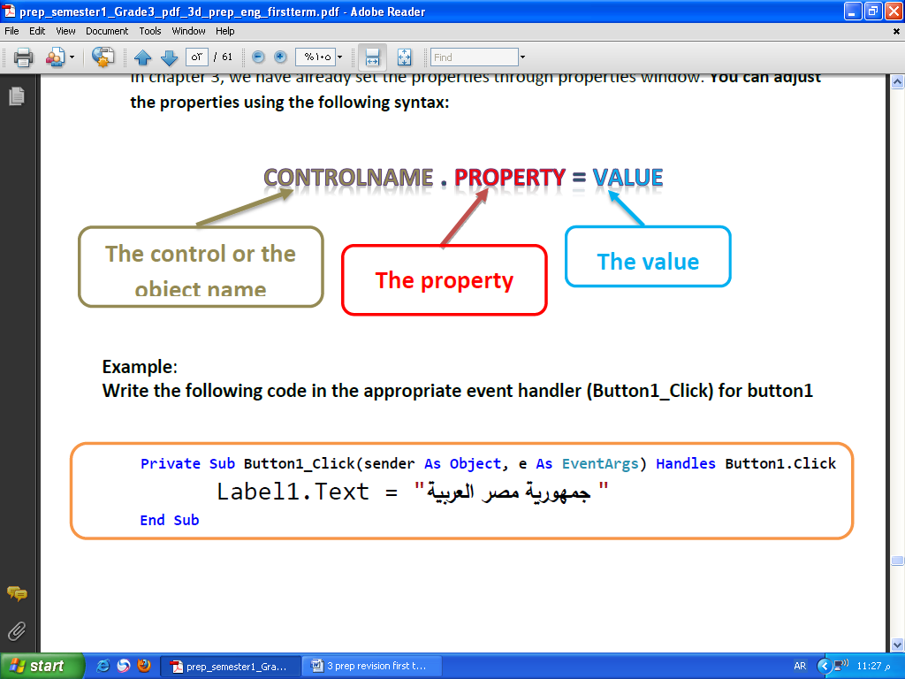
Quations :
- Complete the table with a number from 1 to 5 using the next screen to express every number to what it refers to:
NO. | Indicate
(…5.) | The end of class
(…4.) | The place to write the codes of the class
(2….) | The name of the file that saves the design of the form interface
(…1.) | The name of the file that saves the code
(3….) | The start of the class

- Complete the table using the next screen:
NO. | Indicates
1 | Name of the file where codes are saved.
2 | Name of the file where the Form window interface is saved
3 | The declaration of Class; its name is (Form1).
4 | Space between two lines; to type codes for the Class (Form1)
5 | The end of the class (form 1).
- complete the table using the next screen :
NO. | Indicates
1 | The name of the solution is ……shapes…………
2 | The name of the project is……shapes…………
3 | We can enter the code window more than one way, through :  - Command view code in the shortcut menu context  - function key …F7…….
4 | The purpose of properties in the shortcut menu is ……format the properties of the selected object…..

- Complete the table using the following screen :
NO. | Indicates
1 | A drop-down menu of (Class Names) that displays the names of controls on the form
2 | Form Name (frmsquare)
3 | A drop-down menu of (Method Names) or events; associated with the item selected from the (Class Names) menu.

1- The number of forms is ………one……………
2- number (1) refers to … menu of (Method Names) or events; associated with the item selected….
3- number (2) refers to … menu of (Class Names) that displays the names of controls on the form..…….
4- List three different control tools from the previous screen
- …btncalculate…..
- ……blblength…..
- ……txtlength..
5- The name of the class is ……frmsquare………..

- Answer the question using the following screen :

a- From the previous screen write 3 different events :…click…… …double click… …AutoSizeChanged……
b- frmSquare refers to ……class name…….
c- The events in the window belong to the control ………Button1………..
d- The name of the active tab in the window is …frmsquare.Vb…

- Complete the table using the following screen :

indicatesNO.

NO. | Indicates
1 | The procedure name composed of (object name, event name).
2 | End of procedure line.
3 | What causes the call of the procedure (event occurrence) .
4 | Between the two lines shown; the code that will be executed on calling the procedure is written after the occurrence of the (Event
5 | The declaration of the class line (frmSquare)
6 | The end of (class) line.

- Explain the components of the general syntax to adjust the properties of controls programmatically:
ControlName.Property = Value
… The control or the object name…….
… The property…..
…… The value………

- Explain the following codes through your pervious study for the general syntax to adjust the properties of control programmatically :
(A) Button2.Text = "END"
………write text END on the face of tool………….
(B) Label1.AutoSize = True
……Change size of Label1 automatically depend on text written inside………….

