Computer first term revision for 3 primary

Name : ……………………………………………..
Class : ……………………………………………….

Q 1 :Choose the correct answer :
( keyboard,speakers,letters,printer,numbers,scanner,input
Unit ,symbols ,writing ,paint ,microphone, desktop ,monitor)

- ………… and ………….. are input units .
- We use keyboard in ……………….
- We enter the data to the computer using ……………….
- We see what we write on ………………….
- Keyboard has three types of keys they are …………… , ……………. , ……………….
- ……………… use to talk in it .
- ………………use to listening music .
- ……………….use to print papers .
- …………… is an application that help us in drawing .
- The first screen that appear to me when we turn on our computer is called ……………… .

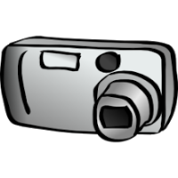
Q 3 :put aline under CPU
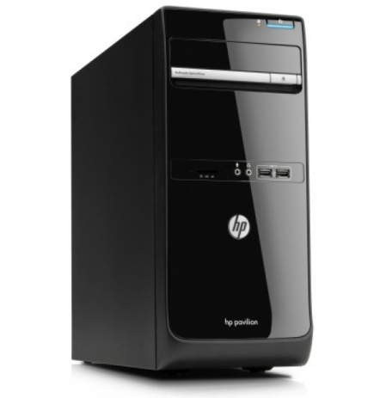

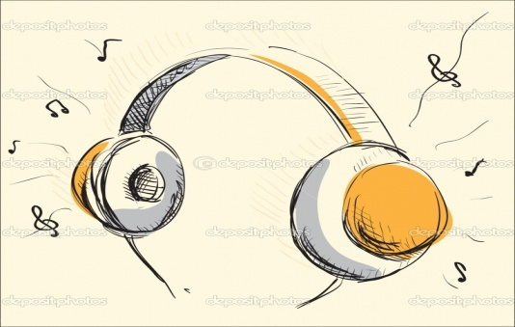
Q4 :write the picture name and(input – output)

..................name : ..................name :
unit.................... unit...................

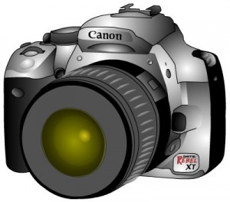
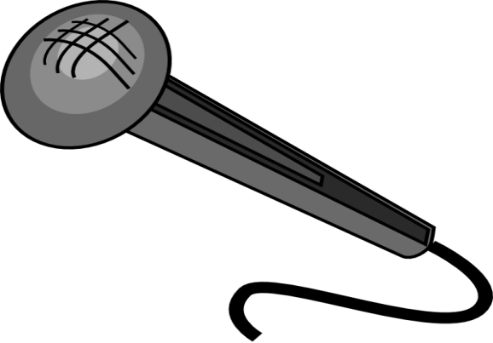

..................name : ..................name :
unit .................... unit ....................

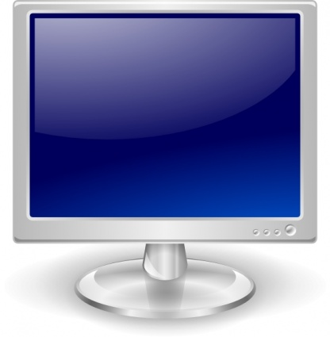
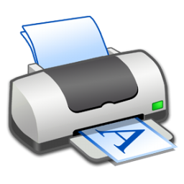

..................name : .................name :
unit.................... unit....................
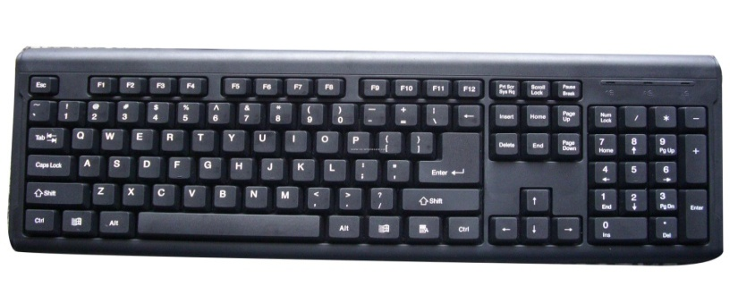

..................name : ..................name :
unit .................... unit ....................

Q 5 :Choose the correct answer :

- We get information use (input-output) unit .
- CPU (process-store) data .
- We inter data into computer using (input-output)
- We use (delete-enter)key to end the line and begin a new one .
- (arrow-delete)key used to delete words .
- (Keyboard-monitor) is an input unit .
- from 0 to 9 are (number-letter) keys .
- the first screen is called (desktop – taskbar )
- (paint – word pad) is an application help us in writing

Q 7 :Match the Icons to it’s mean :
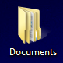
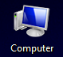
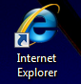
My computer , Recycle bin , My documents , Internet explorer .

