Arabic section
Midyear Revision
Second primary
FIRST term
O.L.
(2017 – 2018)

Name:…………..
Class:…………

Revision sheet o.L ( Grade two )
Test one
1- Listen and write the missing vowel:
1- P_ t 2- L_ ke 3- c_ t 4- h_ n 5- fe_ t
2- Listen and fill in the gaps:
A: …………………. Are you ?
B: fine ,…………………. You ?
3- Match A with B:
1- hen 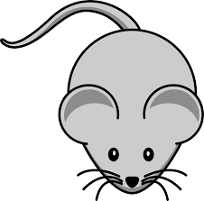
2- mouse
3- bird 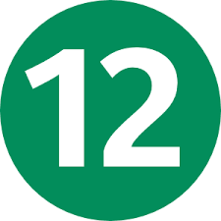
4- dog
5- twelve 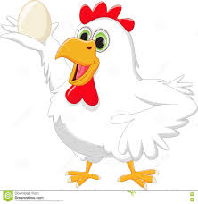

4- Look and circle:
1- 2- 3- 4- 5-
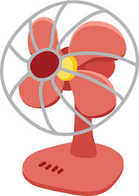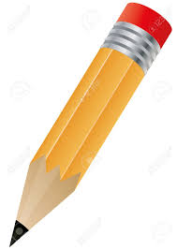
Hand van Pie teacher eraser
Heart fan bell farmer Pencil
5- Unscramble and write:
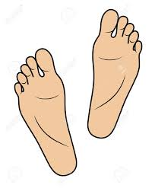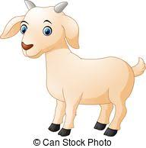
Fete rouf pshee
……………… ………………….. ……………….
6- Look and Write:
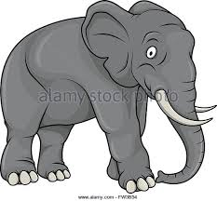
1- Is it a mouse? 2- Is it a van?
……………………………………… ………………………………………
7- Punctuate the following:
iam a girl/
……………………………………………………………………….
8- Copy the following sentences:
1- Is it a ruler?
…………………………………………………………………………………
2- She is a nurse.
…………………………………………………………………………………

Test Two
1- Listen and write the missing vowel:
1- n_ t 2- d_ ck 3- s_ d 4- h_ t 5- v_ n
2- Listen and fill in the gaps:
A: …………………. are you
B: Thank You .
3- Match A with B:
1- Pencil case 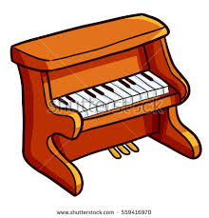
2- violin 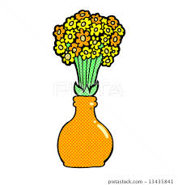
3- vase 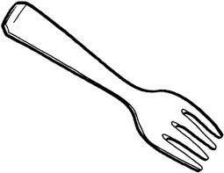
4- fork
5- Piano 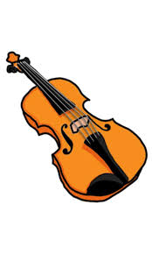
4- Look and circle:
1- 2- 3- 4- 5-
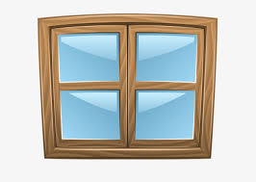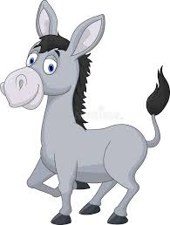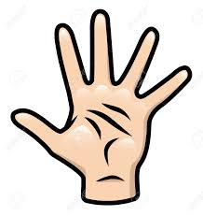
Window tiger ruler head hungry
water horse Pencil hand thirsty
5- Unscramble and write:
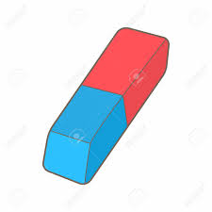
eathcre nomwa easerr
…………………….. ……………………. …………………….
6- Look and Write:
1- Is it a frog ? 2- Is it a van?
……………………………………….. ……………………………………
7- Punctuate the following:
this is a flower/
……………………………………………………………………….
8- Copy the following sentences:
1- How old are you ?
…………………………………………………………………………………
2- She is my mother.
…………………………………………………………………………………

Test Three
1- Listen and write the missing vowel:
1- tre_ 2- fl_ wer 3- clo_ d 4- b_ rd 5- l_ ke
2- Listen and fill in the gaps:
A: Ah-choo!
B: ……………….. You .
A:………………………….
3- Match A with B:
1- mouse 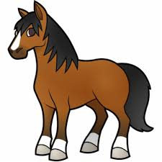
2- pencil 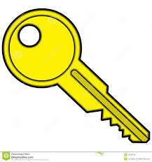
3- girl 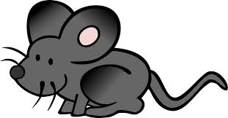
4- horse
5- key
4- Look and circle:
1- 2- 3- 4- 5-
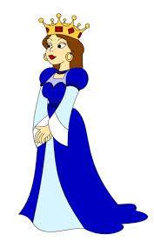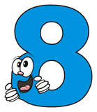
door king chicken seven tiger
window queen bird eight teacher
5- Unscramble and write:
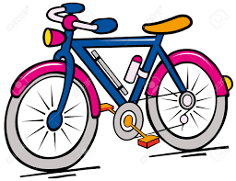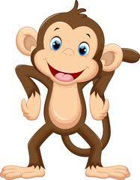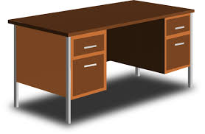
ibke onmeky esdk
……………………………… ……………………………. ……………………
6- Look and Write:
1- Is it a pen? 2- Are you sad?
……………………………………. …………………………………….
7- Punctuate the following:
is this a sailboat/
……………………………………………………………………….
8- Copy the following sentences:
1- What's your name ?
…………………………………………………………………………………
2- My name is Sarah Hassan.
…………………………………………………………………………………

Test four
1- Listen and write the missing vowel:
1- h_rse 2- n_ rse 3- t_ ble 4- m_ lk 5- d_ sk
2- Listen and fill in the gaps:
A: Ouch!
B: Are you ………………… .?
A:I ……………………..so.
3- Match A with B:
1- cloud
2- goat
3- horse
4- woman 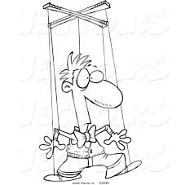
5- puppet
4- Look and circle:
1- 2- 3- 4- 5-
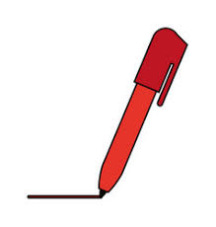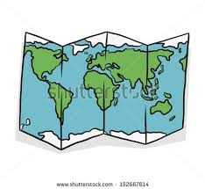
cow duck ten pizza mop
dog desk pen piano map
5- Unscramble and write:
rsaere wdwnio lowfre
………………………. …………………………… …………………………
6- Look and Write:
1- Are you thirsty ? 2- Is this a pencil?
……………………………………… …………………………………
7- Punctuate the following:
there are two cows/
……………………………………………………………………….
8- Copy the following sentences:
1- Welcome to Egypt .
…………………………………………………………………………………
2- Nice to meet you.
…………………………………………………………………………………

