1
2
3
4
5
6
7
8
9
10
11
12 | 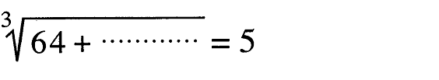
13 | 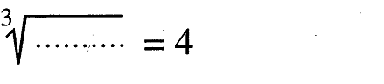
14
15
16
18
19
1 | Exercise ( 2 ) Question ( 8 ) ( 1 )
2 | Exercise ( 2 ) Question ( 4 ) ( 1 )
3 | Exercise ( 2 ) Question ( 4 ) ( 2 )
4 | 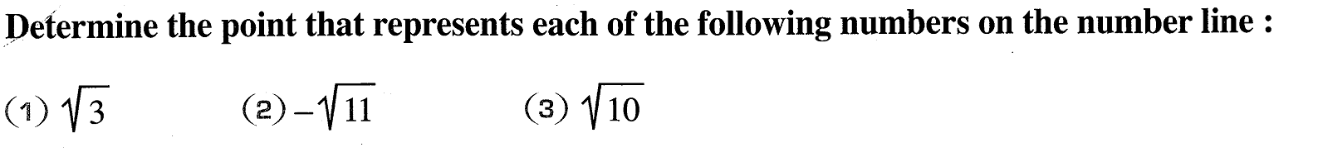  Exercise ( 2 ) Question ( 9 ) ( 4 )
1 | Exercise ( 2 ) Question ( 8 ) ( 1 )
2 | Exercise ( 2 ) Question ( 8 ) ( 1 )
3 | Exercise ( 2 ) Question ( 4 ) ( 1 )
4 | Exercise ( 2 ) Question ( 4 ) ( 2 )
5 | 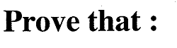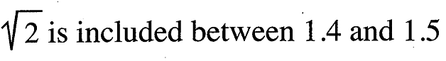  Exercise ( 2 ) Question ( 9 ) ( 1 )
6 | 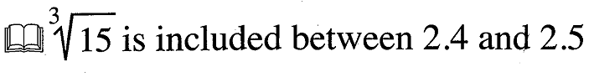  Exercise ( 2 ) Question ( 9 ) ( 4 )
7 | Exercise ( 2 ) Question ( 9 ) ( 4 )

1
2
3
4
5
6
7
8
9
10
11
12
13
14
15
16
17
1 | 2016 Exam ( 7 ) Question ( 3 ) ( a )
2 | 2016 Exam ( 5 ) Question ( 4 ) ( a )
3 | 2016 Exam ( 9 ) Question ( 3 ) ( a )
4 | 2016 Exam ( 11 ) Question ( 3 ) ( a )
5 | 2016 Exam ( 12 ) Question ( 3 ) ( a )
6 | 2016 Exam ( 14 ) Question ( 3 ) ( a )
7 | 22016 Exam ( 15 ) Question ( 3 ) ( a )
1 | 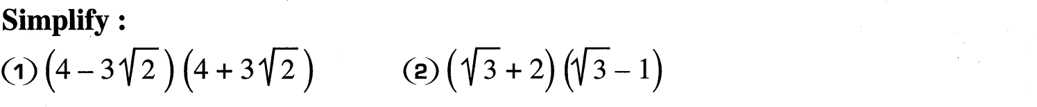2016 Exam ( 1 ) Question ( 3 ) ( a )
2 | 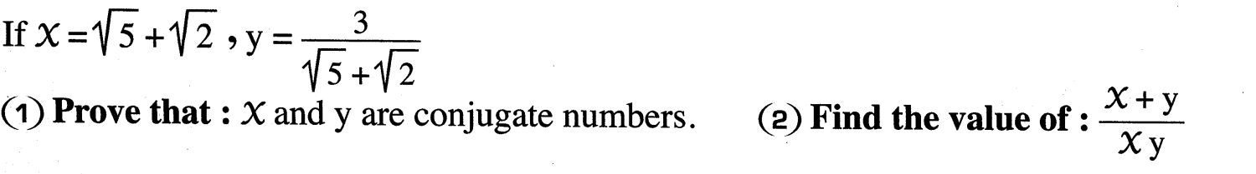2016 Exam ( 2 ) Question ( 3 ) ( b )
3 | 2016 Exam ( 3 ) Question ( 3 ) ( a )
4 | 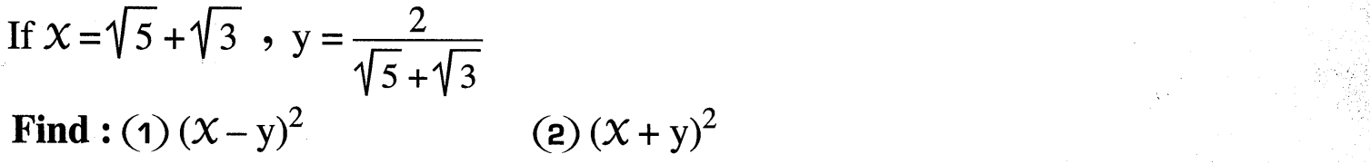2016 Exam ( 4 ) Question ( 4 ) ( a )
5 | 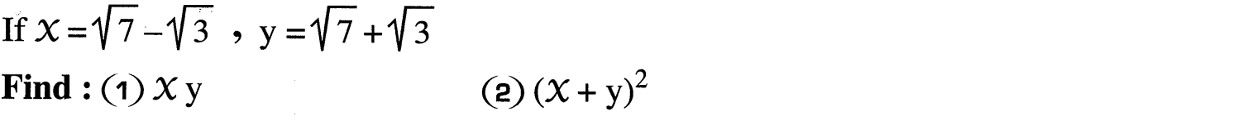2016 Exam ( 5 ) Question ( 3 ) ( a )
6 | 2016 Exam ( 7 ) Question ( 4 ) ( a )
7 | 2016 Exam ( 8 ) Question ( 4 ) ( a )
8 | 2016 Exam ( 9 ) Question ( 3 ) ( b )
9 | 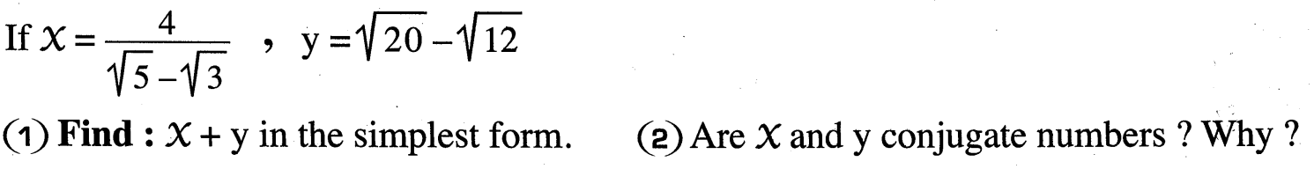2016 Exam ( 10 ) Question ( 4 ) ( b )
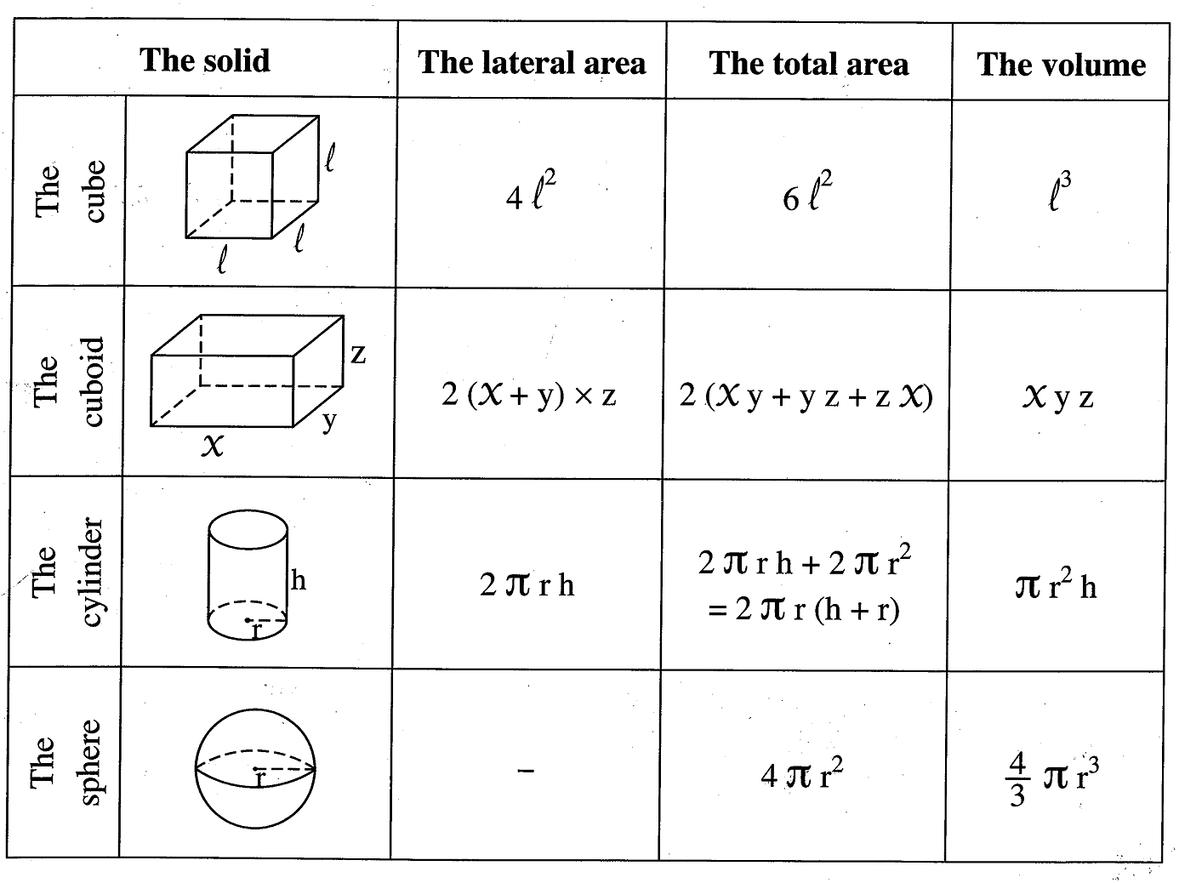
1 | 2016 Exam ( 7 ) Question ( 5 ) ( a )
2 | 2016 Exam ( 1 ) Question ( 4 ) ( b )
3 | 2016 Exam ( 2 ) Question ( 4 ) ( b )
4 | 2016 Exam ( 3 ) Question ( 4 ) ( b )
5 | 2016 Exam ( 4 ) Question ( 4 ) ( b )
6 | 2016 Exam ( 6 ) Question ( 4 ) ( b )
7 | 2016 Exam ( 8 ) Question ( 4 ) ( b )
8 | 2016 Exam ( 9 ) Question ( 5 ) ( a )
9 | 2016 Exam ( 10 ) Question ( 5 ) ( a )
10 | 2016 Exam ( 12 ) Question ( 4 ) ( b )
11 | 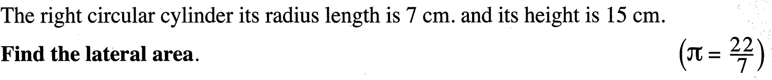2016 Exam (15) Question ( 4 ) ( a )

Geometery
1 | `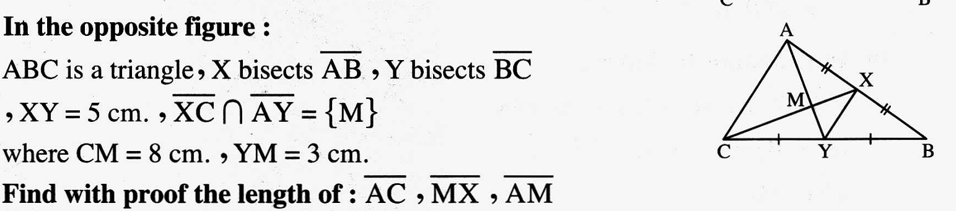2014 Exam (13) Question ( 4 ) ( a )
2 | 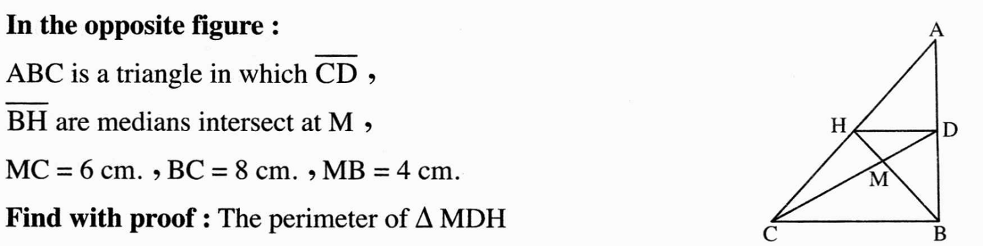  2012 Exam (18 ) Question ( 3 ) ( a )
3 | 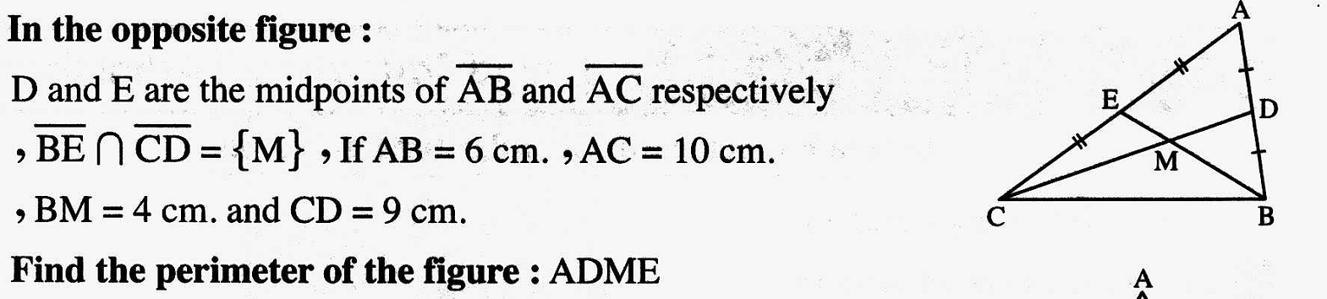2014 Exam (14) Question ( 4 ) ( b )
4 | 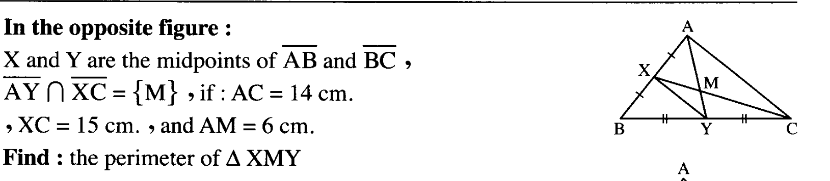  2015 Exam ( 2 ) Question ( 3 ) ( a )
5 | 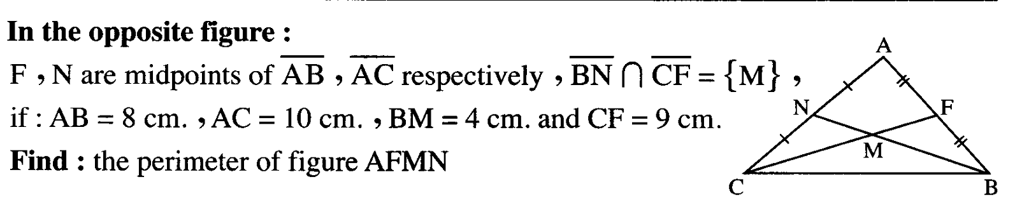  2015 Exam ( 6 ) Question ( 3 ) ( a )
6 | 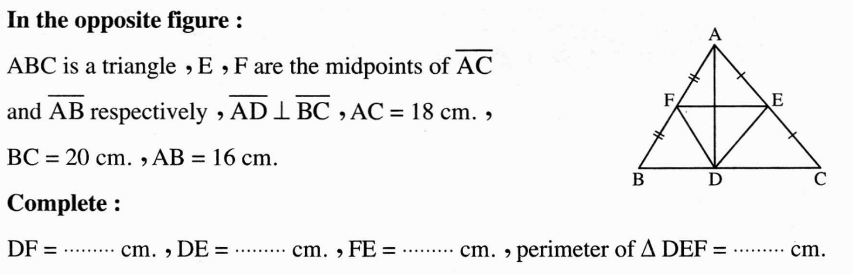  2012 Exam (17) Question ( 4 ) ( a )

1 | 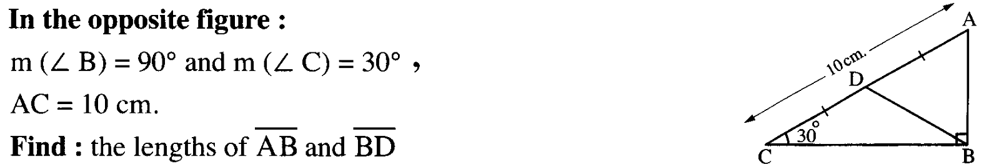  2015 Exam ( 12 ) Question ( 3 ) ( b )
2 | 2014 Exam ( 3 ) Question ( 4 ) ( a )
3 | 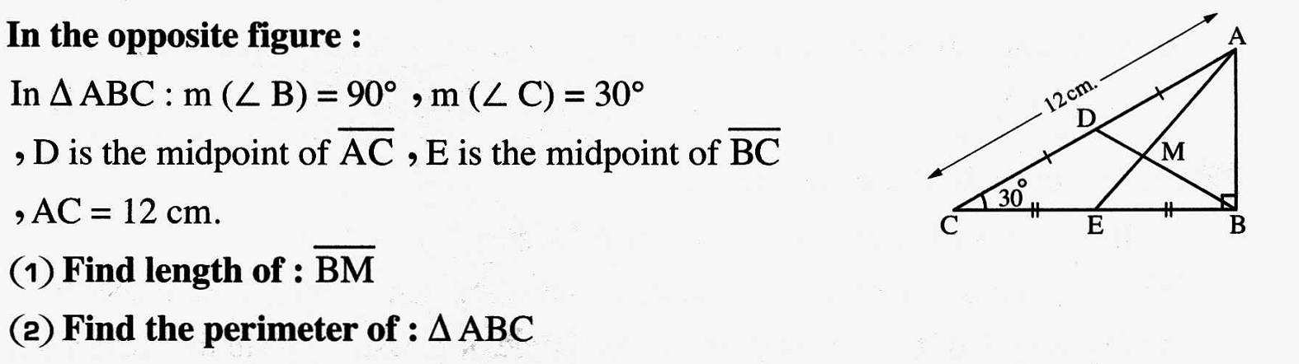2014 Exam ( 12 ) Question ( 5 ) ( a )
4 | 2015 Exam ( 6 ) Question ( 4 ) ( a )
5 | 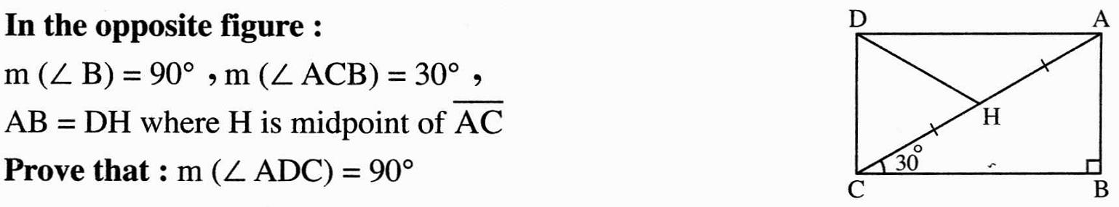  2012 Exam (18) Question ( 5 ) ( a)
6 | 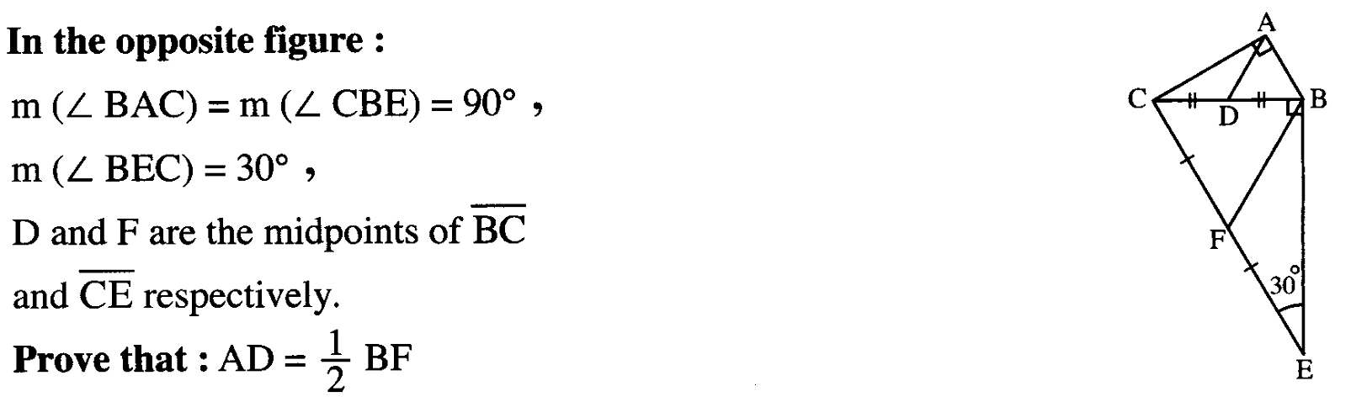  2015 Exam (15) Question ( 4 ) ( a )

1 | 2014 Exam ( 4 ) Question ( 5 ) ( b )
2 | 2012 Exam ( 10 ) Question ( 4 ) ( a )
3 | 2012 Exam ( 4 ) Question ( 4 ) ( b )
4 | 2014 Exam (15) Question ( 3 ) ( b )
5 | 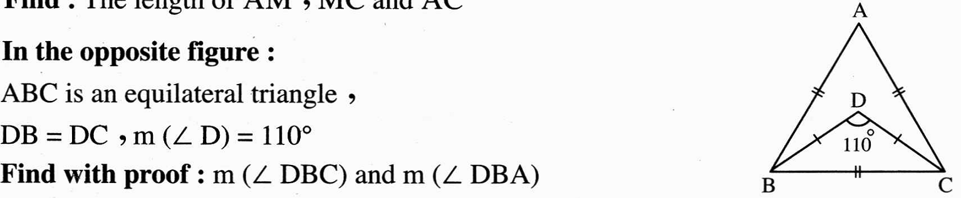  2012 Exam ( 3 ) Question ( 3 ) ( b )
6 | 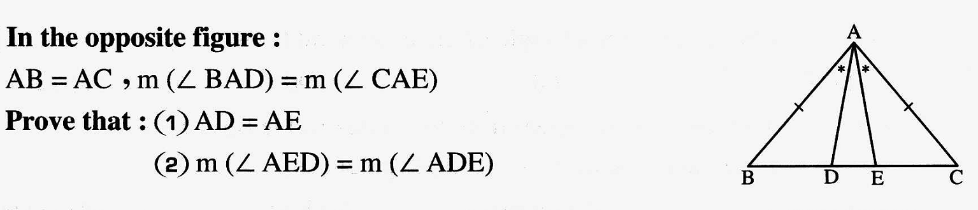2014 Exam ( 12 ) Question ( 3 ) ( b )
7 | 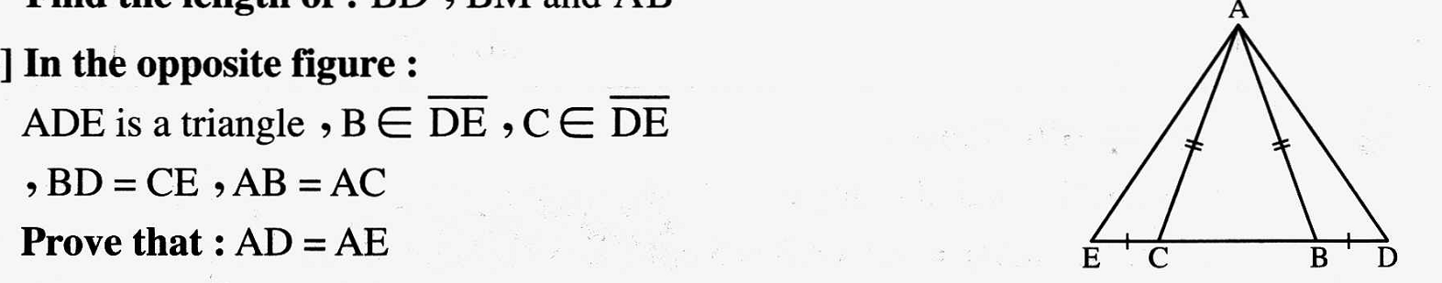2014 Exam ( 9 ) Question ( 3 ) ( b )
8 | 2012 Exam ( 7 ) Question ( 4 ) ( a )

