Mid - year revision
1st primary Lang.

Unit 1
Put (√) or (x)

1.My mother is kind. ( √ )

2.My father is tall. ( √ )

3.My sister is funny. ( √ )

4.Grandma and grandpa are kind. ( √ )

5.An elephant is small. ( × )

6.The mouse is big. ( × )

7.My brother is ten. He is big. ( √ )

8.My mother is helpful. ( × )

9.My baby brother is little. ( √ )

10.Ben's mother is Ahmed. ( × )

2) Re-arrange:

- my – This – family – is.
This is my family.

- is – helpful – mother – My.
My mother is helpful.

3- are – These – friends – my.

These are my friends.

4-is – This – my - grandfather.

This is my grandfather.

5- brother- is – My – big.

My brother is big.

6-my – is - sister – She .

She is my sister.

3) Supply the missing letter:
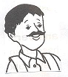 |  | 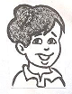 | 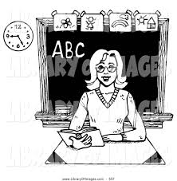 | 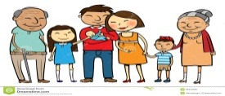
Father | Mother | Brother | Teacher | Family

4)Choose:
1- Sam is my ( brother – grandpa ) , He 's eight .

2- Nina is my ( brother – sister ) .

3- My mother is [ helpful – big ], she helps me .

4- A baby is ( big – little ) .

5- This ( is – am ) my family.

6- The giraffe is [ kind – tall ].

7-Dad, mum, and sister are my (family- friends).

8-My grandfather is [ red – kind ].

9-Tim sits beside me in the class. He is my (teacher- friend).

10- The (cat-lion) is a pet.

5)Look and write a sentence:
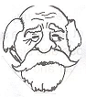
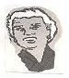
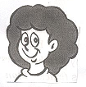

This is my sister. she is funny

This is my grandmother. She is kind.

This is my grandfather. He is kind.

This is my brother. He is big.

This is my father. He is tall.

Unit 2
1)Put (√) or (x):
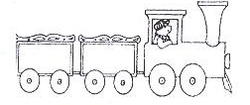

1- These are books. ( × )
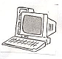

2-This is a lamp. ( × )
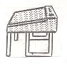

3-This is a desk. (√ )

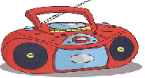
4- This is my radio. ( √ )

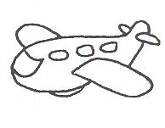
5- This is my toy box. (×)

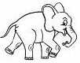
6-This is an elephant. (√)
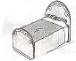

7-This is my bed. (√)

8-This is a chair. (×)

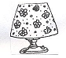
9-This is my lamp. (√)

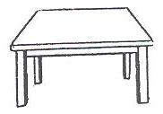
10-This is a table. (√)

2)Re-arrange:
- is - my – This- desk.

This is my desk.

- a – lamp - is –This .

This is a lamp.
- This- a- radio- is.

This is a radio.

4-play – on – I – the – computer.

I play on the computer.

5-is – my – bedroom – new – This.
This is my new bedroom.
6-These – my – books – are .
These are my books.
7-listen – to – We – the – radio.

We listen to the radio.
8-sleep – on – bed – a – We.

I sleep on a bed.

3)Supply the missing letters:

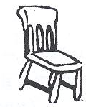 |  | 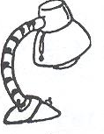 |  | 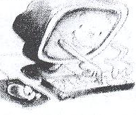
chair | Plane | Lamp | Table | Computer | Radio
4)Choose:

- I have a ( radio – computer) to play games.

- I like to listen to the ( lamp – radio).

- They put the dolls in the ( table – toy box).

- The books are on the ( bin – desk).

- We sit on the ( chair – table ).

- I have a ( lion – lamp) in my room.

- We sleep in a ( bed – table).

- The plane is ( big – little ) .

- The(dog-elephant)is very big.

10.The ant is (big – little).

5)Look and write a sentence:

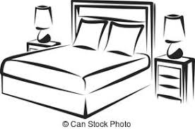
This is a bed.

This is a ball.
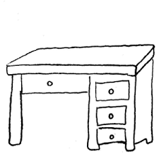
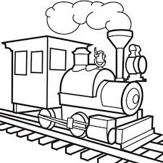
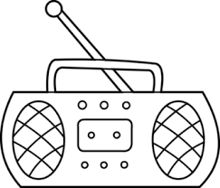
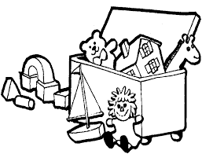

This is a toy box.

This is a plane.

This is a radio.

This is a train.

This is a desk.

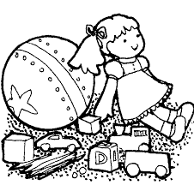

These are toys.
Unit 3
1)Put (√)or(x):
- I can see a star . (√ )
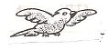
2.I can see a parrot . (√ )
3. I can see an owl . (√ )
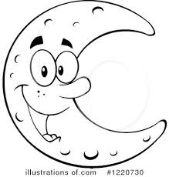
4.I can see a snake. (× )
5.I can see the moon . (√ )
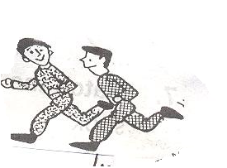
6.I can write. (√ )
7-They can run. (√ )
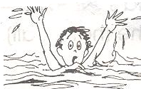
8.He can swim. (× )
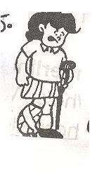
9.She can walk. (× )

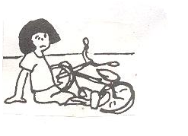
10.I can't ride. ( √ )

2)Re-arrange:
- can – I – the – see – moon .

I can see the moon.
- hear – Can – you – the – owl?

Can you hear the owl?

- He – see – the – can’t – stars .

He can’t see the stars .

- hear – can – I – plane – a .
I can hear a plane.

- can’t – tree – I – hear .
I can’t hear a tree.

- owl –The – see – can - me .

The owl can see me.
- I – see – can – the – moon .

- tree – can't – The – me – see .

The tree can't see me.

3)Supply the missing letters:

 |  | 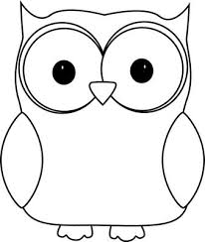 | 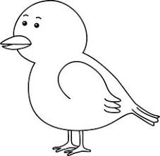
Moon | Sun | owl | Bird | Star

4)Choose:
- There is a (star – tree ) in the sky.

- How old ( am – are) you? I ( are – am ) seven.

- We can hear the ( owl – sun).

- We see the sun in the ( day – night).

- We see the ( sun – stars) in the night.

- Can you see the moon ? Yes, I ( can – can’t).

- We swim in the ( sea – see).

- The clown has got a ( wig – dig) on his head.

- The elephant is ( wig – big).

10.I put the ( bin – wig ) on my head.
5)Look and write a sentence:

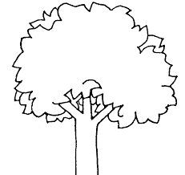

This is a tree.

This is a bird.

This is an owl.

This is the sun.

This is the moon.

Unit 4

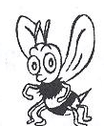
1) Put () or ():
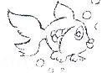
- It is a butterfly. ( × )
- It is a fish. ( √ )
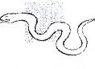
- It is a frog. ( × )
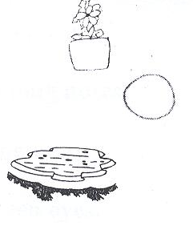
- It is a flower. ( √ )
- It is an orange. ( √ )
- It is a pond. ( √ )

2)Supply the missing letters:

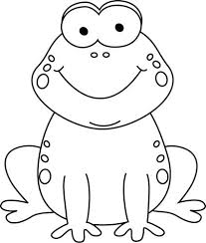 | 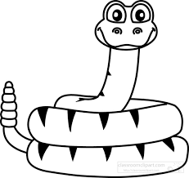 | 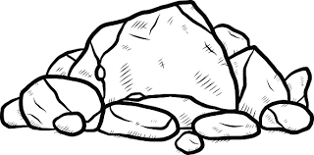
frog | snak e | rock | butterfly | flower

3) Re-arrange:

1.long – snake – is – The .
The snake is long.

2.butterfly – is – beautiful – The .
The butterfly is beautiful.

3.are – black – Beetles.
Beetles are black.

4.grass – Snakes – are – in – the.
Snakes are in the grass.
5.wall – flowers- The – are – on – the .
The flowers are on the wall.

6.in – the – pond- The -Fish- is.
The fish is in the pond.

4)Choose:

- The beetle is ( black – white).

- The apples are on the ( train – tree).

- The flowers are on the ( wall – table ).

- The eggs are in the ( nest – hat).

- The ( fly – butterfly ) is beautiful.

- The fish is in the ( pin – pond).

- The ( fish – frog) is on the rock.

- Flowers and trees are in the ( garden – green)

- ( How – What) are these ? They’re eggs.

10.What ( is – are) this ? It is a nest.

11.What ( is – are) these? They are apples.

12.Sam can ( run – bun ) in the sun.

13.Sam has got a ( sun – mug).

5)Look and write a sentence:
This is a butterfly

This is a snake.

This is a flower.

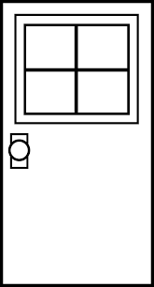

This is a door.

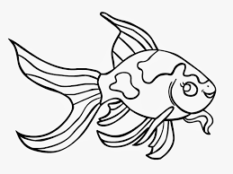
This is a fish.

Grammar
Choose:

1. ( He – She – It ) is my father .
2.( He – She – It ) is my sister .
3. ( He – She – It ) is a ball .
4. ( He – It - They ) are blue.
5.It [ am – is ] a rabbit.
6.Sama [ is – are ] a doctor.
7.I [ are – am ] a farmer.
8.You [ is – are ] a bus driver.
9.He [ am – is ] in primary one.
10.They [ is – are ] boys.
11. (Are- Is ) he happy?
12.(Are – Is ) they sad?
13.We (isn't – aren't) brothers.
14.She (isn't – aren't) my friend.
15.Is she cold? Yes, she (is – isn't).
16. Are they hot?No, they (are – aren't).
17.Are we friends? Yes, we (are – aren't).
18.Is it a dog? No, it ( is- isn't).
19.( This – These) is my desk.

20.( This – These) are my books.

21.( This – These) is my computer.

22.( This – These) are my chairs.

23.This is my ( bed – beds).

24.These are my ( lamp – toys).

25.This ( is – are ) a train.

26.These are ( doll – dolls).

27.This is a ( car – cars).

28.These ( is –are) desks.

29. Can a tree see? No , it ( can – can’t).

30. Can a star hear? No, ( it can – it can’t).

31. Can a dog see? Yes, ( it can - it can’t).

32.It is (a – an) owl.

33. She is (a – an ) teacher.

34.He is (a – an ) boy.

35.It is (a – an) umbrella.

36.The frog (can – can't) fly.

37. The fish (can – can't) swim.

38.The monkey (can – can't) jump.

39.The lion (can – can't)climb a tree.

40.The bird (can – can't) fly.

41. The pencils are (in – on) the pencil case.

42. I can see the stars (in – under) the sky.

43.I sleep (under – on) the bed.

44. I sit ( on – next to ) my friend.

45.The lamp is (in – on ) the table.

Look and write a sentence:

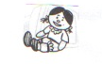
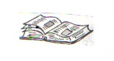

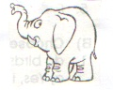
This is a doll. This is a book.
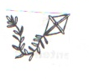

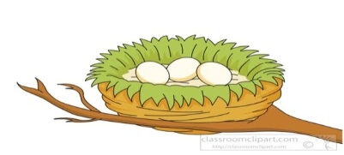
This is a kite. This is an elephant.

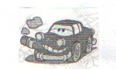

This is a tree. This is a car.

These are dogs. These are bags.

These are flowers. This is a nest.

Story
(The ant and the Cricket)
Complete:
1-It's summer time.The sun is …………………
2-The sky is ………………………………
3-Here's a Cricket in the ………………..……..
4-He…………….... and………………..and plays.
5-There is an ………….…. She is very small.
6-She's finding……………..….. to eat.
7-Mrs ant, please…………….. now.
8-……………….……. is coming soon.
9-You must find food, or you'll be………………
10-Now let's sing a ……………………...
11-The cricket must …………………. food.
12-The wind is ………………………
13-The rain is…………………….…..
14-The ant is in her home.She's……………... and happy.
15-It's cold with………………..……..
16- The cricket is …………………….…

17- The cricket has no ……….... or ……………..
18- The Cricket will work hard next ……………

Answer key

1.hot
2.blue
3.field
4.sings, jumps
5.ant
6.food
7.stop
8.Winter
9.hungry
10.song
11.find
12.cold
13.wet
14.warm
15.snow
16.hungry
17.lunch - sweet
18.summer
Please study from your booklets, books and copybooks

