1st Primary
Language Section
Revision
Please study from English booklet,grammar booklet,composition booklet,copybooks and books

- Put ( √ ) or (X):

- An elephant is small. ( )
- The sky is blue. ( )
- My mother is helpful. ( )
4.Grandpa and grandma are kind. ( )

5.The apple is black. ( )
6.The ant is big. ( )

7.Ben is ten. He is my dad. ( )

8.My sister is kind. ( )
9.The sun is big. ( )
10.The clown is funny. ( )
11.My sister is kind. ( )
12.The mouse is big. ( )
13. The egg is white. ( )
14. The nut is little. ( )
15. The giraffe is tall. ( )
16. My brother is ten, he is big. ( )
- Rearrange:
- is – This – my – mother.

………………………………………………………………………………
- are – These – friends – my.

………………………………………………………………………………
3. brother-is –My- tall.

………………………………………………………………………………
- is – This – my - grand father.

……………………………………………………………………………..
5- is – This – father – my.

……………………………………………………………………………..
6-family – is – This – my.

……………………………………………………………..................
7. mother – is –My– helpful.

...................................................................................
8.grandma – My - is – kind.

…………………………………………………………………………………

*Supply the missing letters:

 | 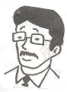 | 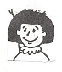
mo_ her | fa_ _er | _ i_ter
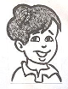 | 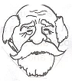 | 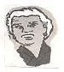
br_th_r | gr_nd fa_ _er | gr_nd mo_ _er
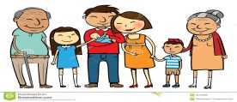 | 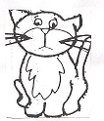 | 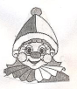
f_mi_y | p_ _ | fu_ _y
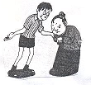 | 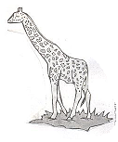 | 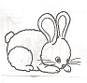
h_ _p_ul | ta_ _ | li _ _le

*Choose:

- My dad is (tall – little).

- My baby brother is (little – big).
- I (am – are) six.
- My mother is (baby – helpful).

- They (am – are) students.
- (She-He) is my mother.
- He (am – is – are) a good boy.
- She (am-is) happy.
- Sam is my (friend-grandpa), he is eight.
- My (dad-sister) is funny.
- (He - It ) is an elephant.
- (She – He) is my father.
- My grandfather is [ red – kind ].

- My mother is [ helpful – big ], she helps me .
- The (cat-lion) is a pet.
Grammar
Put in : [ He – She – It – they -we]
1- The door is shut . _ _ _ _ _ _ _ _ _ is not open .
2- The boy is sitting . _ _ _ _ _ _ _ _ _ is not standing .
3- Mum is in the Kitchen . _ _ _ _ _ _ _ _ _ is not in
the bedroom
4- The girls are happy . _ _ _ _ _ _ _ _ are not sad .
5- The babies are in bed . _ _ _ _ _ _ _ _ _ _ are sleeping .
6- Rana is my friend . _ _ _ _ _ _ _ _ _ _ _ is six .
7- Amr is my brother . _ _ _ _ _ _ _ _ _ _ is little .
8- Salma and I is nice._ _ _ _ _ _ _ is seven years old .
9- This is a mouse . _ _ _ _ _ _ _ _ _ _ _ is little .
10- These are elephants . _ _ _ _ _ _ _ _ _ are
big and grey .

Choose :
1- This is Amr . [ He – She – It ] is my father .
2- This is Mona . [ He – She – It ] is my sister .
3- What's this ? [ He – She – It ] is a ball .
4- [ He – She – It ] is a nice dog .
5- The pencils are in the bag . [ We – He – They ] are
the pencils.
Complete the sentence with (am / is /are) :
1- She _ _ _ _ _ _ _ _ Wendy .
2- We _ _ _ _ _ _ _ _ fat .
3- Ramy _ _ _ _ _ _ _ tall .
4- I _ _ _ _ _ _ _ _ _ seven .
5- The girls _ _ _ _ _ _ _ _ young .
6- Hala and I _ _ _ _ _ _ _ _ thin .
7- You _ _ _ _ _ _ _ _ a good boy .
8- They _ _ _ _ _ _ _ _ _ twins .
9- Ahmed _ _ _ _ _ _ _ _ my father .
10- He_ _ _ _ _ _ _ _ _ a boy .

Choose:
- It [ am – is ] a rabbit.
- Sama [ is – are ] a doctor.
- I [ are – am ] a farmer.
- Samy [ is – are ] a bus driver.
- It [ are – is ] a kite.
- He [ am – is ] in primary one.
- It [ is – are ] a flask.
- You [ are – am ] a pupil.
- They [ is – are ] boys.
- Hany [ are – is ] happy.
Composition
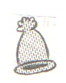
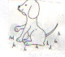

1. ……………………… . 2. ……………………………….
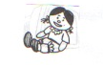
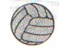

3. ……………………… . 4. ………………………………….
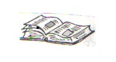
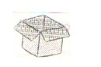

5. ………………………… . 6. …………………………………….. .
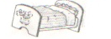

7. ……………………………… . 8. ………………………………. .

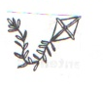

9. ………………………………… . 10……………………………………….
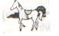
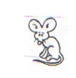

11. ………………………………… . 12………………………………….

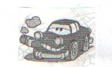

13. ……………………………….. . 14. …………………………….. .
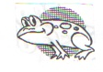

15. ……………………………….
Story

Complete:
1-It's summer time, The sun is ………………………
2-The sky is ………………………..
3-Here's a……………………. in the …………………..
4-He…………………. and …………….……..and plays.
5-There is an ……………. She is very…………...……
6-She's finding………………………. to eat.
7-Mrs ant, please………………….now.
8-Don't…………………… food today.
9- He sings a …………………….. all day long.
10- She's finding food to …………………..
Choose
1-It's (summer - winter – autumn) the sun is hot.
2- The sky is (red - yellow – blue).
3- Here's a (frog – cricket - crocodile) in the field.
4- There's an ant. She's very (small - big).
5- She works all (winter- summer).
6- The summer is (long- short).

Answer key
Complete:
- hot
- blue
- Cricket – field
- Sings – jumps
- ant – small
- food
- stop
- find
- song
- eat
Choose
- summer
- blue
- cricket
- small
- summer
- long

