Arabic section
Midyear Revision
First primary
FIRST term
O.L.
(2017 – 2018)

Name:…………..
Class:…………

Revision sheet O.L
Test one
1- Point and Identify the object
 |  | 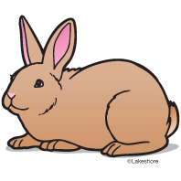 | 1- dog
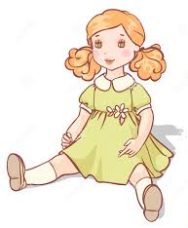 |  |  | 2-boy
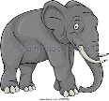 |  |  | 3-elephant

2- Listen and answer yes or No
1- Is this a house? 2- IS it a bird? 3- IS it a bus?

( ) yes ( ) No ( ) Yes ( ) No ( ) Yes ( ) No
3-Match:
1- girl. 2- ant . 3- jacket .

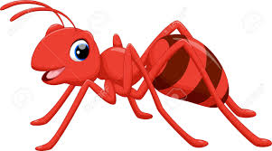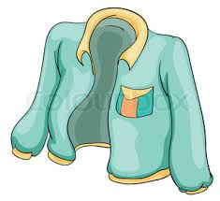

4- Count:
1 2 3 ……… 5 6 ……… 8 9 ………

5-Point to the odd letter
1- P T r
2- m e H
3-Q T a

Test Two
1- Point and Identify the object
 |  |  | 1- ant
 |  | 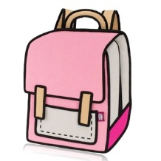 | 2-star
 |  |  | 3-walk

2- Listen and answer yes or No
1- IS he a boy? 2- Is it blue? 3- Can he wave?
( ) yes ( ) No ( ) Yes ( ) No ( ) Yes ( ) No
3-Match:
1- hen 2- doll 3- fan
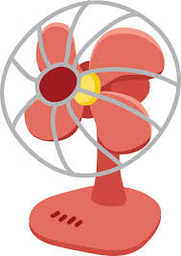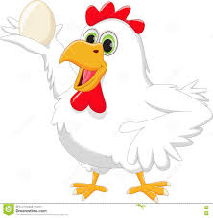

4- Count:
1 2 3 ……… 5 6 ……… 8 9 ………

5-Point to the odd letter
1- S V z
2- m T H
3-b p C

Test Three
1- Point and Identify the object
 |  |  | 1- ink
 |  | 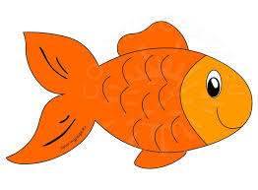 | 2-fish
 |  |  | 3-father

2- Listen and answer yes or No
1- Is he a boy? Is it a heart? 3- Are they five?
( ) yes ( ) No ( ) Yes ( ) No ( ) Yes ( ) No
3- Match:
1- mother 2- swim 3- bus

4- Count:
1 2 ………4 5 ………7………
9 ………

5- Point to the odd letter
1- S T w
2- u o R
3-E K g

Test Four
1- Point and Identify the object
 |  |  | 1- fan
 |  |  | 2-hen
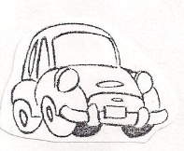 |  | 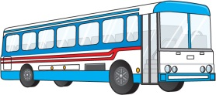 | 3-car

2- Listen and answer yes or No
1- Can she draw? 2-Can it fly? Is it a donkey?
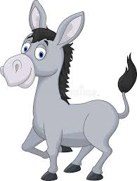
( ) yes ( ) No ( ) Yes ( ) No ( ) Yes ( ) No
3-Match:
1- garden 2- bird 3- brother

4- Count:
1 2 ………4 ……… ……… 7 ………… 9 10

5- Point to the odd letter

1- A g b
2- M t Z
3-T Y m

