Mid - year revision
1st primary Lang.

Unit 1
Put (√) or (x)

1.My mother is kind. ( )

2.My father is tall. ( )

3.My sister is funny. ( )

4.Grandma and grandpa are kind. ( )

5.An elephant is small. ( )

6.The mouse is big. ( )

7.My brother is ten. He is big. ( )

8.My mother is helpful. ( )

9.My baby brother is little. ( )

10.Ben's mother is Ahmed. ( )

2) Re-arrange:

- my – This – family – is.

- is – helpful – mother – My.

3- are – These – friends – my.

4-is – This – my - grand father.

5- brother- is – My – big.

6-My – is - sister – She .

3) Supply the missing letter:
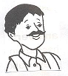 |  | 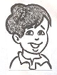 | 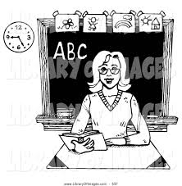 | 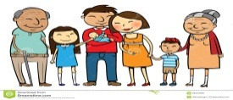
Fa _ _ er | M _ th _r | B_ o _ her | Tea _ her | Fa _ i _ly

4)Choose:
1- Sam is my ( brother – grandpa ) , He 's eight .

2- Nina is my ( brother – sister ) .

3- My mother is [ helpful – big ], she helps me .

4- A baby is ( big – little ) .

5- This ( is – am ) my family.

6- The giraffe is [ kind – tall ].

7-Dad, mum, and sister are my (family- friends).

8-My grandfather is [ red – kind ].

9-Tim sits beside me in the class. He is my (teacher- friend).

10- The (cat-lion) is a pet.

5)Look and write a sentence:
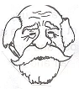
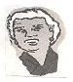
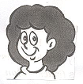

Unit 2
1)Put (√) or (x):
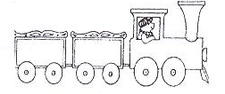

1- These are books. ( )
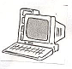

2-This is a lamp. ( )
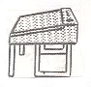

3-This is a desk. ( )
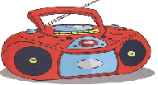

4- This is my radio. ( )

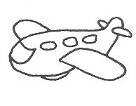
5- This is my toy box. ( )

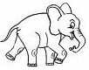
6-This is an elephant. ( )
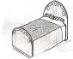

7-This is my bed. ( )

8-This is a chair. ( )

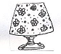
9-This is my lamp. ( )

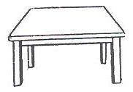
10-This is a table. ( )

2)Re-arrange:
- is - my – This- desk.

- a – lamp - is –This .

- This- a- radio- is.

4-play – on – I – the – computer.

5-is – my – bedroom – new – This.

6-These – my – books – are .

7-listen – to – We – the – radio.

8-sleep – on – bed – a – We.

3)Supply the missing letters:

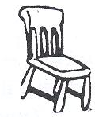 |  | 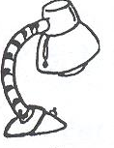 |  | 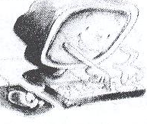
_ha _r | Pl _n _ | L _ _ p | Ta _ l _ | Co _ pu _ er | Rad _ _
4)Choose:

- I have a ( radio – computer) to play games.

- I like to listen to the ( lamp – radio).

- They put the dolls in the ( table – toy box).

- The books are on the ( bin – desk).

- We sit on the ( chair – table ).

- I have a ( lion – lamp) in my room.

- We sleep in a ( bed – table).

- The plane is ( big – little ) .

- The(dog-elephant)is very big.

10.The ant is (big – little).

5)Look and write a sentence:

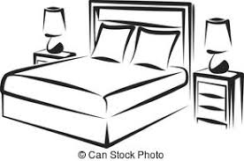

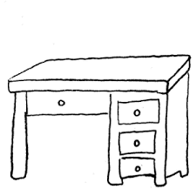
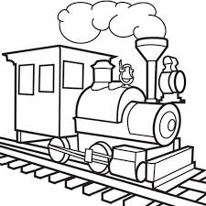
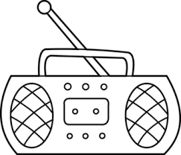
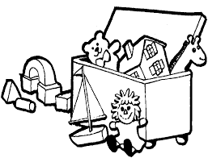

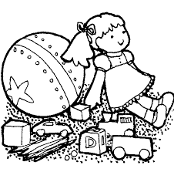

Unit 3
1)Put (√)or(x):
- I can see a star . ( )
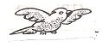
2.I can see a parrot . ( )
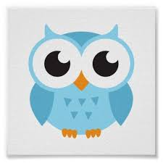
3. I can see an owl . ( )
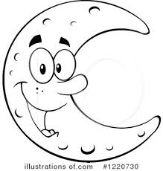
4.I can see a snake. ( )
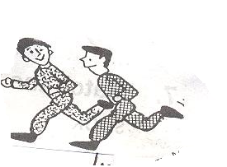
5.I can see the moon . ( )
6.I can write. ( )
7-They can run. ( )
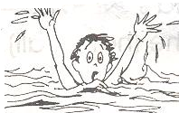
8.He can swim. ( )
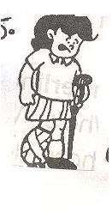
9.She can walk. ( )

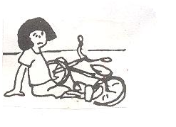
10.I can't ride. ( )

2)Re-arrange:
- can – I – the – see – moon .

- hear – Can – you – the – owl?

- He – see – the – can’t – stars .

- hear – can – I – plane – a .

- can’t – tree – I – hear .

- owl –The – see – can - me .

- I – see – can – the – moon .

- tree – can't – The – me – see .

3)Supply the missing letters:

 |  | 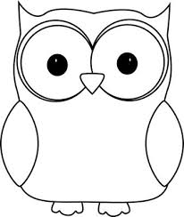 | 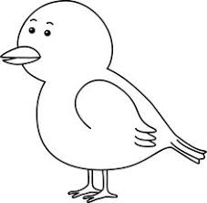
M _ _n | S _ _ | _ _ l | B _ r _ | St _ _

4)Choose:
- There is a (star – tree ) in the sky.

- How old ( am – are) you? I ( are – am ) seven.

- We can hear the ( owl – sun).

- We see the sun in the ( day – night).

- We see the ( sun – stars) in the night.

- Can you see the moon ? Yes, I ( can – can’t).

- We swim in the ( sea – see).

- The clown has got a ( wig – dig) on his head.

- The elephant is ( wig – big).

10.I put the ( bin – wig ) on my head.
5)Look and write a sentence:

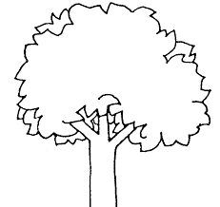

Unit 4

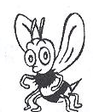
1) Put () or ():
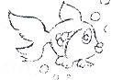
- It is a butterfly. ( )
- It is a fish. ( )
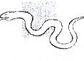
- It is a frog. ( )
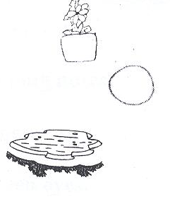
- It is a flower. ( )
- It is an orange. ( )
- It is a pond. ( )

2)Supply the missing letters:

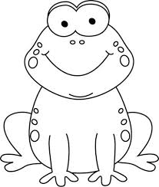 | 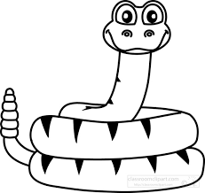 | 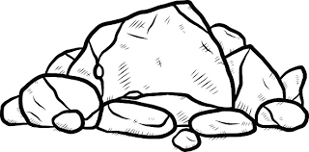
f _ _ g | s _ a _ e | r _ c _ | bu _ _erfly | fl _w _r

3) Re-arrange:

1.long – snake – is – The .

2.butterfly – is – beautiful – The .

3.are – black – Beetles.

4.grass – Snakes – are – in – the.

5.wall – flowers- The – are – on – the .

6.in – the – pond- The -Fish- is.

4)Choose:

- The beetle is ( black – white).

- The apples are on the ( train – tree).

- The flowers are on the ( wall – table ).

- The eggs are in the ( nest – hat).

- The ( fly – butterfly ) is beautiful.

- The fish is in the ( pin – pond).

- The ( fish – frog) is on the rock.

- Flowers and trees are in the ( garden – green)

- ( How – What) are these ? They’re eggs.

10.What ( is – are) this ? It is a nest.

11.What ( is – are) these? They are apples.

12.Sam can ( run – bun ) in the sun.

13.Sam has got a ( sun – mug).

5)Look and write a sentence:

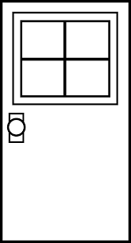
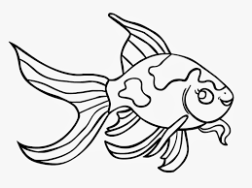

Grammar
Choose:

1. ( He – She – It ) is my father .
2.( He – She – It ) is my sister .
3. ( He – She – It ) is a ball .
4. ( He – It - They ) are blue.
5.It [ am – is ] a rabbit.
6.Sama [ is – are ] a doctor.
7.I [ are – am ] a farmer.
8.You [ is – are ] a bus driver.
9.He [ am – is ] in primary one.
10.They [ is – are ] boys.
11. (Are- Is ) he happy?
12.(Are – Is ) they sad?
13.We (isn't – aren't) brothers.
14.She (isn't – aren't) my friend.
15.Is she cold? Yes, she (is – isn't).
16. Are they hot?No, they (are – aren't).
17.Are we friends? Yes, we (are – aren't).
18.Is it a dog? No, it ( is- isn't).
19.( This – These) is my desk.

20.( This – These) are my books.

21.( This – These) is my computer.

22.( This – These) are my chairs.

23.This is my ( bed – beds).

24.These are my ( lamp – toys).

25.This ( is – are ) a train.

26.These are ( doll – dolls).

27.This is a ( car – cars).

28.These ( is –are) desks.

29. Can a tree see? No , it ( can – can’t).

30. Can a star hear? No, ( it can – it can’t).

31. Can a dog see? Yes, ( it can - it can’t).

32.It is (a – an) owl.

33. She is (a – an ) teacher.

34.He is (a – an ) boy.

35.It is (a – an) umbrella.

36.The frog (can – can't) fly.

37. The fish (can – can't) swim.

38.The monkey (can – can't) jump.

39.The lion (can – can't)climb a tree.

40.The bird (can – can't) fly.

41. The pencils are (in – on) the pencil case.

42. I can see the stars (in – under) the sky.

43.I sleep (under – on) the bed.

44. I sit ( on – next to ) my friend.

45.The lamp is (in – on ) the table.

Look and write a sentence:

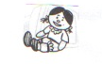
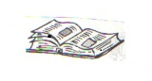

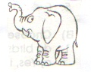
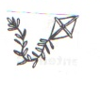

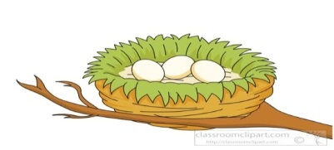
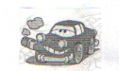

Story
(The ant and the Cricket)
Complete:
1-It's summer time.The sun is …………………
2-The sky is ………………………………
3-Here's a Cricket in the ………………..……..
4-He…………….... and………………..and plays.
5-There is an ………….…. She is very small.
6-She's finding……………..….. to eat.
7-Mrs ant, please…………….. now.
8-……………….……. is coming soon.
9-You must find food, or you'll be………………
10-Now let's sing a ……………………...
11-The cricket must …………………. food.
12-The wind is ………………………
13-The rain is…………………….…..
14-The ant is in her home.She's……………... and happy.
15-It's cold with………………..……..
16- The cricket is …………………….…

17- The cricket has no ……….... or ……………..
18- The Cricket will work hard next ……………

Answer key

1.hot
2.blue
3.field
4.sings, jumps
5.ant
6.food
7.stop
8.Winter
9.hungry
10.song
11.find
12.cold
13.wet
14.warm
15.snow
16.hungry
17.lunch - sweet
18.summer
Please study from your booklets, books and copybooks

