1
2 | 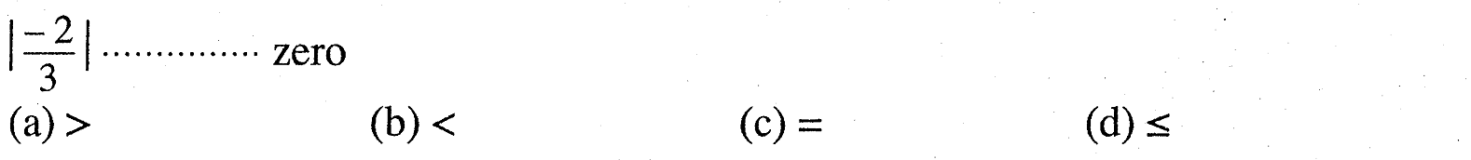
3
4
5
6 | 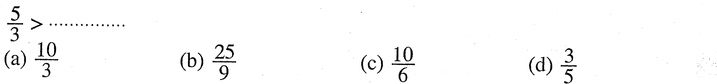
7 | 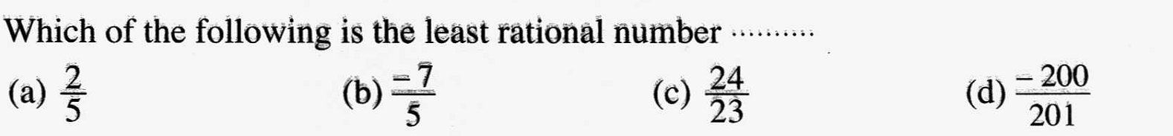
8 | 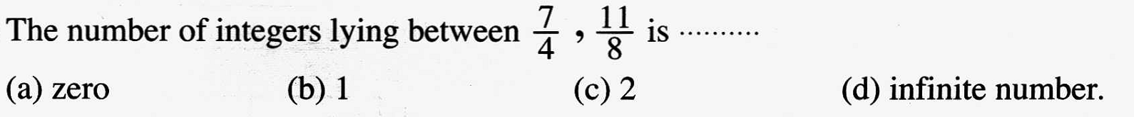
9
10 | 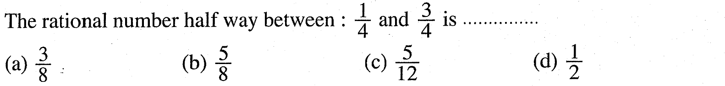
11 | 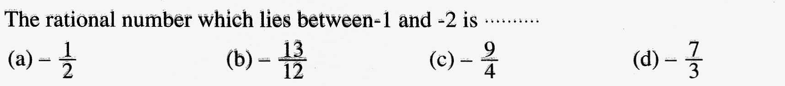
12 | 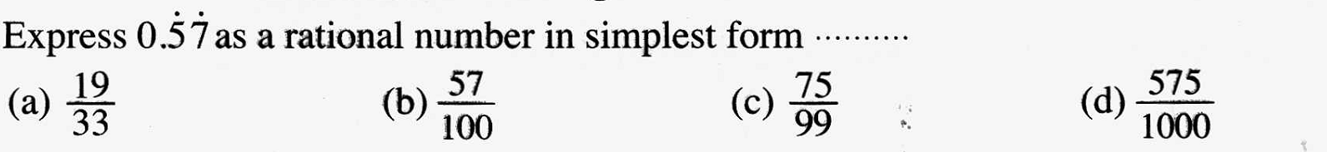
13 | 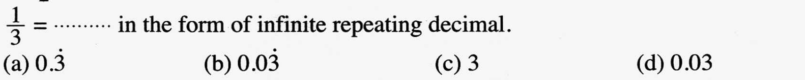
14
15 | 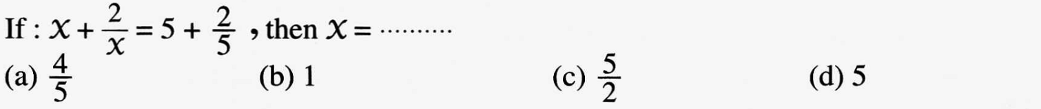
16 | 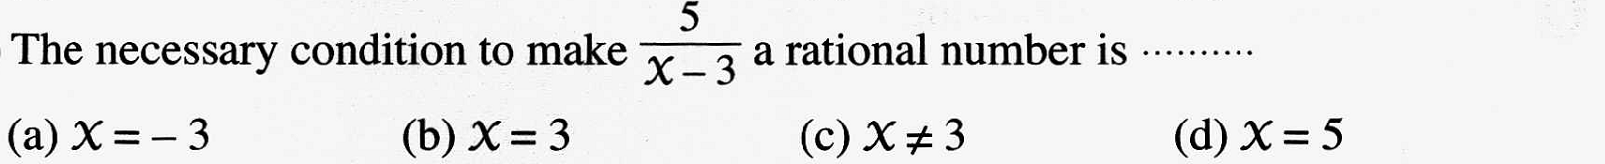
17
18
19
20 | 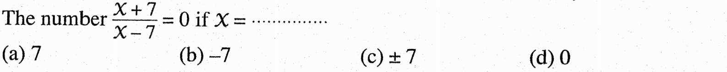
21
23
24
25
26
27
28
29
30
31
32
33
34
35
36
37
38

1
2
3
4
5
6
7
8
9
10
11
12
13
14
15
16
17
18
19
20
21
22
23
24
25
26
27
28
29
30
31
32
33
34
35
36
37
38
39
40
41
42
43
44
45
46
47
48
49

1
2
3
4
5
6
7
8
9
10
11
12 | 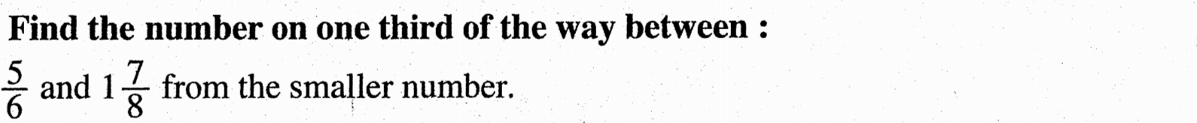

1 | 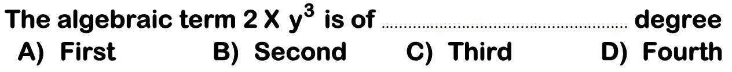
2
3
4
5
6
7
8
9
10
11
12
13
14
15
16
17
18
19
20 | 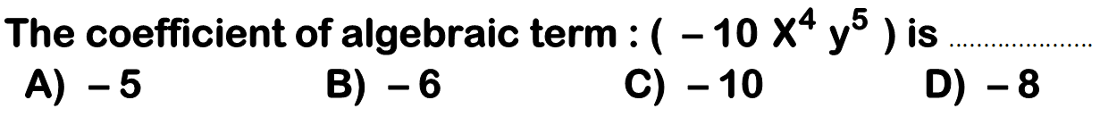
21
22
23
24
25
26
1
2
3
4
5
6
7
8
9
10
11
12
13
14
15
16
17
18
19
20
21
22
23
24
25
26
27
28
29
30
31
32

1
2
3
4
5
6
7
8
9
10
11
12
13
14
15
Geometery
10 | 2014 Exam (15) Question ( 4 ) ( b )
11 | 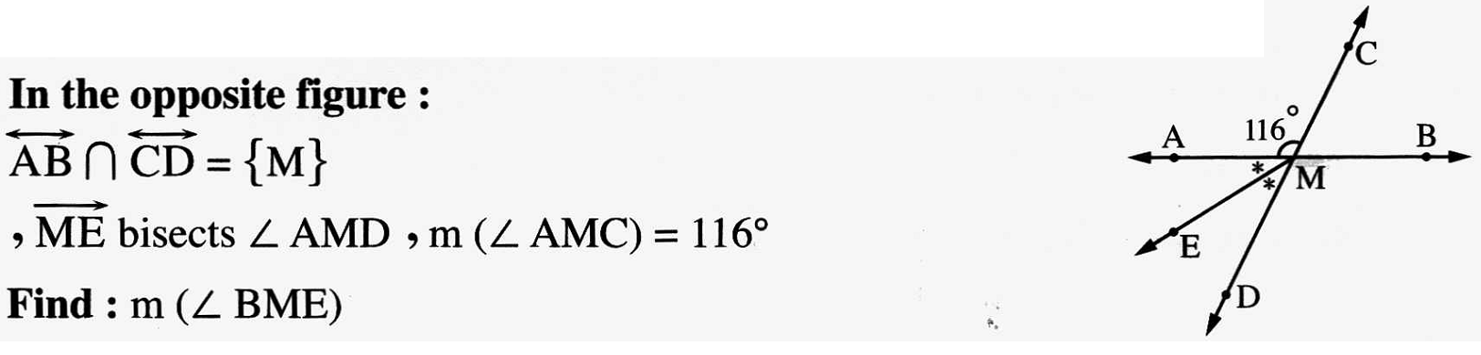2014 Exam ( 12 ) Question ( 3 ) ( b )
1
2 | 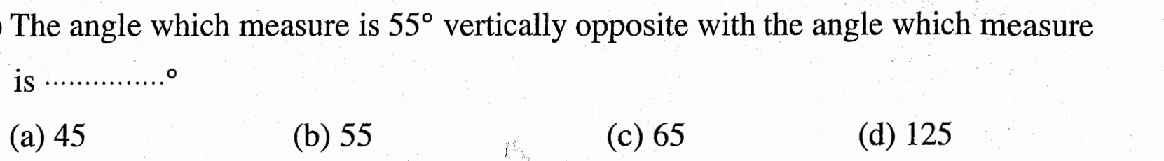
3 | 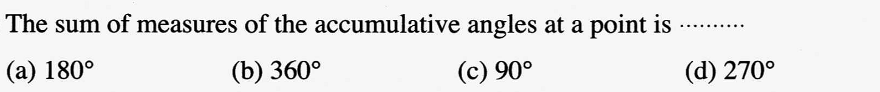
4
5 | 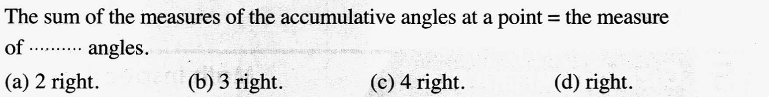
6 | 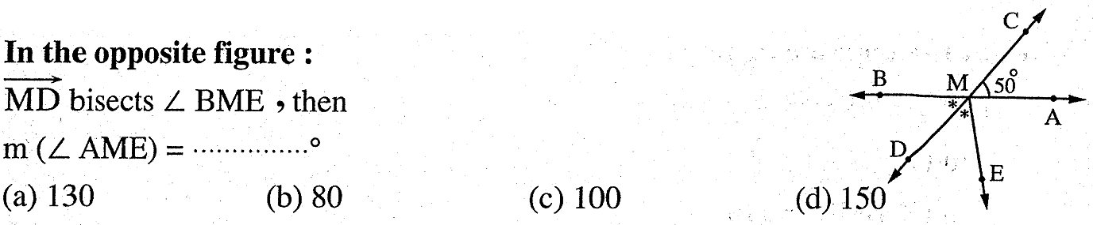
7
8
9 | 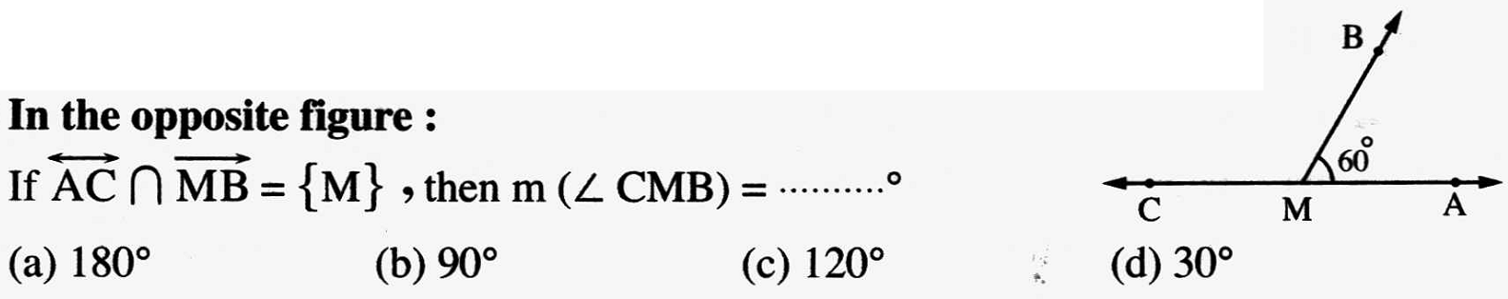
10
11 | 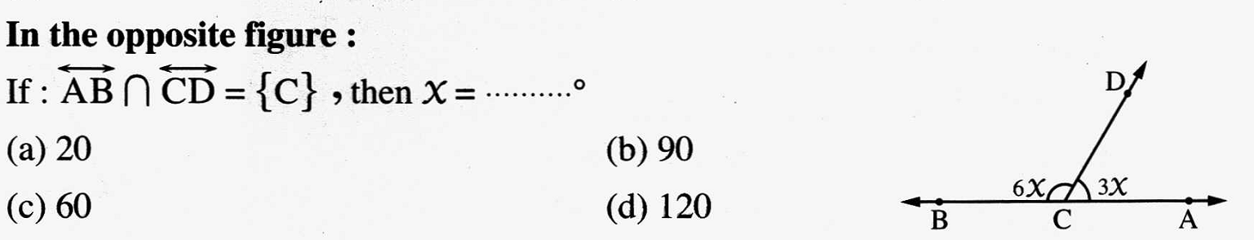
12
13 | 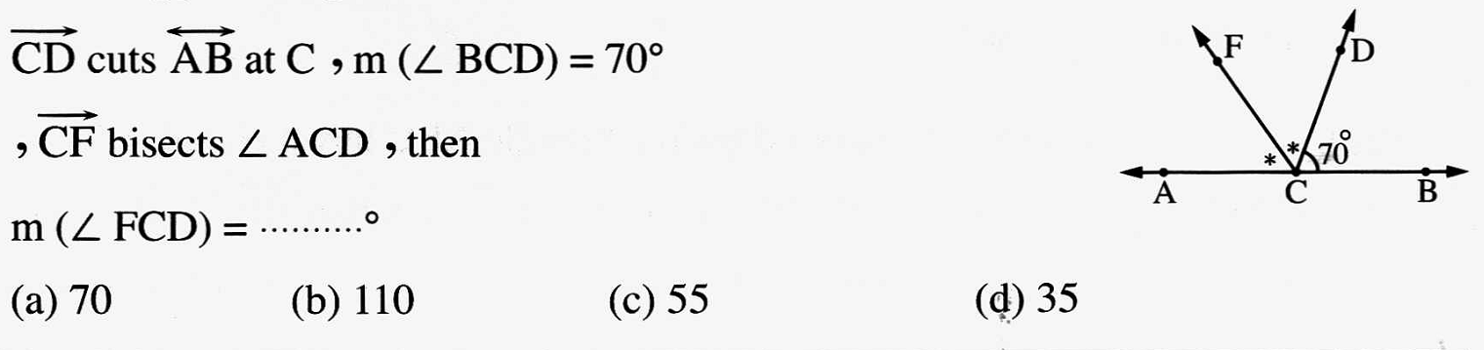
14 | 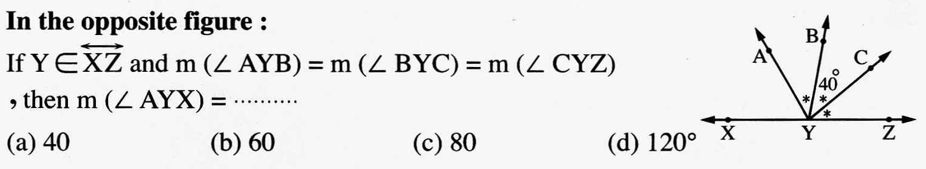
15 | 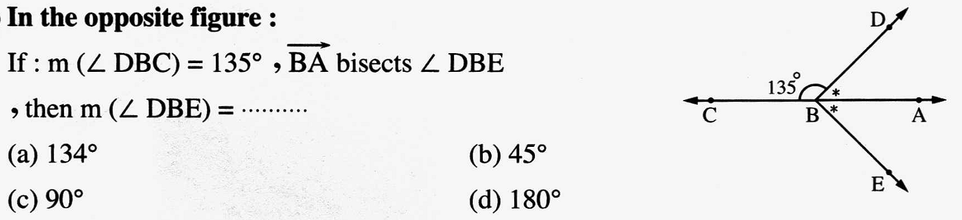
1 | 2014 Exam ( 7 ) Question ( 3 ) ( b )
2 | 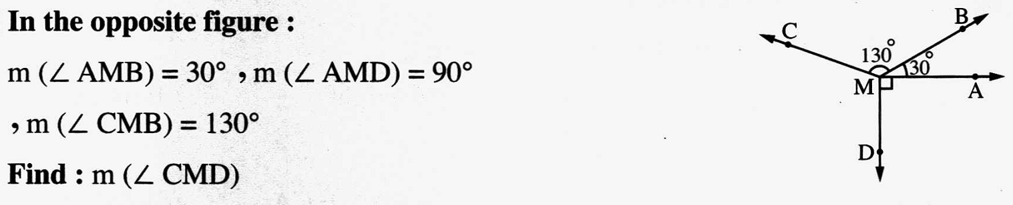2014 Exam (15) Question ( 4 ) ( a )
3 | 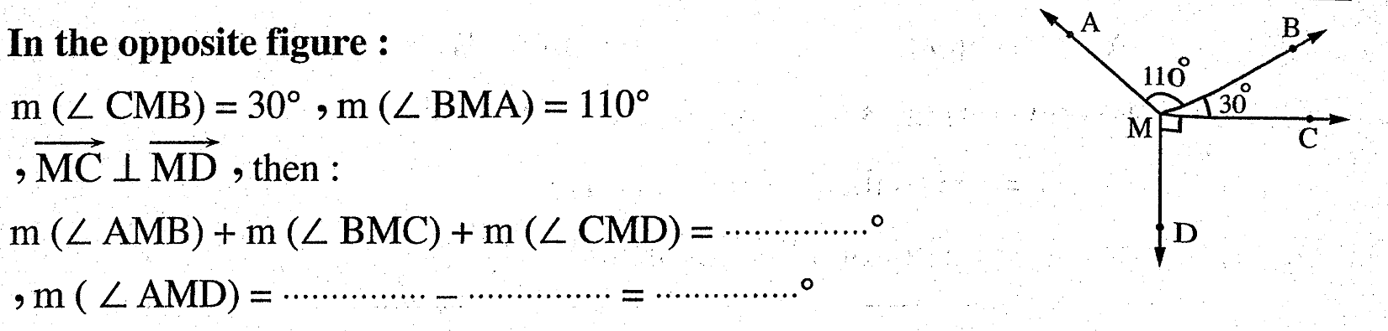2015 Exam ( 7 ) Question ( 5 ) ( a )
4 | 2013 Exam ( 4 ) Question ( 5 ) ( b )
5 | 2015 Exam (14) Question ( 3 ) ( b )
6 | 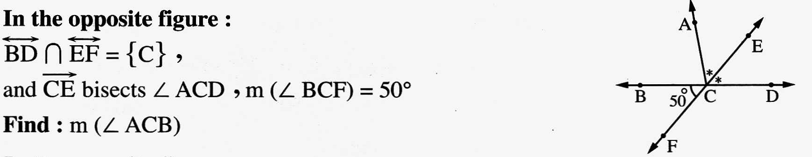2013 Exam ( 2 ) Question ( 3 ) ( a )
7 | 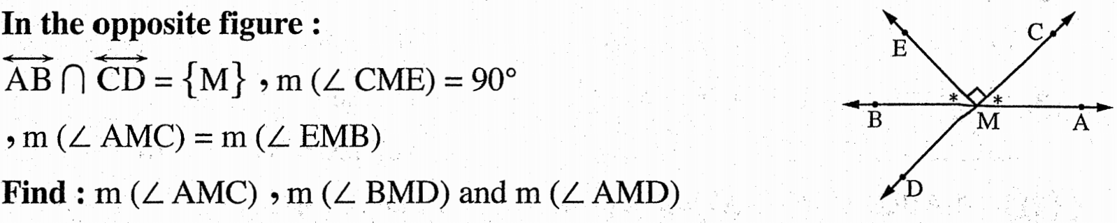2015 Exam ( 12 ) Question ( 3 ) ( b )
8 | 2014 Exam ( 6 ) Question ( 3 ) ( a )
9 | 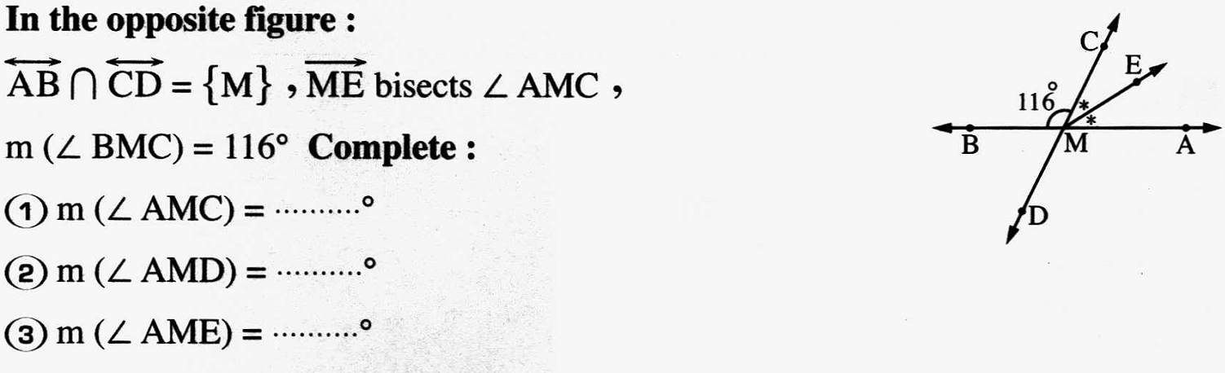2014 Exam ( 8 ) Question ( 3 ) ( a )
10 | 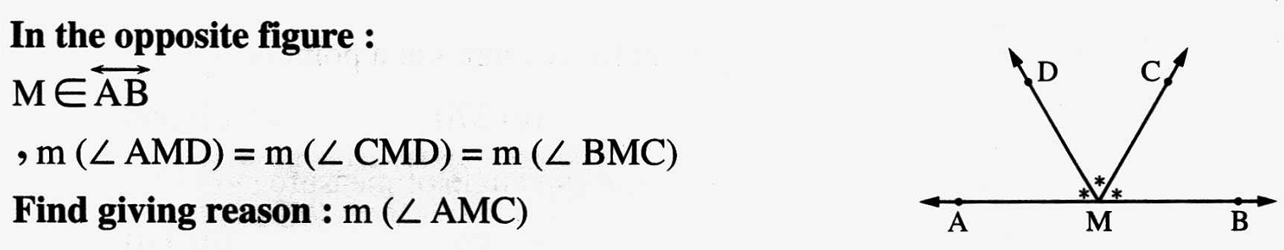2014 Exam ( 10 ) Question ( 4 ) ( b )
11 | 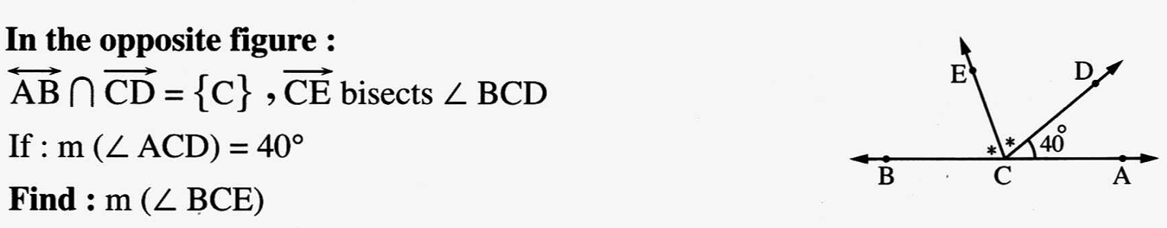2013 Exam ( 3 ) Question ( 4 ) ( a )
1 | 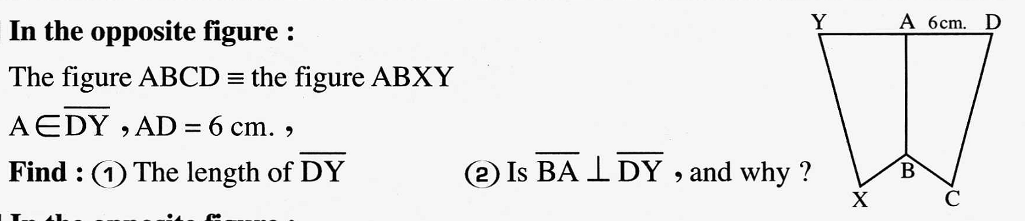2013 Exam ( 12 ) Question ( 4 ) ( a )
2 | 2013 Exam ( 15 ) Question ( 3 ) ( a )
3 | 2013 Exam ( 8 ) Question ( 4 ) ( a )
4 | 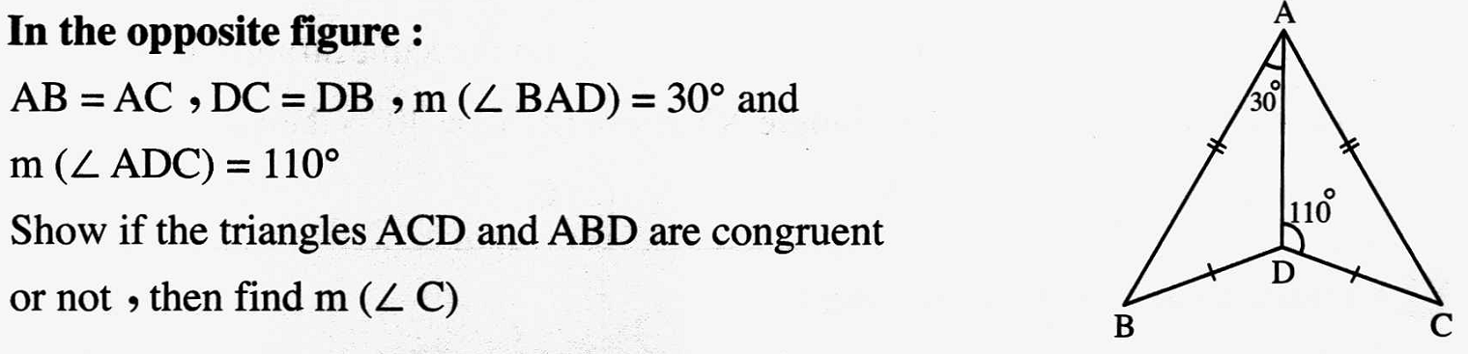2014 Exam ( 10 ) Question ( 5 ) ( b )
5 | 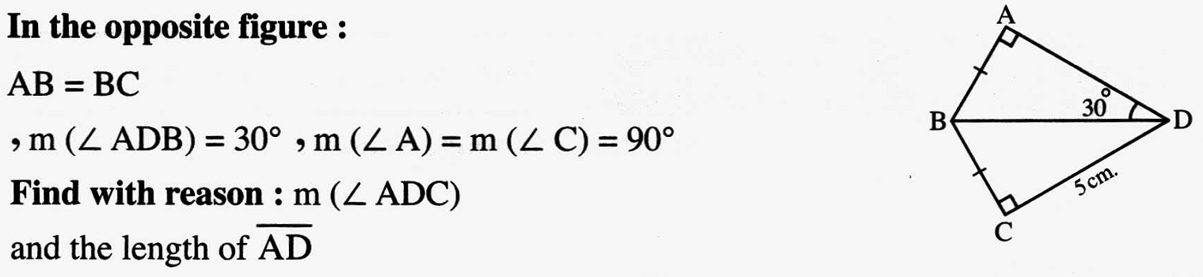2014 Exam ( 10 ) Question ( 4 ) ( a )
6 | 2015 Exam ( 15 ) Question ( 3 ) ( a )
7 | 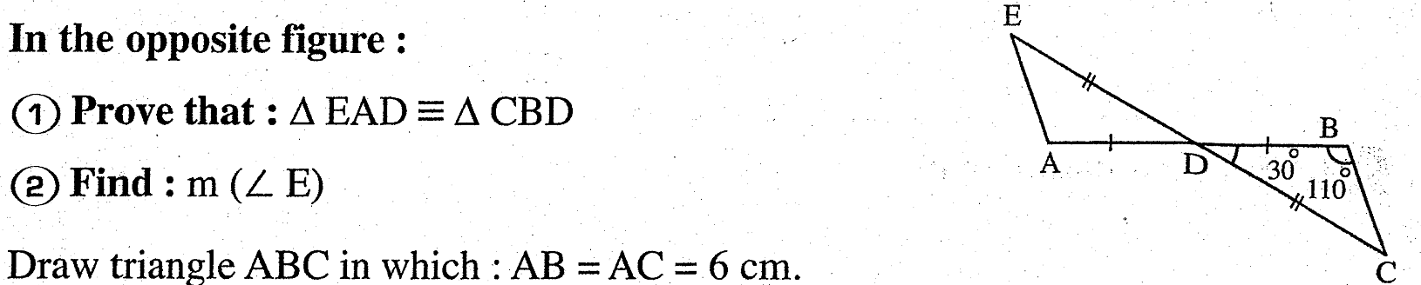2015 Exam ( 9 ) Question ( 5 ) ( a )
8 | 2015 Exam ( 4 ) Question ( 5 ) ( a )
9 | 2013 Exam ( 13 ) Question ( 3 ) ( a )
 | 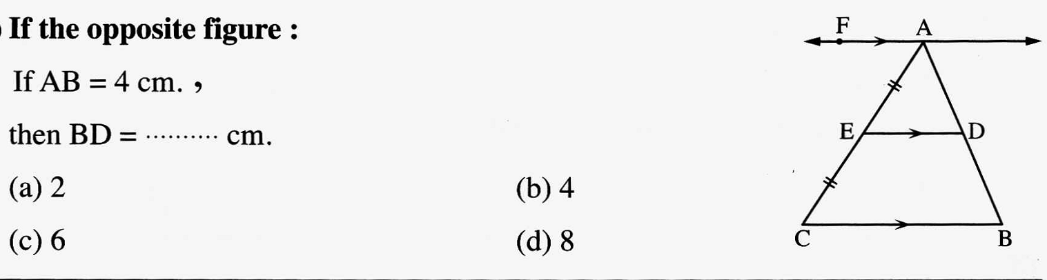
 | 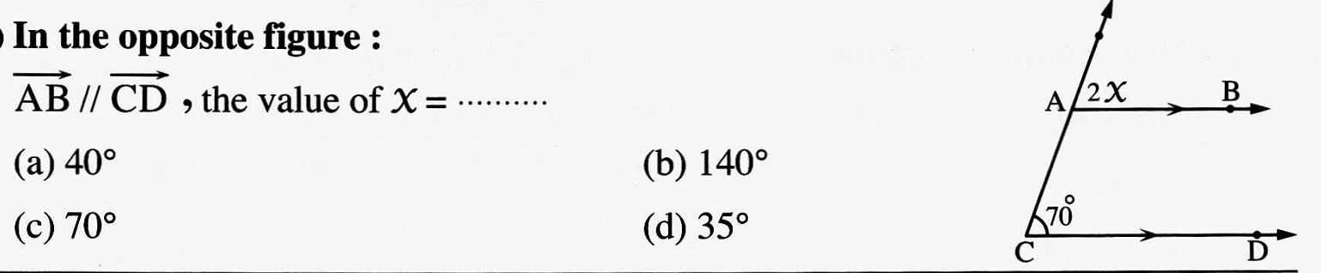
 | 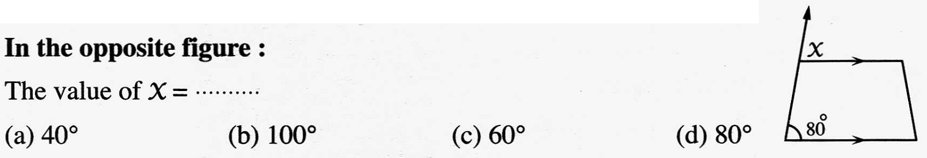
 | 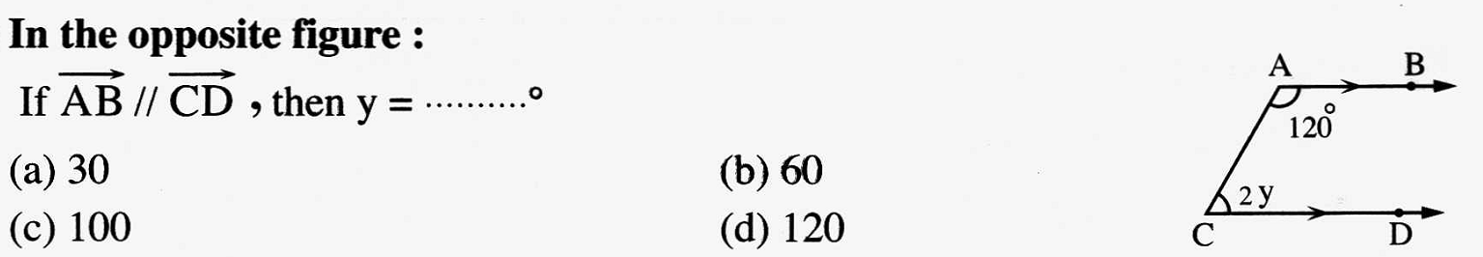
 | 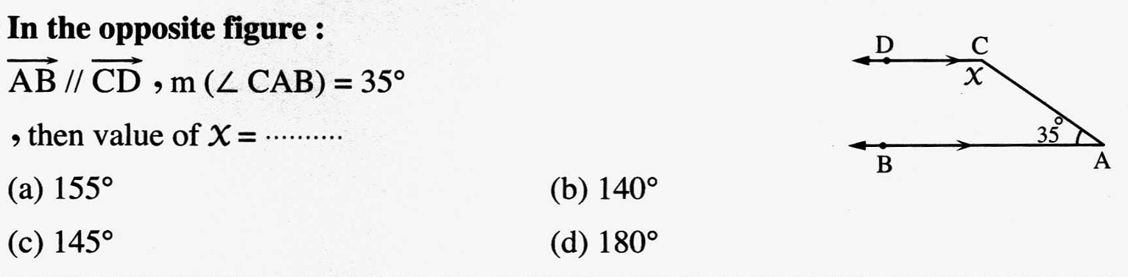
 | 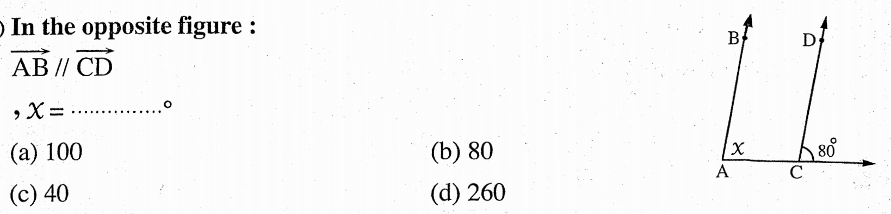

1
2
3
3 | 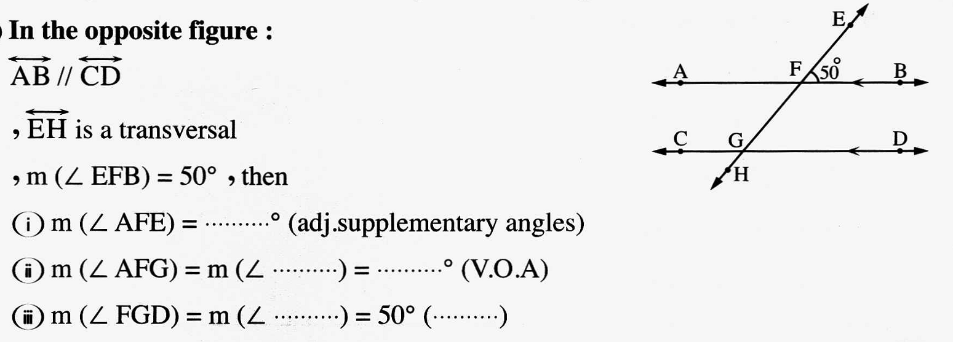
4
5
5
5
6
6
6 | 