Test (1)
(1)Listen and Circle:
1.dusted 2.invited 3.climbed Chopped weeded baked
(2)Listen and Complete:
Hoda: Wake up, Mona.
Mona: What (1)time Is it, Hoda?
Hoda: It`s seven (2)o`clock It is time for breakfast.
Mona: What`s for (3)breakfast?
Hoda: We are having beans and (4)eggs.
(3)Circle the odd word and replace it with a correct one:
1.kebab – salad – beefburger – lemonade. (cheese)
2.Where - How – were – When. (Who)
3.pots – dogs – forks – pans. (spoons)
4.blue – red – juice – green. (yellow)
5.breakfast – cheese – three – bread. (rice)

(4)Fill in the gaps using the words in the box:
[Yard – busy – lazy – hanging – putting]
Everyone is (1)busy today. Mona`s grandmother is (2) hanging
Up the clothes. The pets are in the (3)yard eating their food. Mona`s brother is doing the laundry. Mona is in her bedroom making her bed. Mona`s brother is (4) putting away the groceries.
(5)Read the passage and answer the questions:
Sarah`s favourite subjects are English and Maths. She likes to read English in the library. She thinks maths is fun. In summer, she goes to the library with her friend Mona. Sarah helps her friend in the library. They put away books, sweep the floor and water the flowers. She goes to the library three times every week.
A-True or False:
1-Sarah likes to read English in the library. ( T )
2-Sarah goes to the library with her friend. ( T )
3-She goes to the library four times every week. ( F )
B-Answer the following questions:
4-What are Sarah`s favourite subjects?
They are English and Maths
5-Where does Sarah help her friend?
In the Library
(6)Rearrange the following words to make correct sentences:
1.will – She – a haircut – have.
She will have a haircut.
2.for – looking – I`m – museum – the.
I`m looking for the museum
3.are – you – What – eating ?
What are you eating?
4.a – won – Reem – yesterday- prize.
Reem won a prize yesterday.
(7)Look and write a paragraph of FOUR sentences by using the guiding words:
[breakfast – family – like – eggs]
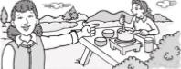
They are at the park. They are eating breakfast. They are eating beans and eggs. They are happy.

(8)Punctuate the following:
1.i met mona and sarah
I met Mona and Sarah .
2.where`s dalia going on Friday
Where`s Dalia going on Friday ?

Test 2
(1)Listen and Circle:
1.marker 2.candle 3.uncle
Sister puddle bicycle
(2)Listen and complete:
Ali: Where are you going?
Sami:I am going to school.
Ali: How do you go to school?
Sami:I go to school by bus
Ali: What is your favourite subject?
Sami: I like maths.It`s interesting.

(3)Circle the odd word and replace it with a correct one:
1.laugh – play – blue – sleep. (go)
2.winter – summer – beach – spring (fall)
3.went – fed – red – hung. (ate)
4.home – campsite – library – go (park)
5.dish – spoon – car – pan (pot)
(4)Choose the correct answer from a , b , c , d:
1.What did she ………….?
a)cooked b)cooks c)cooking d)cook
2.What`s ……………. Breakfast?
a)at b)on c)for d)under
3.Heba won a ………………
a)slice b)prize c)smile d)tree
4.Suzi ………….. buy the ticket yesterday.
a)don`t b)didn`t c)isn`t d)doesn`t
(5)Read the passage and answer the questions:
Yesterday was Friday. Nada didn`t go to school on Friday. Nada went to the supermarket. Nada bought French fries and orange juice. Her mother bought some vegetables and fruits. Her mother is a teacher.
She works at a primary school. She walks to school everyday.
A-True or False:
1.Yesterday was a holiday. ( T )
2.Nada bought meat and rice. ( F )
3.Nada`s mother goes to school on foot. ( T )

B-Answer the following questions:
4.What did her mother buy?
Some fruits and vegetables
5.Where did Nada go on Friday?
She went to the supermarket
(6)Rearrange the following words to make correct sentences:
1.did – What – do – yesterday – they?
What did they do yesterday?
2.going to – a friend – Heba – is – visit.
Heba is going to visit a friend.
3.watch TV – home – you – Did – at?
Did you watch TV at home?
4.looking – for – I`m – museum – the.
I`m looking for the museum
(7)Look and write a paragraph of FOUR sentences
Using the following guiding words.
[family – dinner – have – happy]
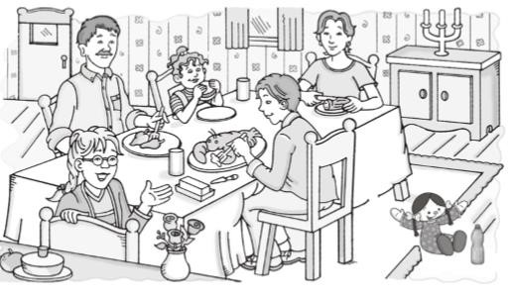
This is my family. They are at home. They are eating breakfast. They are happy.
(8)Punctuate the following :
1.is today monday, tamer
Is today Monday, Tamer?
2.amina isn’t going to cairo
Amina isn`t going to Cairo.

Test 3
(1)Listen and circle:
1.sleep 2.bigger 3.puddle
Sweep better riddle
(2)Listen and complete:
Mariam: I`m looking for the museum.Is it far From here?
Woman: Not really. Walk along this street, turn right and you`ll find it .
Mariam: Did you say turn right or turn left?
Woman: Turn right.It`s on the left.
Mariam: Thank You.
Woman: You`re welcome.
(3)Circle the odd word and replace it with a correct one: 1.French fry – beefburger – spaghetti – lemonade. (rice)
2.play – swim – sang – watch (sing)
3.car – truck – lake – van (taxi)
4.brother – sister – man – mother (father)

(4)Fill in the gaps using the words in the box:

[taxi – ice cream – download – eat – Friday]
I`m Yasmeen. I have a friend. Her name is Aya. I visit my friend on Friday We download a video. We like to buy ice cream In the evening, I take a taxi to go home.

(5)Read the passage and answer the questions:
Rehab and her sister Sara had breakfast very early in the morning. After breakfast, they had orange juice. Then Rehab swept the floor. When their friend Laila came, they went out. Laila wanted to have a haircut. In the evening, Rehab and Sara went back home and Laila gave them two stories to read. They enjoyed the stories very much.
A)True or False:
1.In the evening, Sara and Rehab had orange juice. ( F )
2.Laila swept the floor. ( F )
3.Rehab and Sara went out with Laila.( T )
B)Answer the following questions:
4.Why did the girls go out?
Because Laila wanted to get a haircut
5.What did Laila give Rehab and Sara?
Two stories
(7)Look and write a paragraph of FOUR sentences:
(Park – slide – eat – flavour)
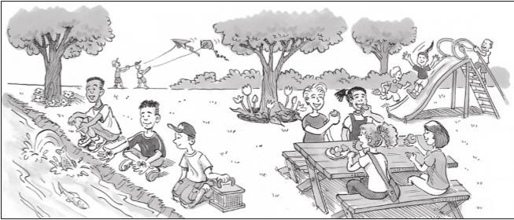
They are at the park. They are sliding on the slides. They are eating sweets. They are happy.
(8)Punctuate:
1.ali met magdi and hany yesterday
Ali met Magdi and Hany yesterday.
2.what s israa going to have
What`s Israa going to have?

Test 4
(1)Listen and circle:
1.better 2.ruler 3.flower
Butter listen slide
(2)Listen and complete:
Mostafa: Hi,Hanaa!
Hanaa: Hi,Mostafa! What are you eating?
Mostafa: Rice and meat. Try some.
It`s good.
Hanaa:No, thanks
Mostafa: Come on. Just a little.
Hanaa: Do you like to drink orange juice?
Mostafa: Yes, I do
(3)Circle the odd word and replace it with a correct one:
1.at – in – cotton – on. (under)
2.Ali – Hend – Omar – Mohamed. (Ahmed)
3.Art – maths – English – van. (Science)
4.Monday – Friday – May – Saturday (Sunday)

(4)Choose the correct answer :
1.We …………. Pick apples in the fall.
a)was b)will c)is d)am
2.He`s going to …………… a friend.
a)send b)buy c)eat d)visit
3.It`s so …………. I`m thirsty.
a)old b)cold c)hot d)young
4.What kind of juice ……… Hanan want?
a)did b)do c)am d)are
(5)Read the passage and answer the questions:
Kareem, Mona, Heba, Huda and Sami are friends. They are in primary five. Mona and Kareem like the summer. They want to go to the beach. They want to build sand castles. Huda likes the fall. She wants to play in the leaves. Sami likes the spring. Heba likes the winter because she goes skiing.
A)True or False:
1.Huda wants to play in the leaves in the winter. ( T )
2.Mona and Kareem want to go to the beach. (T )
3.Sami likes the fall. ( F )

B)Answer the following questions:
4.What`s Huda`s favourite season?
She likes the Fall
5.Who likes the winter?
Heba likes it
(6)Rearrange the following words to make correct sentences:
1.Adel – Is – tall ?
Is Adel tall?
2.for – art – It`s – class – time.
It`s time for art class.
3.popcorn – some – get – Let`s .
Let`s get some popcorn.
4.you – going – are – What – to play?
What are you going to play?

(7)Look and write a paragraph of FOUR sentences: (bed room – door – baby – crawl)
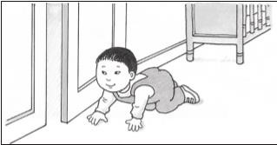
The baby is in the bedroom. He is crawling near the door. He is small. He is happy.
(8)Punctuate:
1.ahmed and ramy aren’t short
Ahmed and Ramy aren`t short.
2.it s my brother s book
It`s my brother`s book.

