Alsun modern school

Time for English

Mid-year Revision 2019&2020

Name:
Class:

Test 1
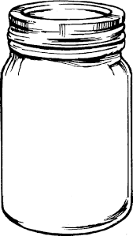
- Listen and number the pictures:

- Listen and fill in the gaps:
Noha: How old …………are…… you?
Sally: I ………'m…… ten years old.
- Read and match (A) with (B):
A | B
- We(c)  - This is (a)  - My sister's birthday(d)  - You are(b) | - for you.  - welcome.  - are walking to school.  - is on Monday.  - 's running.

4.Choose the correct word(s) between brackets:
- I'm (hungry – thirsty – angry). I want to eat.
- He is five (years – ears – yards) old.
- Who (am – is – are) she?
- It (aren't – am not – isn't) eating.
- My birthday is (in – of – on) Wednesday!

5. Look at the pictures and unscramble the words:

Uqestion
question ihtrg
right
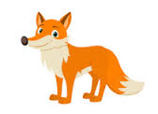
.

Othmer ofx
Mother fox
- Look and write a sentence under each picture:

He is readinig a book This is for you
- Punctuate the following sentence:
my birthday is on Sunday
My birthday is on Sunday .
- Copy the following sentence:
See you tomorrow
…………………………………………………………………………………………………

Test 2
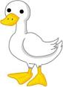
- Listen an number the pictures:
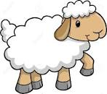
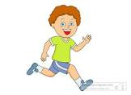

- Listen and fill in the gaps:
A: ………happy …………… birthday.
B: Thanks.
A: You're ………welcome……………………….
- Read and match (A) with (B):
A | B
- Happy (c)  - They(a)  - She is(b)  - Is today (e) | - aren't sleeping.  - eating.  - birthday.  - Wednesday.  - Monday?
4. choose the correct word(s) between brackets:
1. She's (watch – watches – watching) TV.
2. How old are (he – you – they) ? - I'm ten.
3. He (is – am – are) walking to school.
4. (See – Give – Read) you tomorrow !

- He's (talking – reading – walking) a book.
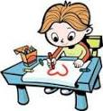
5.Look at the pictures and unscramble the words:

Ukdc rdwa
Duck draw

Itfyf ings
Fifty sing
- Look and write a sentence under each picture:
I can see yo-yo. He is crying
- Punctuate the following sentence:
how old are you
How old are you ?

- Copy the following sentence:
Is today Sunday?
……………………………………………………………………………………………………….

Test 3
1- Listen and number the pictures in order:
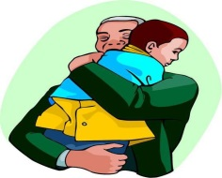

2- Listen and fill in the gaps:

A | : | This is ......for........ you
B | : | .....happy......... birthday

[ 3 ] Read and match A with B:
{ A } | { B }
- How old (C) | a- my father.
- Who is (D) | b- you?
- Is Today (E) | c- are you ?
- He is (A) | d- She?.
 | e- Monday ?

[ 4 ] Choose the correct answer
1- He (is- am - are )studying English.
2- Nice to (talk –meet - eat ) you.
3- ( When - where – how )are you from?
4- May I (speak - meet – run ) to Hisham, please?
5- I live (on -in - to ) Giza.

[ 5 ] Look at the pictures and unscramble the words
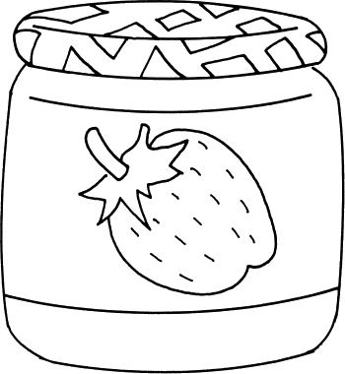 |  | 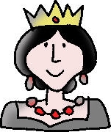 | 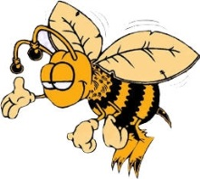
maj | shfi | eeunq | eeb
Jam | fish | queen | bee

Look and write a sentence under each picture )[ 6 ]

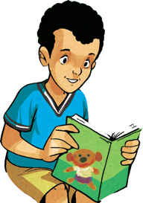 | 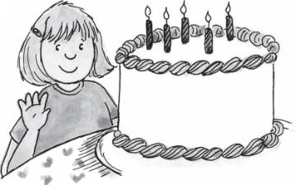
He is reading a book | I'm five years old

[ 7 ]-Punctuate the following sentence:
i 'm eight
I 'm eight .

[ 8 ]-Copy the following sentence:
1-They playing the guitar.
……………………………………………………………………………………
2- She is my mother.
……………………………………………………………………………………

Test 4
 |  | 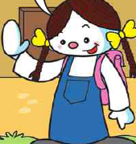 |  | 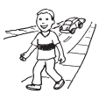
(.......) | (.......) | (......) | (.......) | (.....)
1-Listen and number the pictures:
2-Listen and fill in the gaps:
Ahmed : How ........old........... are you ?
Mona : I'm ......six............. .
3-Read and match A with B:
A) welcome. | Where do you live? (c) | 1
b) She's my mother. | See you (d) | 2
c) I live in Minia . | You're(a) | 3
D) tomorrow . | Who's she?(b) | 4
C) lion .
4-Choose the correct word(s) between brackets :
1-She ( is – am –are ) my sister .
2-My birthday is (in –on– of ) Friday.
3-What's she ( do – does – doing ) ?
4-These(are- is – am ) flowers.
5-This is (for – four - on ) you .

5- Look at the pictures and unscramble the words :
 | 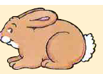
ivfe | abtbir | tea | Nisg | tej
Five | rabbit | eat | sing | jet
6-Look and write a sentence under each picture:
 | 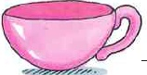
I'm six years old . | This is a cup
7- Punctuate the following sentence:
ali and maher live in minia
Ali and Maher live in Minia ?

8-Copy the following in good handwriting:
They are watching TV.
…………………………………………………………………………………………………………

Test 5
1-Listen and number the pictures:
 | 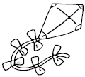 |  | 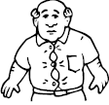
(.......) | (.......) | (......) | (.......) | (......)
2-Listen and fill in the gaps:
Ahmed : What time is ..........it.............. ?
Mona : It's ........five...............o'clock .
a) I'm ten . | Oh.You speak (b) | 1
b) English very well . | This is(c) | 2
c) for you . | How old are you?(a) | 3
d) my father . | He's (d) | 4
e) years old.
3-Read and match A with B:
4-Choose the correct word(s) between brackets :
1-We ( am – is –are ) laughing .
2-What's (they – you– he ) doing?
3-Heba is ( sing – sings – singing ) .

4-That ( are - is - am ) a red flower.
5-She is my ( brother – sister- father ) .
5- Look at the pictures and unscramble the words:
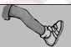 | 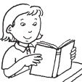 | 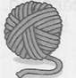
gel | aerd | Rayn | Upc | maj
Leg | read | yarn | Cup | jam

6-Look and write a sentence under each picture:
She is my mother | He is eating
7- Punctuate the following sentence:
Does ahmed live in minia
Does Ahmed live Minia ?
8-Copy the following in good handwriting
He is my brother.
…………………………………………………………………………………….

Test 6

1-Listen and number the pictures:
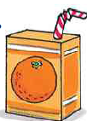 |  | 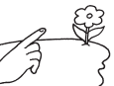
(.......) | (.......) | (......) | (.......) | (......)

2-Listen and fill in the gaps:
Ahmed :Where ………do………… you live ?
Mona : I live ...........in............Minia

3-Read and match A with B:
 | a) She ? | Happy(d) | 1
 | b) jacket. | Bye- (e) | 2
 | c) Minia . | Who is (a) | 3
 | d) birhday. | I'm from (c) | 4
 | e) bye!
4-Choose the correct word(s) between brackets :
1-How old are( he – you –they )? - I'm ten.
2-No, it (isn't – am not – aren't ).

3- (He - You - She )are crying.
4-(Who- What – How ) is she ? -She's my mother
5-What( am – is- are ) they doing ?

5- Look at the pictures and unscramble the words :
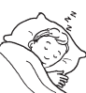 |  |  | 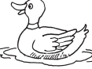 | 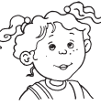
elesp | nria | rade | Ckdu | tressi
Sleep | rain | read | duck | sister

6-Look and write a sentence under each picture:
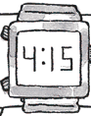 | 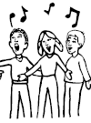
It is for fifteen | The are singing
7- Punctuate the following sentence:
we re live in cairo
We' re live in Cairo .

8-Copy the following in good handwriting:
He is playing football .
…………………………………………………………………………………………….
Test 7
1-Listen and number the pictures:
 | 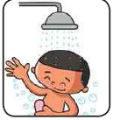 | 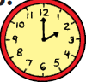 | 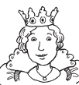
(.......) | (.......) | (......) | (.......) | (......)
2-Listen and fill in the gaps:
Ahmed :Hello. May I speak ........to......... Ahmed, Please?
Mona : ........sure ! Hold on............... .

3-Read and match A with B:
 | a) Hold on. | They are(c ) | 1
 | b) so much . | Sure. (a) | 2
 | c) studying English. | Thank you (b) | 3
 | d) France . | I'm from (d) | 4
 | e) birthday.
4-Choose the correct word(s) between brackets :
1-( See – Eat –look ) you tomorrow.
2-Maha is (draw – draws– drawing ).
3- ( He– We– I )are shouting.

4-Who is ( they – she – you )? –She's a girl.
5-I ( am – is- are ) singing .

5- Look at the pictures and unscramble the words :
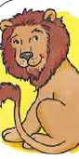 | 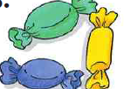 | 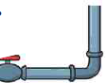 | 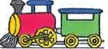
onli | adcyn | eppi | Naitr | Oyugtr
Lion | candy | pipe | Train | yogurt

6-Look and write a sentence under each picture:
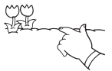 | 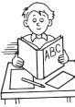
Those are white flowers | He is reading abook

7- Punctuate the following sentence:
no it's tuesday
No, it's Tuesday
8-Copy the following in good handwriting:
English is fun.
…………………………………………………………………………….

