Connect 1

First primary

Revision sheet

2019/2020

Name: ………………………………………………….

Class: ……………………………………………………

Study:

Unit (1)

Bus – bag – bee – book - friends

Unit (2)

Nose – hands – eye – face – ear – hair - neck

Unit (3)

Pencil – pencil case – ruler – sharpener - dog

Unit (4)

Cake – candle – card – oil – orange – olives - balloon

Unit (5)

Father – mother – brother – sister – grandfather – grandmother – flag - tree

Unit (6)

Guitar – drum – piano – flute – triangle – taste – smell

Unit (7)

Bedroom – bathroom – kitchen – living room – home – garden – ant – star – circle – apple - square

Unit (8)

Camel – king – queen – key – pyramids – sphinx - kite

Unit (9)

Computer – box – swim – skip – dig – kick – flower

*Test 1*

1. Read and circle:
2. 2. 3. 4.

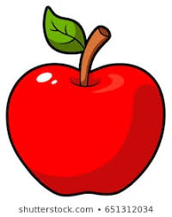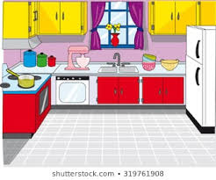

Bathroom square Star Apple

Kitchen circle kite Ant

1. Match (A) with (B):

|  |
| --- |
| 1.guitar c  2.dog d  3.touch e  4.home b  5.rectangle a |

|  |
| --- |
| a.    b.    c.    d.  e. |

1. Listen and write the missing letter:

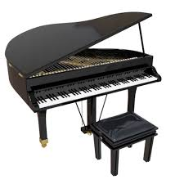1. 2.

Rectangle piano

1. 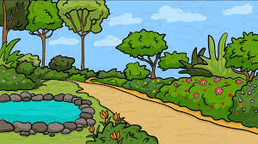 4.



Family Garden

1. Odd one out:

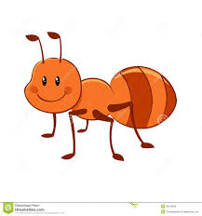



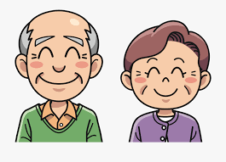

*Test 2*

1. Identify the object:

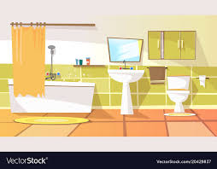

1. Living room



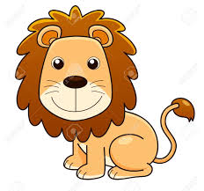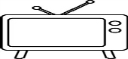

1. tea

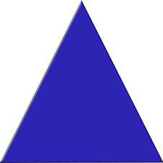

1. rectangle

****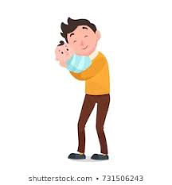

1. sister



1. Kitchen
2. 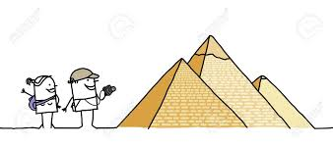Listen and answer (Yes) or (No): Yes No
3. I can see pyramids.

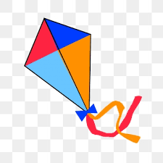

1. There is a kite.



3.It is an ant.

3) Match (A) with (B):

|  |
| --- |
| 1.teeth c  2.neck e    3. bus a  4.book b  5.wash d |

|  |
| --- |
| a.    b.  c.    d.  e. |

4) Count:

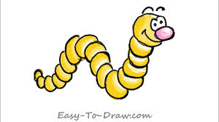

10

2

3

1

9

88

7

6

5

4

1. Unscramble and write:

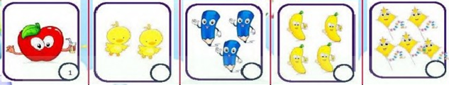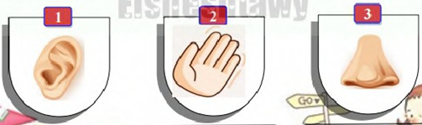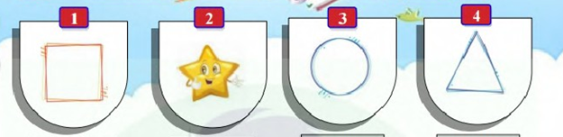

Qauers nahd noe

Square hand one

1. Hand writing:

She is in the kitchen.

She is in the kitchen .

1. Punctuation:
2. can he throw the ball

Can he throw the ball?

1. the pyramid is big

The pyramid is big .

*Test 3*

1. Read and circle:
2. 2. 3. 4.

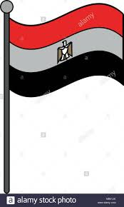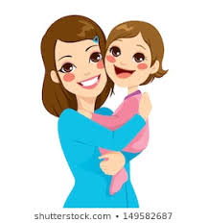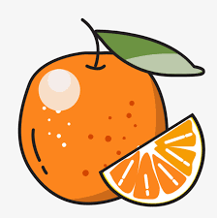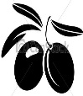

Mother Olives Yellow flag

father Oil Orange tea

1. Match (A) with (B):

|  |
| --- |
| 1.  c  2.nose d  3.pencil case  b  4eye e  5.brother a |

|  |
| --- |
| a.  b.  c.    **C:\Users\peso\Pictures\download (2).jpg**  d.    e. |

1. Listen and write the missing letter:

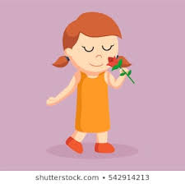1. 2. 2.

Cairo smell

1. 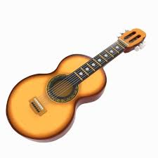 4.



Guitar Eight

1. Odd one out:

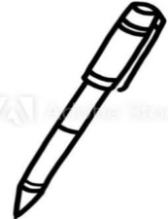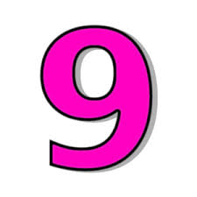



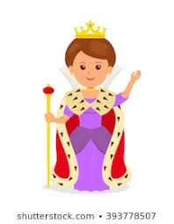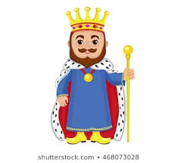

*Test 4*

1. Identify the object:

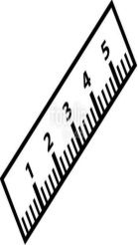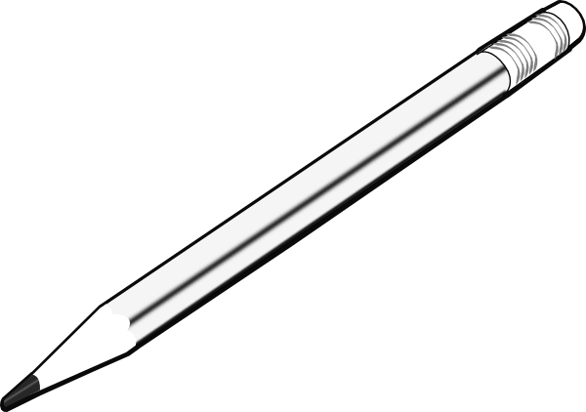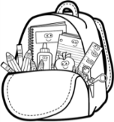

1. pencil



1. seven

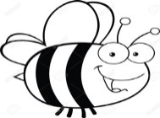

1. bee

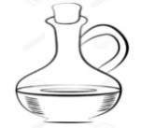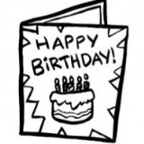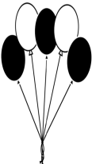

1. balloons

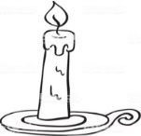

1. orange
2. 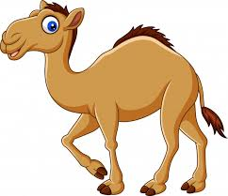Listen and answer (Yes) or (No): Yes No
3. The camel is big.



1. He is my father.

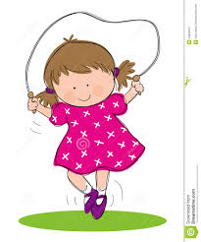

1. I can skip.

3) Match (A) with (B):

|  |
| --- |
| 1.queen c  2.kick d    3. key b  4.insect a |

|  |
| --- |
| a.  b.    c.    d. |

4) Count:



10

2

3

1

9

8

7

6

5

4

1. 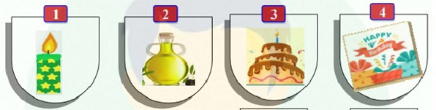Unscramble and write:

ncdale ilo keca ardc

candle oil cake card

1. Hand writing:

I live in cairo.

I live in Cairo .

1. Punctuation:
2. how old are you

How old are you ?

1. i’m six

I’m six.

*Test 5*

1. Look and Circle:
2. 2. 3. 4.

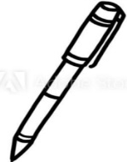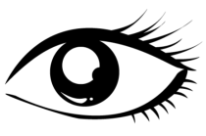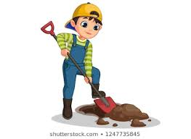

Computer eye pencil kick

box teeth pen dig

1. Match (A) with (B):

|  |
| --- |
| 1.card d  2.five c  3.sharpener a  4.tree e  5.throw b |

|  |
| --- |
| a.  b.    c.    d.  e. |

1. Listen and write the missing letter:

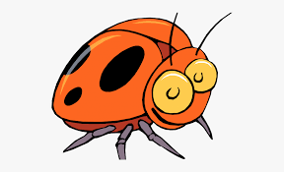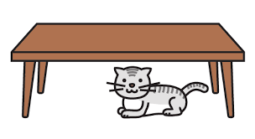1.. 2.. 2.

under insect

3. 4.

TV king

1. Odd one out:



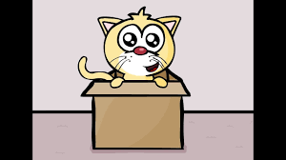

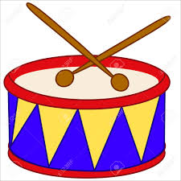

*Test 6*

1. Identify the object:



1. flowers

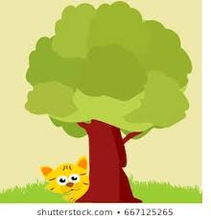

1. in

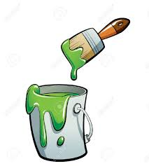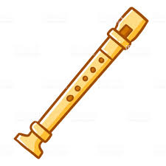

1. flute

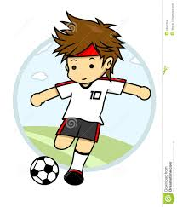

1. swim





1. family
2. Listen and answer (Yes) or (No): Yes No



1. I can play the piano.



1. I can dig.

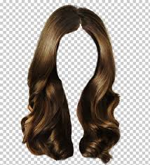

1. I have a long hair.

3) Match (A) with (B):

|  |
| --- |
| 1.taste B  2.ant D    3. hair A  4.circle C |

|  |
| --- |
| a.    b.    c.  d. |

4) Count:



10

2

3

1

9

8

7

6

5

4

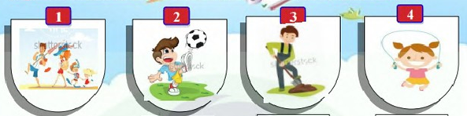

1. Unscramble and write:

eabhc ckki gdi kspi

beach kick dig skip

1. Hand writing:

I can swim.

I can swim .

1. Punctuation:

1.where is it

Where is it ?

2.it’s under the table

It’s under the table.