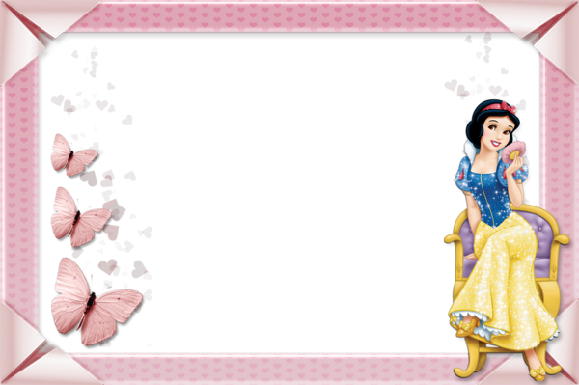
Daddy finger daddy finger where are you
Family fingers
Here I am here I am how do you do

Mammy finger mammy finger where are you
Here I am here I am how do you do
.
Brother finger brother finger where are you
Here I am here I am how do you do

Sister finger sister finger where are you
Here I am here I am how do you do

.
Baby finger baby finger where are you
Here I am here I am how do you do

