Bingo

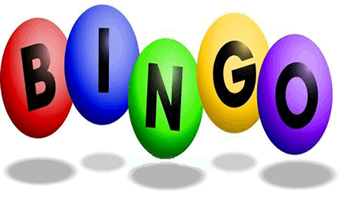
There was a farmer had a dog,
And Bingo was his name-o.
B-I-N-G-O!
B-I-N-G-O!
B-I-N-G-O!
And Bingo was his name-o!
There was a farmer had a dog,
And Bingo was his name-o.
(Clap) -I-N-G-O!
(Clap) -I-N-G-O!
(Clap) -I-N-G-O!
And Bingo was his name-o!
There was a farmer had a dog,
And Bingo was his name-o.
(Clap, clap) -N-G-O!
(Clap, clap) -N-G-O!
(Clap, clap) -N-G-O!
And Bingo was his name-o!
There was a farmer had a dog,
And Bingo was his name-o.
(Clap, clap, clap) -G-O!
(Clap, clap, clap) -G-O!
(Clap, clap, clap) -G-O!
And Bingo was his name-o!
There was a farmer had a dog,
And Bingo was his name-o.
(Clap, clap, clap, clap) -O!
(Clap, clap, clap, clap) -O!
(Clap, clap, clap, clap) -O!
And Bingo was his name-o!
There was a farmer had a dog,
And Bingo was his name-o.
(Clap, clap, clap, clap, clap)
(Clap, clap, clap, clap, clap)
(Clap, clap, clap, clap, clap)

